* **­­What is Docker & How to install it in Windows OS**
* **To check how many images is created**

**++docker images**

* **To remove docker image**

**++ docker rmi <image-name>**

* **To check how many containers is running**

**++ docker ps -a**

* **To delete the containers**

**++ docker rm -f <container-id>**

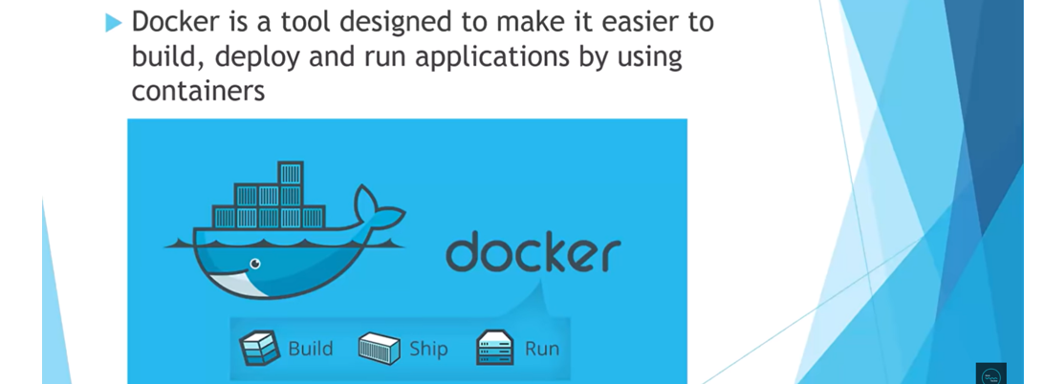



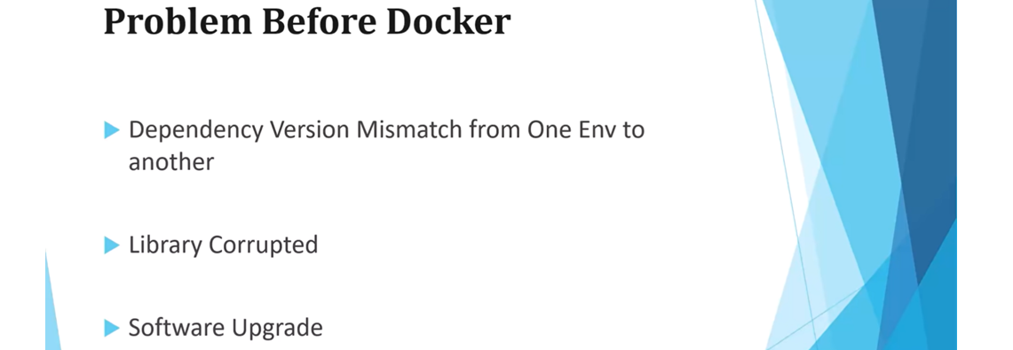

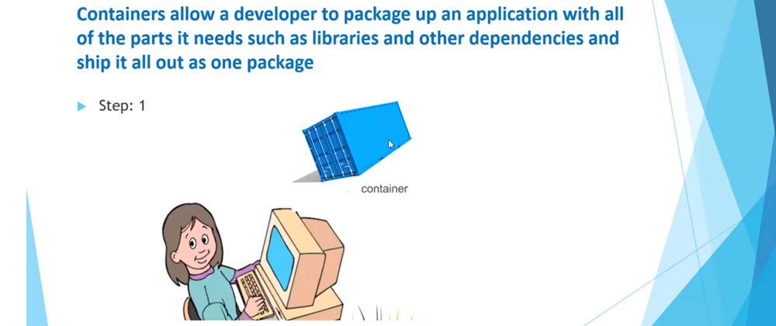





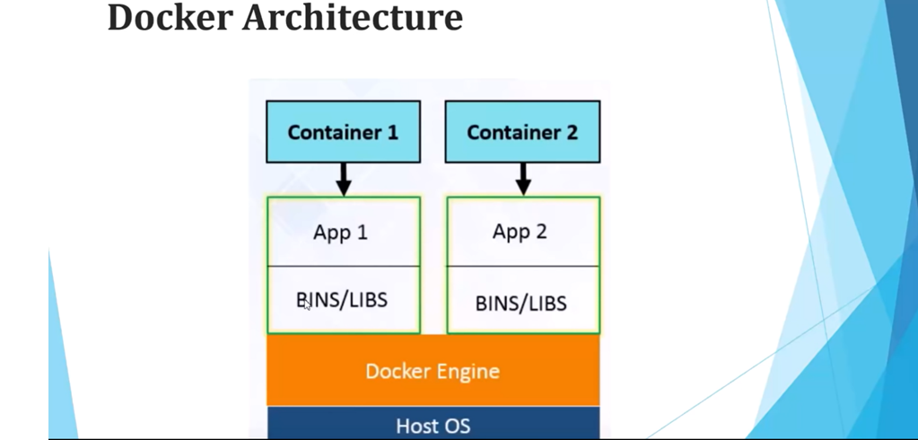

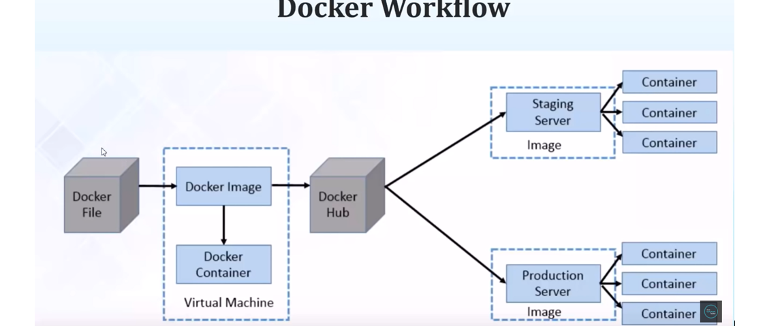

Docker hub is like a central repository of docker images.

* **Docker - Dockerizing your Spring Boot Application**

We can dockerize any java application so let’s create a spring boot application and then we will create a Dockerfile and then we will create a docker image and we will dockerizing our application means creating a docker file creating a docker image and run or deploy that image on docker container the entire process called dockerizing our application.

**Application**- **spring-boot-docker**

**Dependency** – **Spring Web**

Now let’s create one rest endpoint to verify whether our application is running over container or not.

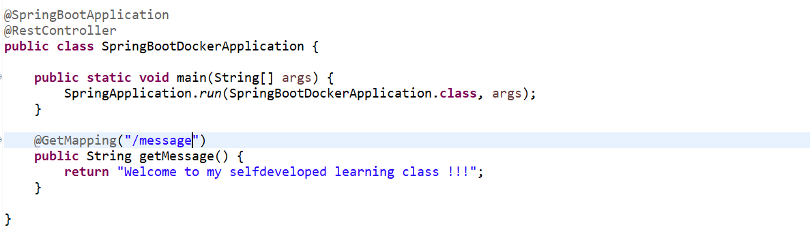

Let’s create one docker file

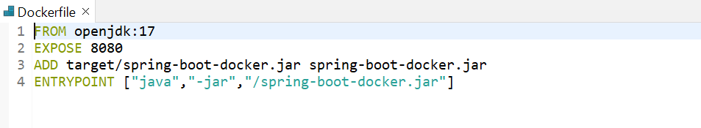

1st one is **FROM** means start with a base image containing with our java runtime, so here we are going to write a jdk related thing. This openjdk:17 image is available in our docker hub.

2nd one is **EXPOSE** I am giving 8080, so the mean of this expose make port 8080 available to outside this container.

3rd one is **ADD** so here we need to add our jar of this application (spring-boot-docker). So here let’s specify the path where we can get the jar **target/**spring-boot-docker.jar spring-boot-docker.jar

4th one is **ENTRYPOINT** so, here we need to specify the command to run the jar. ["java","-jar","/spring-boot-docker.jar"].

Till now we didn’t create the jar. So, now let’s create the jar first. So go to pom.xml file in <build> tag add one tag called <finalName> and specify jar name.

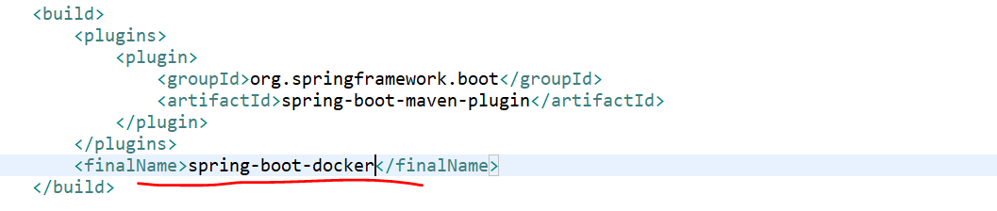

Now let’s generate our jar.

App->Run AS->Maven Install

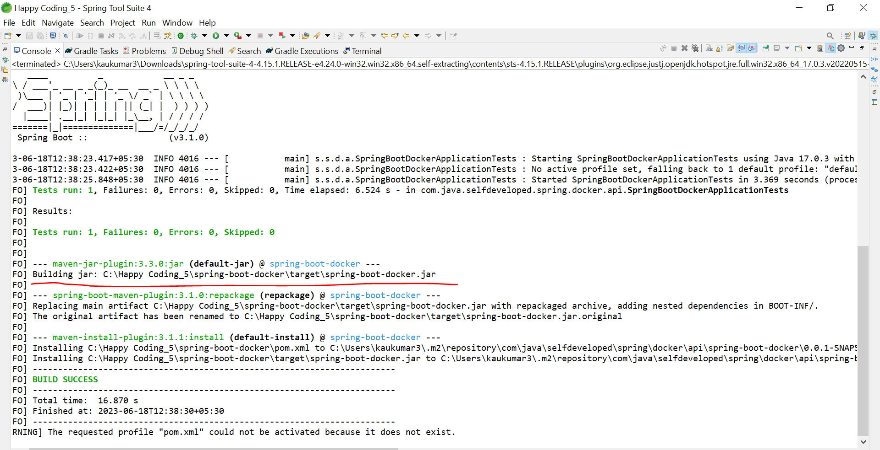

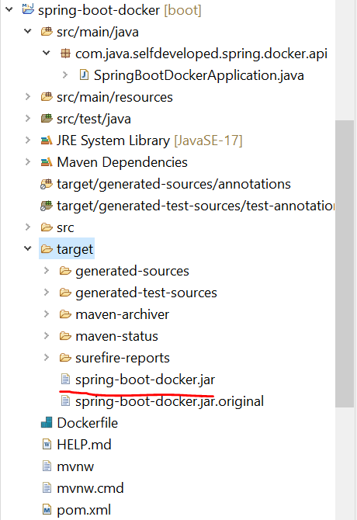

Now finally we have created the jar.

So now we need to create a docker image of it.

Go to project directory and open the command prompt, as we already installed the docker desktop so we can run all command through cmd as well. Type one command.

**++ docker build -t spring-boot-docker.jar .**

so as of now there is no images in our docker repository.

**++ docker logout**

**++ docker login**  //+dockerjimaihu +KrTum5h87@7

**++ docker build -t spring-boot-docker.jar .**

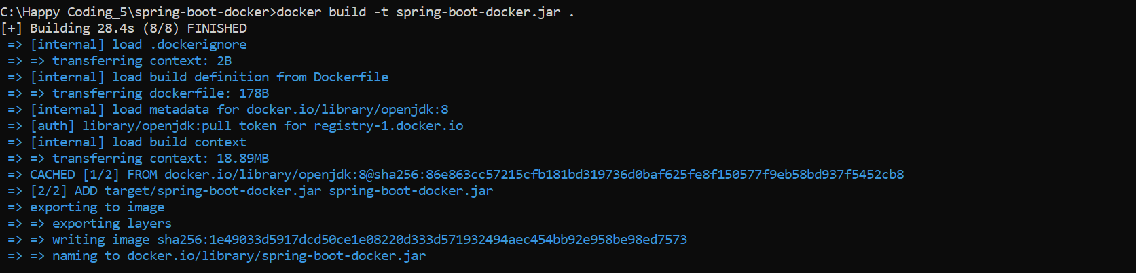

**++ docker images**



Now we need to run this docker images.

**++ docker run -p 9090:8080 spring-boot-docker.jar**

So, this 8080 is my local port what we specify in our docker file and this 9090 will be run on our container.

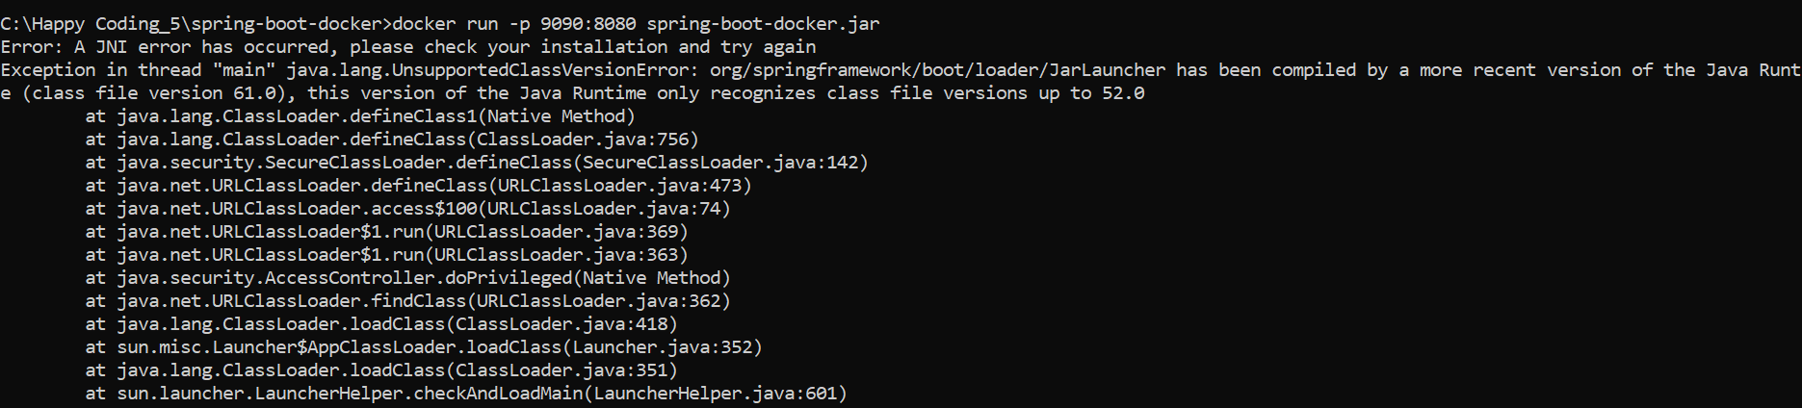

Getting exception so. Let’s fix this issue first.

Java build path-> Library->alternate JRE-> jdk 17 path

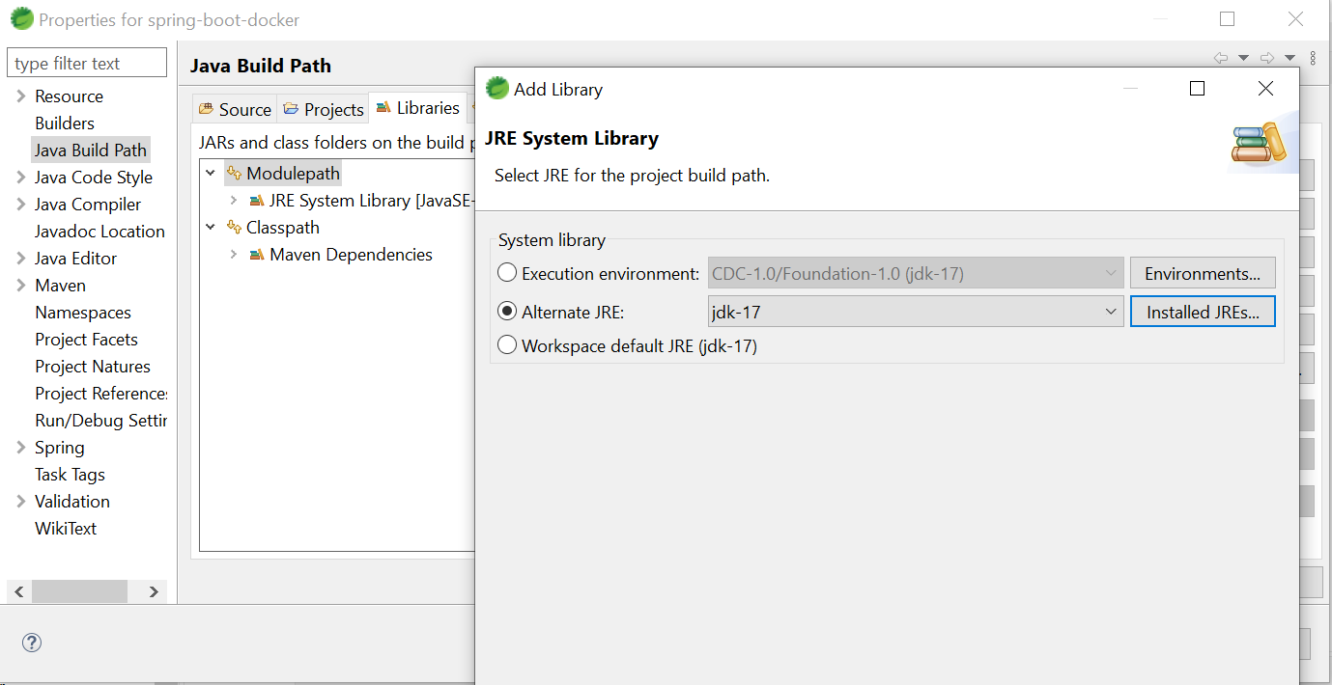

Java app->configuration->java compiler-> 1.8 selected( compiler version should be lower version of our jdk and jre earlier it was 17)

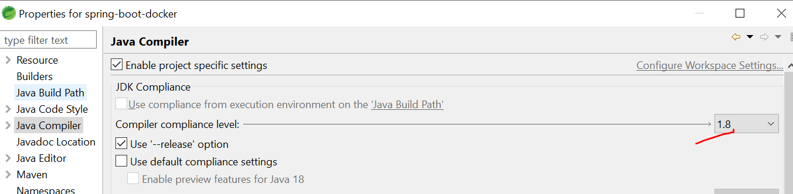

Now build the project again and create a docker image and then try to run it.

While do Maven clean our jar got remove

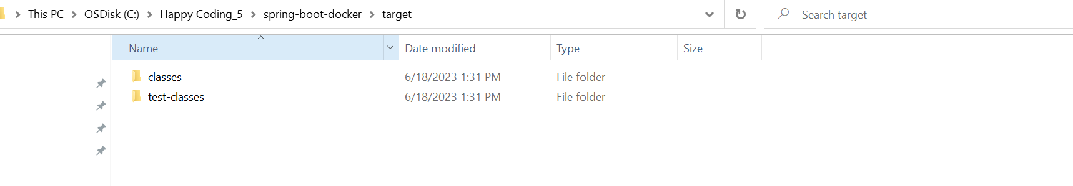

Now let’s create our jar using **Run AS** -> **maven install**

Now we created our jar again and now let’s create a docker image and let’s try to run it.

Ultimately, we found the issue the issue was we are running our application in local on jdk 17 and we specified the jdk version 8 on our Dockerfile.

So always keep in mind our java compiler version always should be lower than our jdk or jre version.

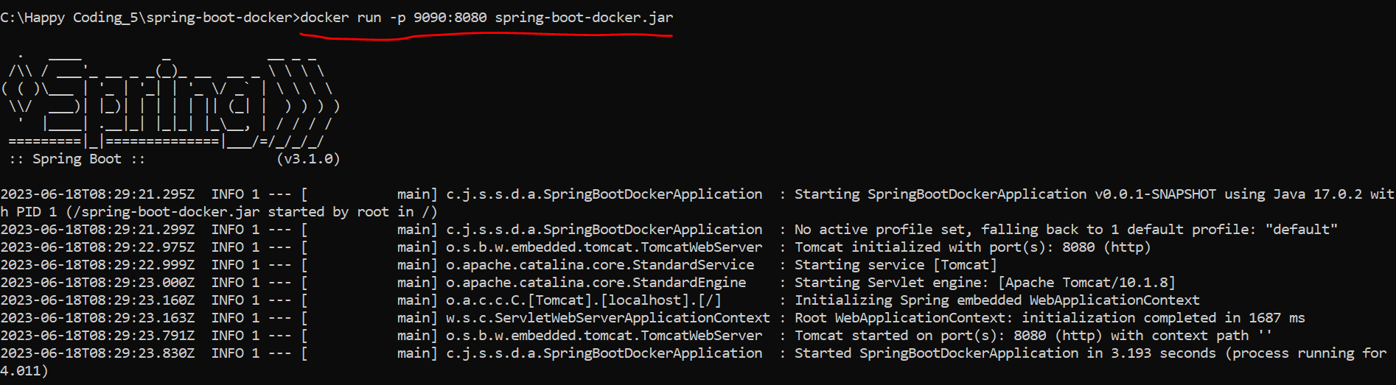

So, here 9090 is our container port and 8080 is our local port.

Now our application is deployed and running on docker container you can access on port 9090. Now once our docker image is deployed in our container you can be able to access it.

Now instead of our local host let’s use our System IP address.

<http://192.168.65.0:9090/message>

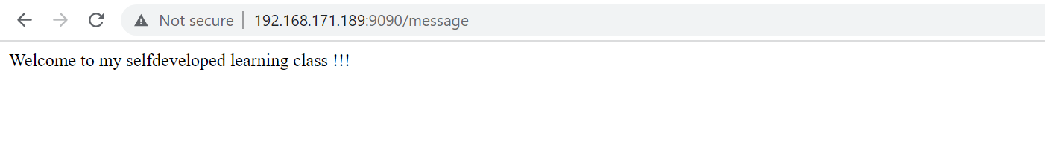

Similarly, we are exposing our local port 8080 as well so we can access on local host:8080 as well.

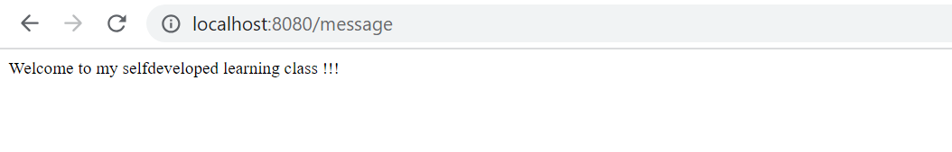

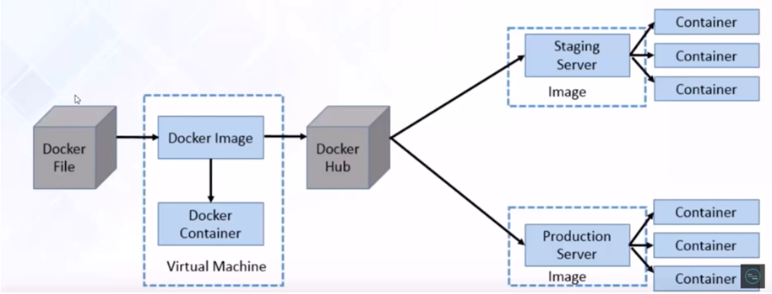

So, this is what our docker flow we have created the docker image and we up our instances in our docker container and we are able to access it our port 9090.

* **Docker - Pushing and Pulling Docker Image to Docker Hub**

Let’s see how to push our docker image to docker hub and how to pull it from docker hub.

What exactly this **docker hub**. Docker hub is a kind of repository. as we have a repository like Github where we can store our SourceCode similarly docker image we can store in our **docker hub**.

As this docker hub is a kind of repository so we need to create an account in our docker hub.

**Credentials**: dockerjimaihu/KrTum5h87@7

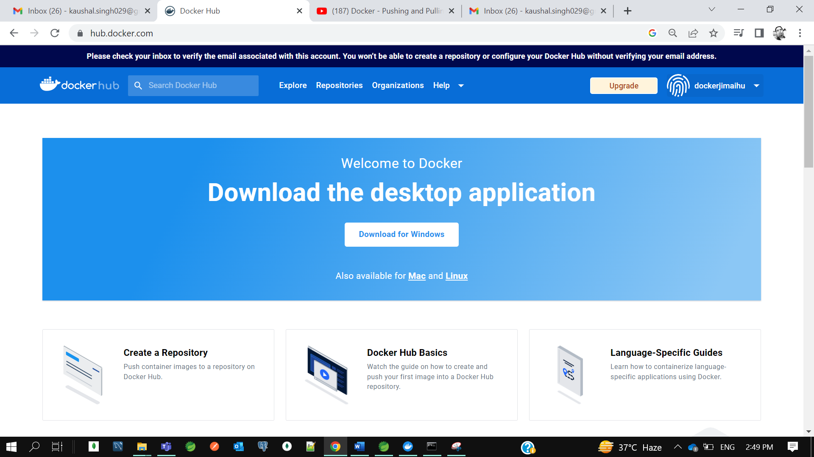

So, we logged in.

Now we need to login from the cmd.

**++ docker login**

**++ docker image ls**



So, we have created one docker image in previous tutorial so let’s push to our docker hub.

As docker hub is a public repository. so, we need to specify some tag to our docker image to identify that this docker image belongs to this **dockerjimaihu**. So, we need to specify a tag. Our tag should be same as our docker userid.

So, to specify a tag there is a command in docker

**++ docker tag spring-boot-docker.jar dockerjimaihu/spring-boot-docker.jar**

To push our docker image on docker hub

**++ docker push dockerjimaihu/spring-boot-docker.jar**

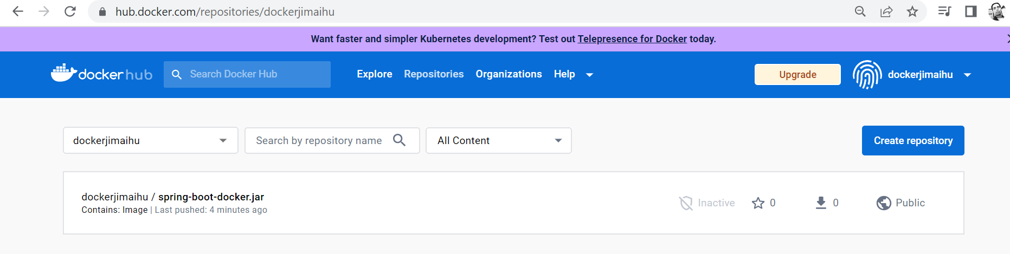

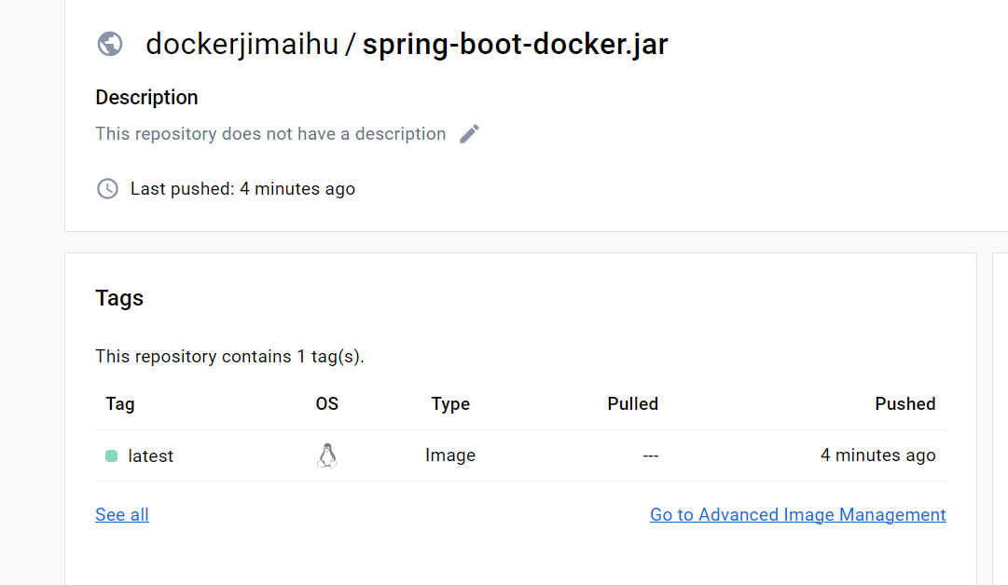

So, we can go to our docker hub repository, and we can see our **spring-boot-docker** image.

Now let’s pull this image and run the docker image

**++ docker pull dockerjimaihu/spring-boot-docker.jar:latest**



Now we pulled the image. Now let’s run…

**++ docker run -p 9090:8080 dockerjimaihu/spring-boot-docker.jar**

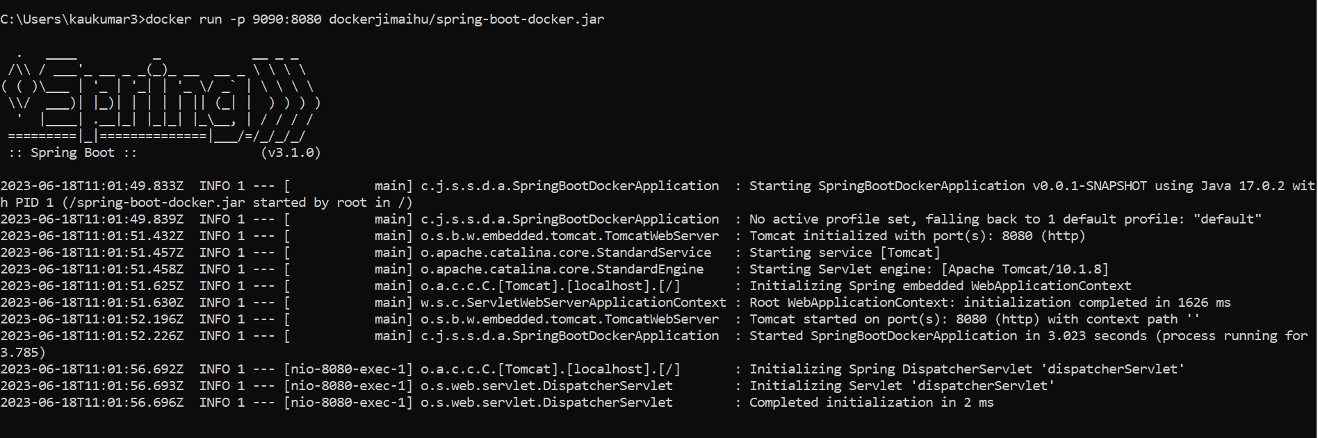

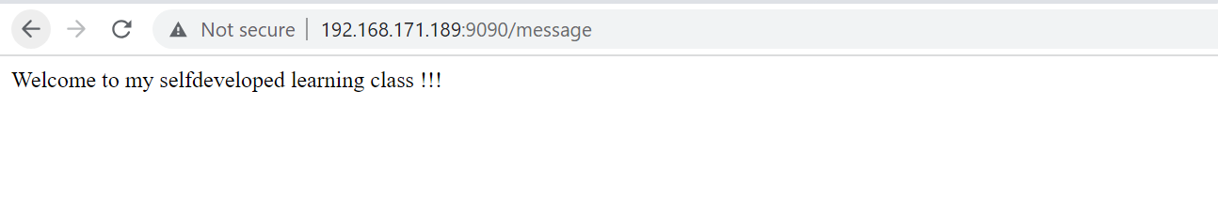

So instead of our localhost we need to use our Ip Address.  
so this is so easy developers no need to install anything in their local machine, they just need to pull the image from docker hub, and they need to run it on their local system.

* **Build and push Spring Boot Docker images using Maven plugin**

So earlier we were using docker file to create a docker image now let’s use maven plugin.

Now let’s create a springboot project and we will dockerize using maven plugin.

**App**- spring-boot-docker-maven

**Dependency**-Spring Web

Now go to pom.xml and let’s change the jar name here

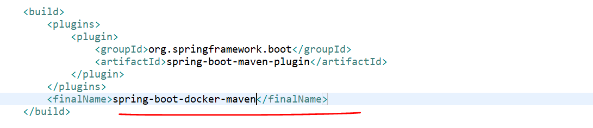

Now let’s create the Dockerfile.

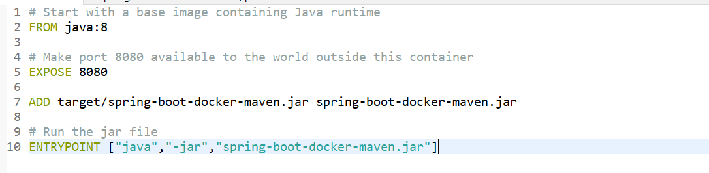

Now we need to generate the jar.

Run AS -> **Maven Install**

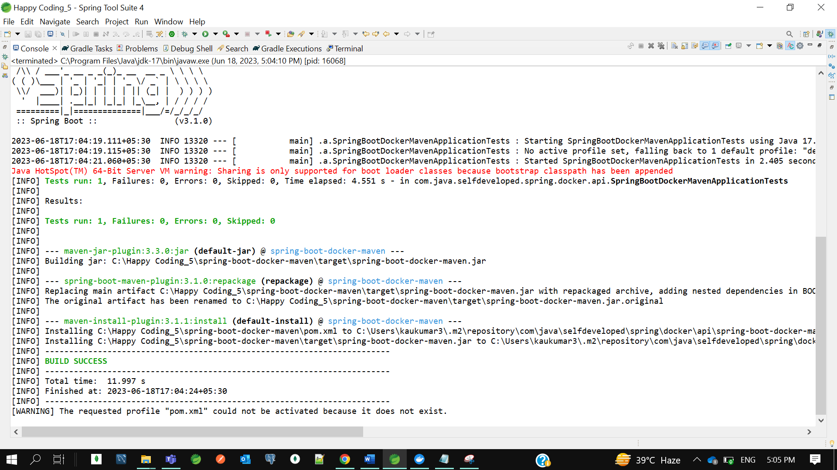

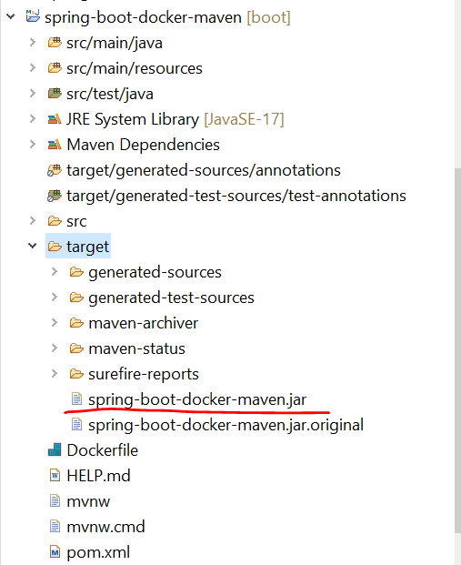

>>> Now let’s add the maven plugin to build an image and push it to the docker hub.

so inside plugins let me add the plugin.

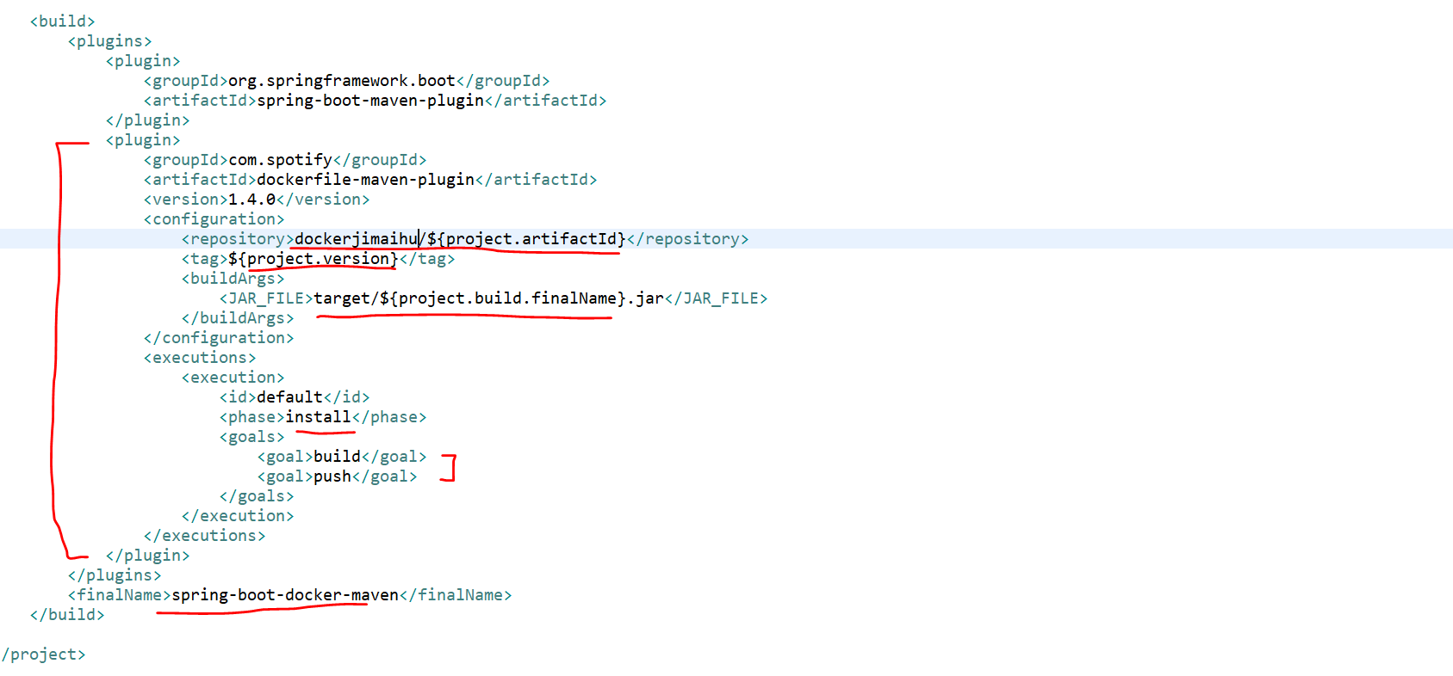

So, the plugin is **dockerfile-maven-plugin**. The version is 1.4.0. in the repository we need to specify the docker_id here. docker_id is nothing the username of your docker hub. So here the docker_id is **dockerjimaihu** andthen the project artifact id which is **spring-boot-docker-maven** so, with the same name the image will be deployed to the docker hub. We specified the jar file here target/**project.build.finalN**ame which is **spring-boot-docker-maven.jar.** we set the goal as build and push inside the install.

So, once you run the docker install it will cover both build and push.so, it will build the image and it will push to the docker hub.

Before docker install let’s first login to the docker hub through cmd.

*** I got some exception here*********

* **Building Docker Images using Jenkins step by step | Devops Integration**

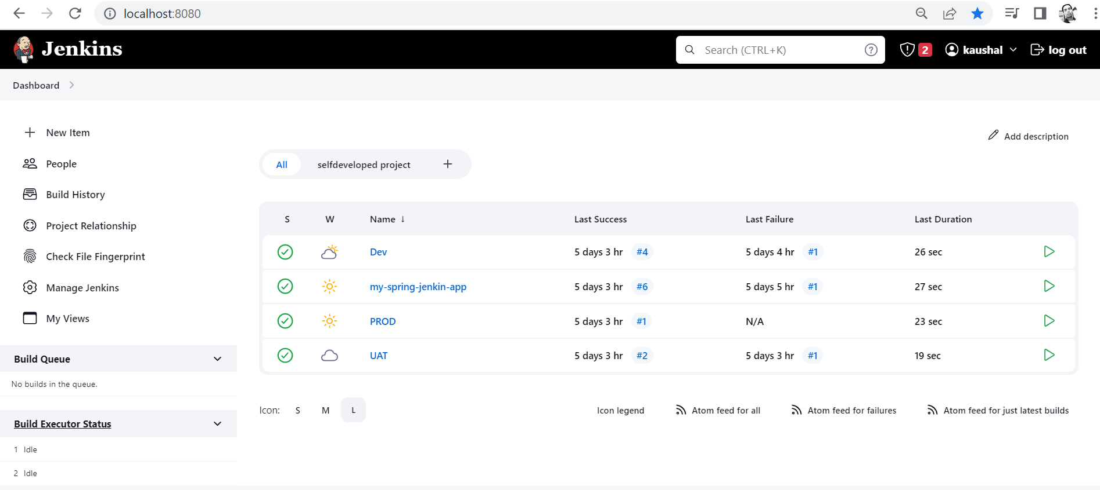

Let’s start with Devops Integration. So, you should have basic knowledge about docker and jenkins.

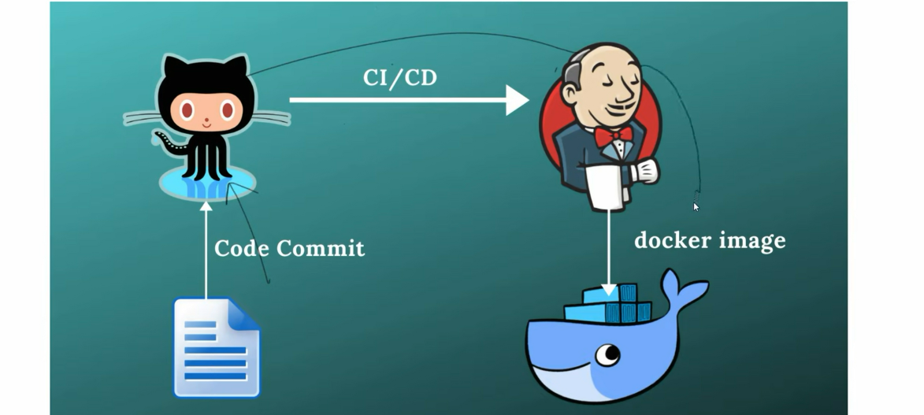

We will create one github repository. and that repo we will integrate with jenkins. So that each code commit to my github jenkins will process continuous Integration and deployment. Once the Jenkin build is succeeded, then jenkins will create a docker image for us and he will push the docker image to docker hub.

So, here we are not going to create a docker image manually and we are not going to push the docker image to docker hub. All the dockerizing stuff would be done by jenkins itself.

Let’s create a java project and that java project will sink with github and then github will link with Jenkin.

**App**- docker-jenkin-integration

Now we specify the jar name in our pom.xml

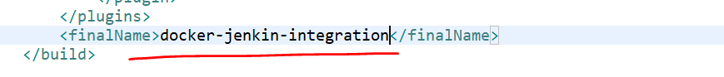

**Github:**

Create a github repository with name **docker-jenkin-integration** and commit our code to github.

We have committed and pushed our changes to github using below cmd-

Gilt Repo- <https://github.com/kaushal8707/docker-jenkin-integration.git>

* git init
* git status
* git add .
* git commit -m "first commit"
* git branch -M main
* git remote add origin https://github.com/kaushal8707/docker-jenkin-integration.git
* git push -u origin main

we have committed our code to main branch.

So, we have created code base and we sink with github.

Now this github need to sink with jenkins.

Now run the jenkins war our start jenkin which will run on port 8080

Now create a job and select free style project. And follow jenkins initial tutorial.

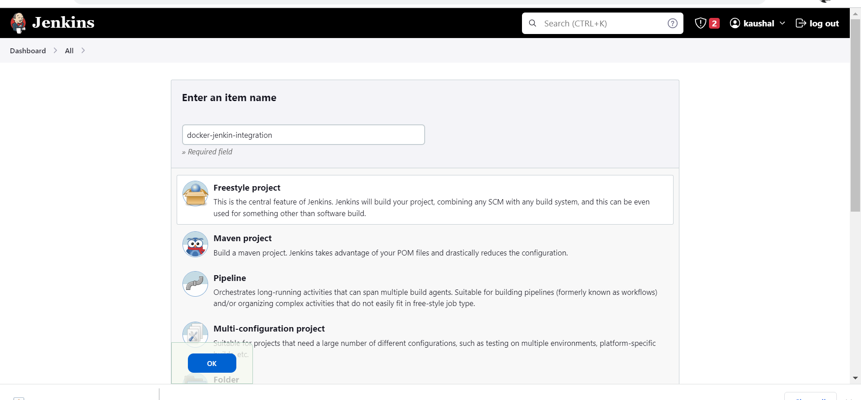

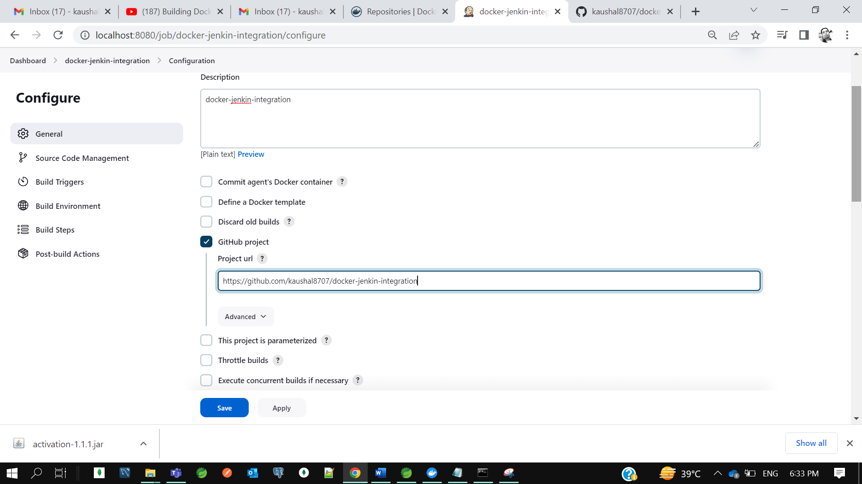

**Jenkin credential- kaushal8707/KrTum5h87@7**

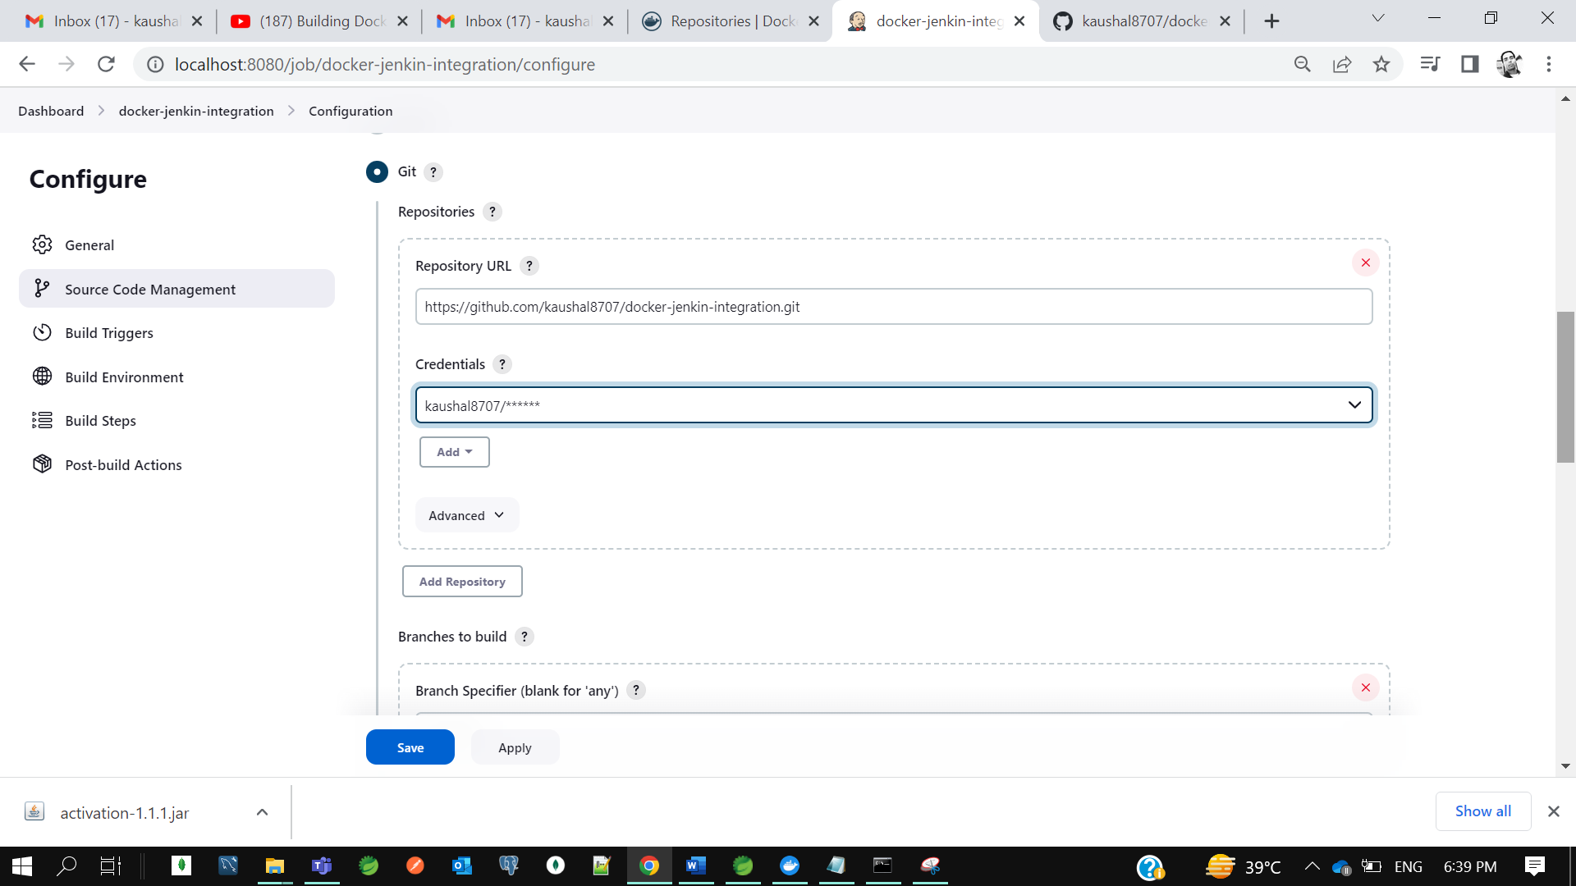

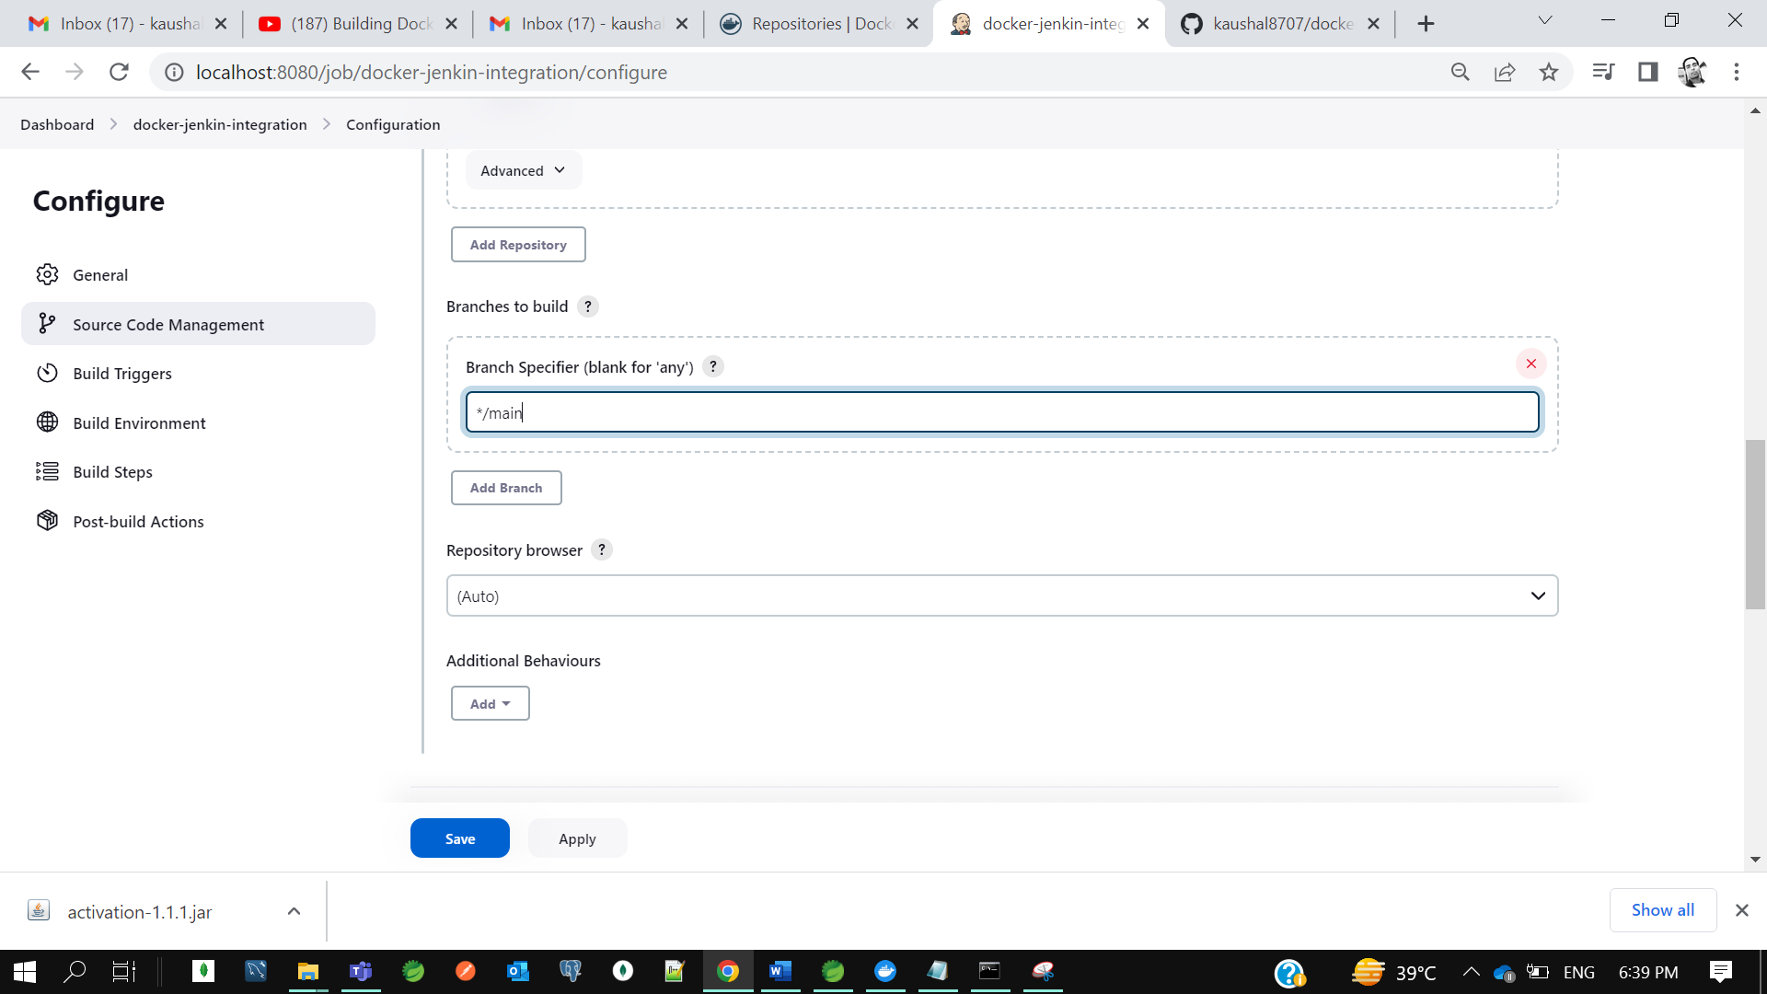

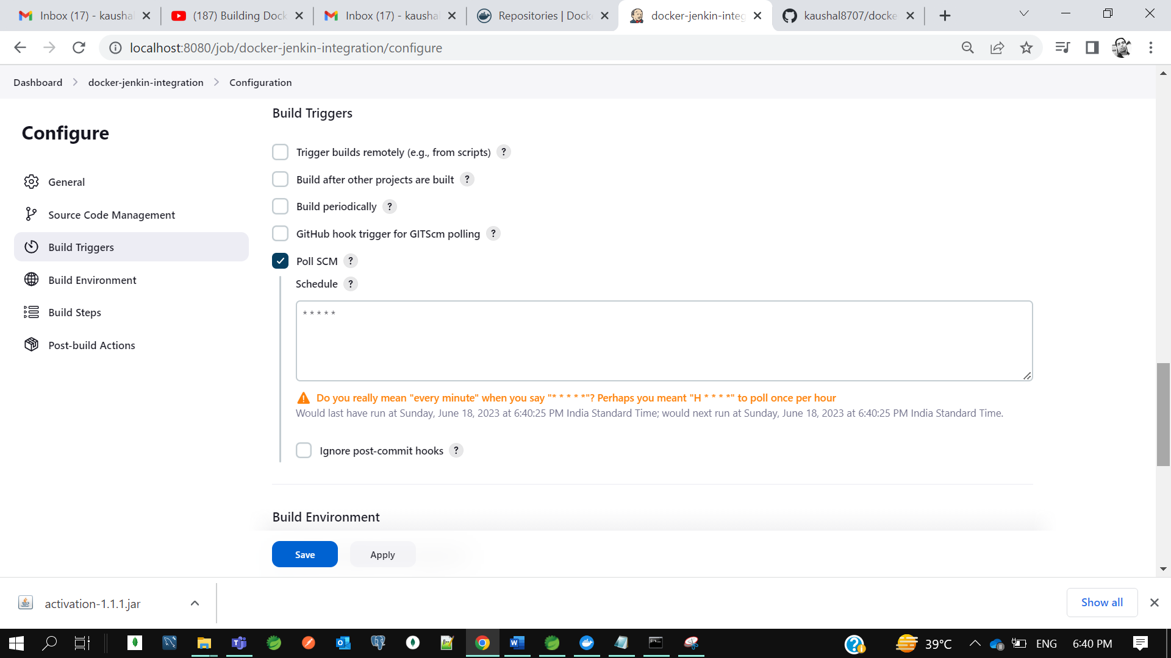

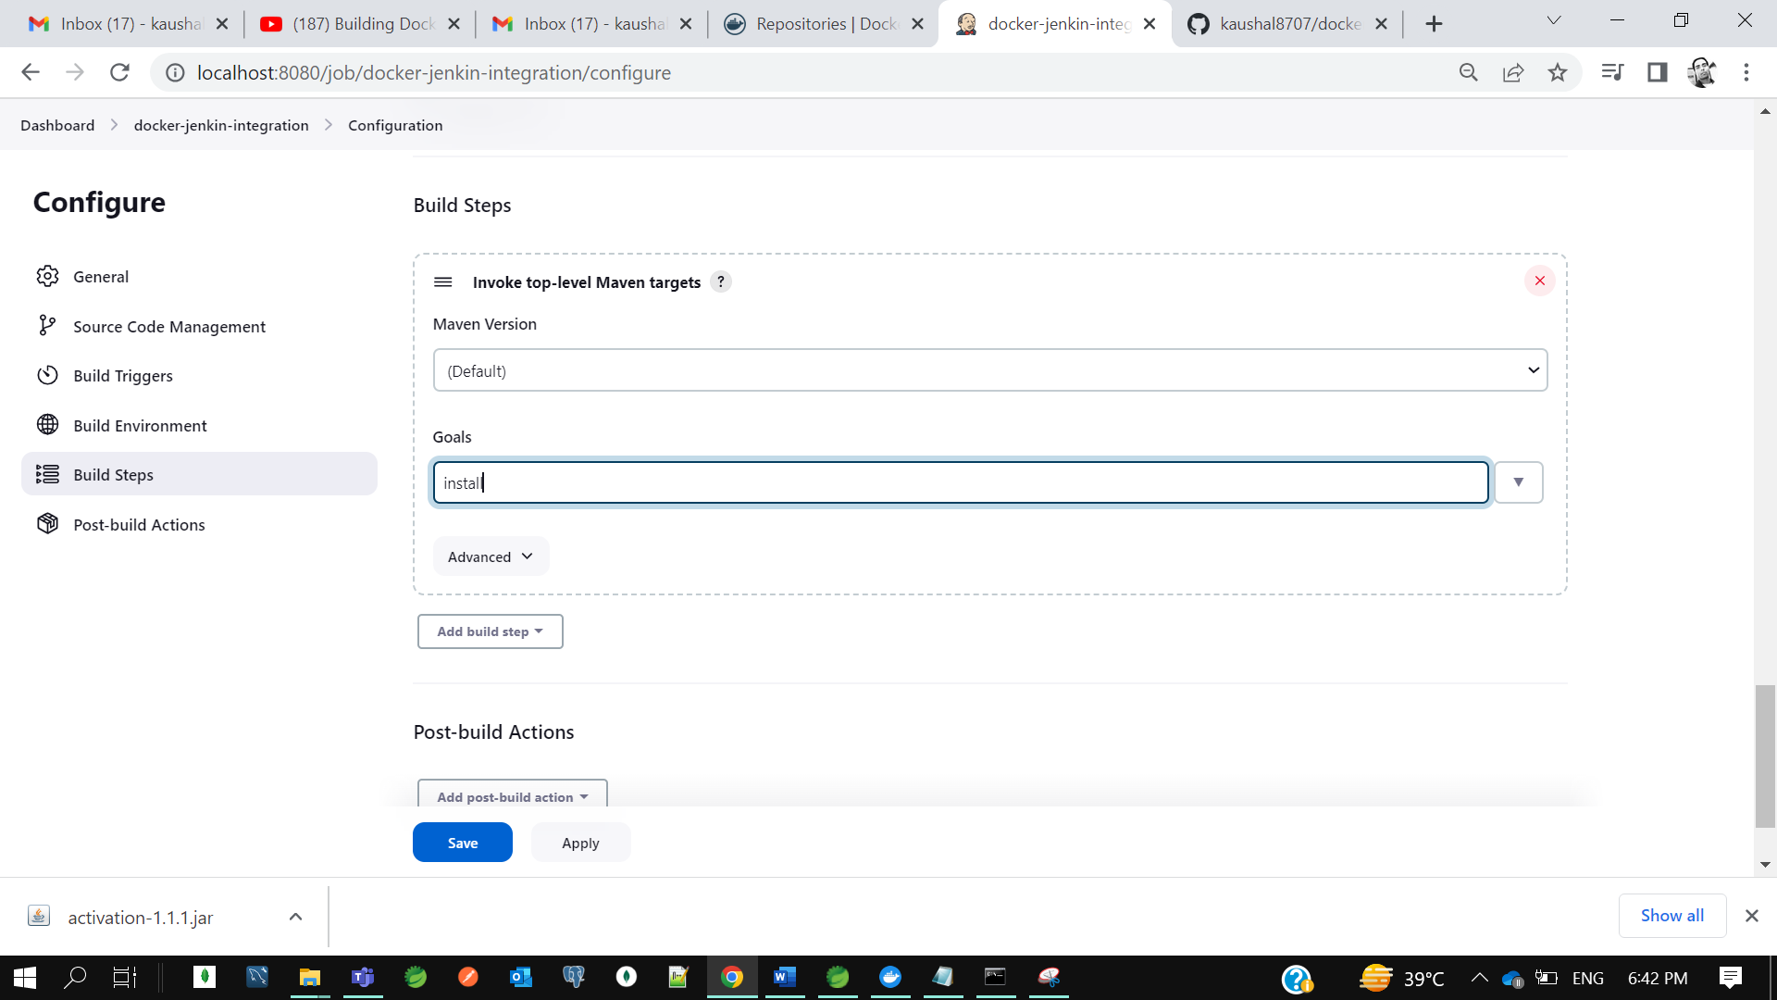

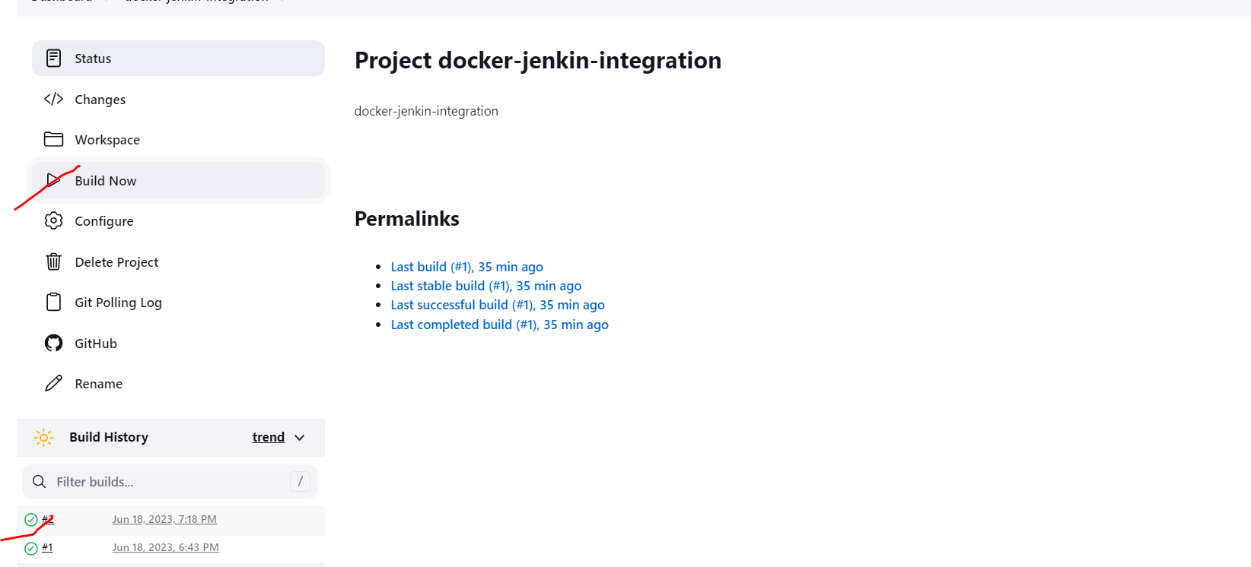

Our build got successful.

Now let’s verify the sink between github and jenkins we will change the code and commit in github the build should automatically start in jenkins. So, when we will commit jenkins will start the maven goal install which we configure to start the maven build.

So, we can see our build got succeeded.

Now we need to integrate jenkins with docker

So, go to jenkin we need to add one plugin. As I already installed docker plugin

Jenkin Home-> Manage jenkins->plugin-> installed plugin-> 3 docker plugin as marked

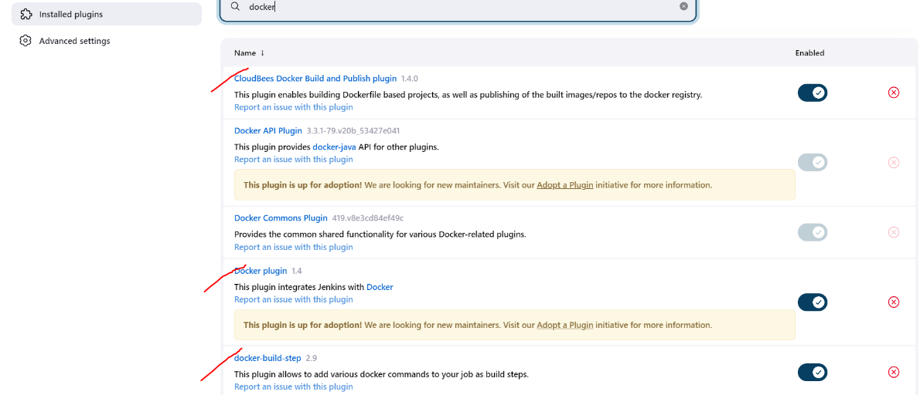

To verify either your jenkins plugin installed successful or not.

Go to jenkins-> project->configure-> add build steps.

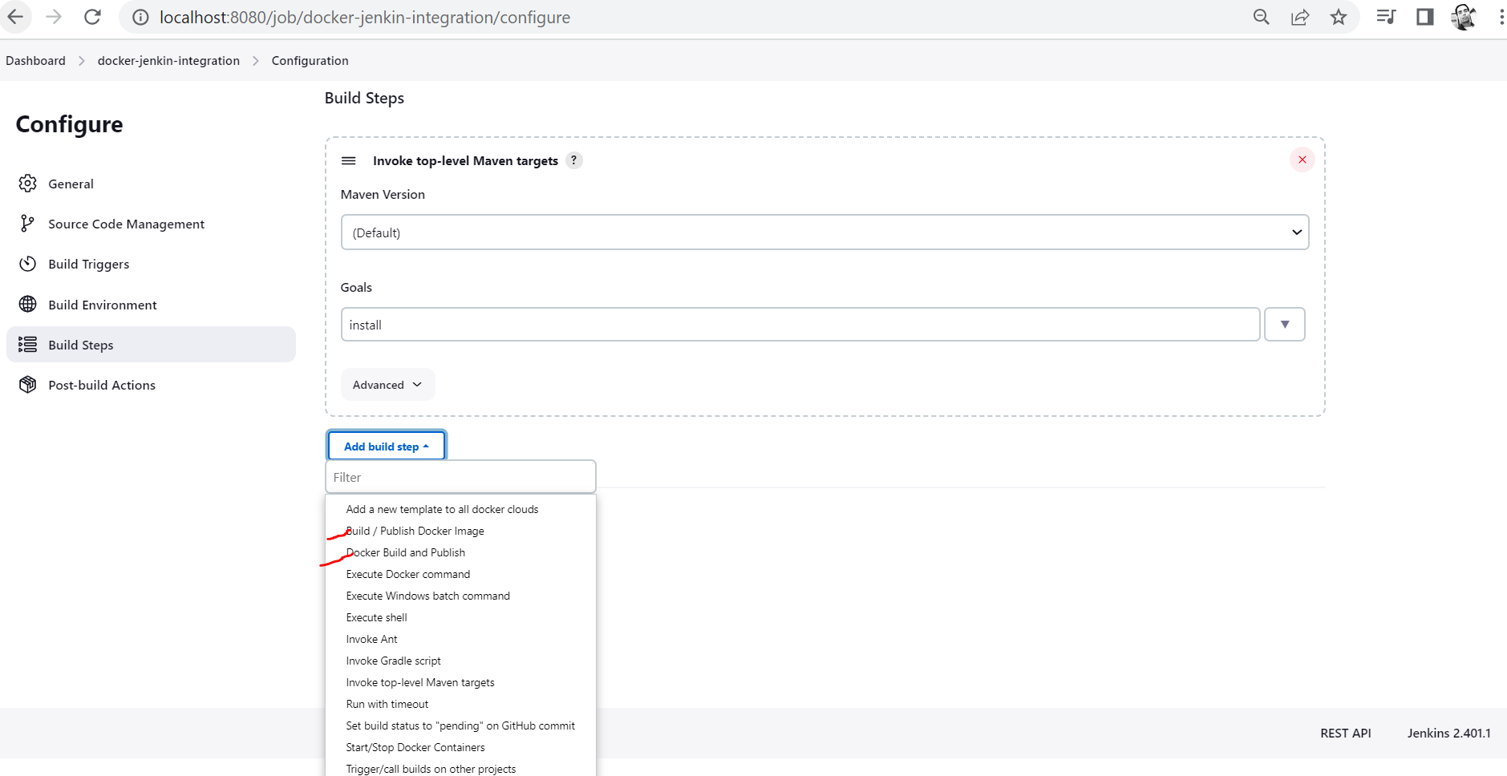

***Now how jenkins will understand your java code that we need to create a docker image.

***How we can instruct jenkin that take this code and build a docker image for us.so for that we need to create the Dockerfile in our code. In our java code we will add Dockerfile and that we will push to github. Now jenkin will load it from github and he will process the build once the build is succeeded jenkin will able to create the docker image and he will be able to push the docker image to docker hub.

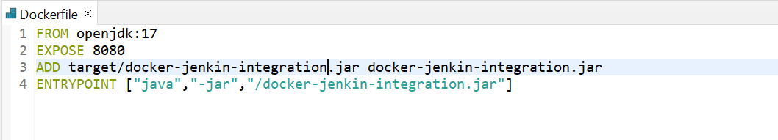

Let’s commit this code to git.

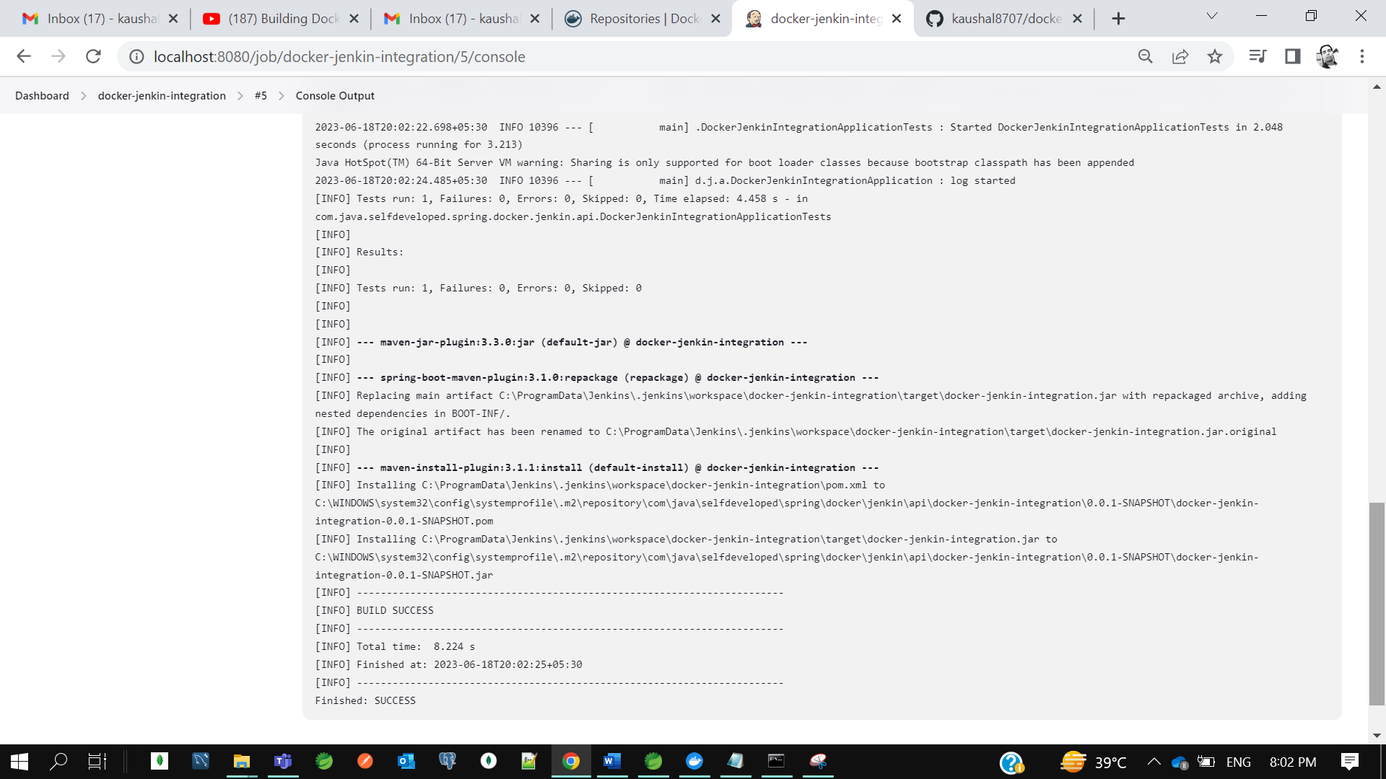

So, build got successful.



So, in jenkin we added the plugin and in our code we already added the docker file.

How we can instruct jenkin that take this code and build a docker image for us.so for that we need to create the Dockerfile in our code. In our java code we will add Dockerfile and that we will push to github. Now jenkin will load it from github and he will process the build once the build is succeeded jenkin will be able to create the docker image and he will be able to push the docker image to docker hub.

So for that I need to give Docker Hub credential to Jenkins.

Project jenkin-> configure->add build step->docker build and publish->

In repo name of docker hub give **tag_name/docker_image_name**

And along with it we need to add our docker hub credential

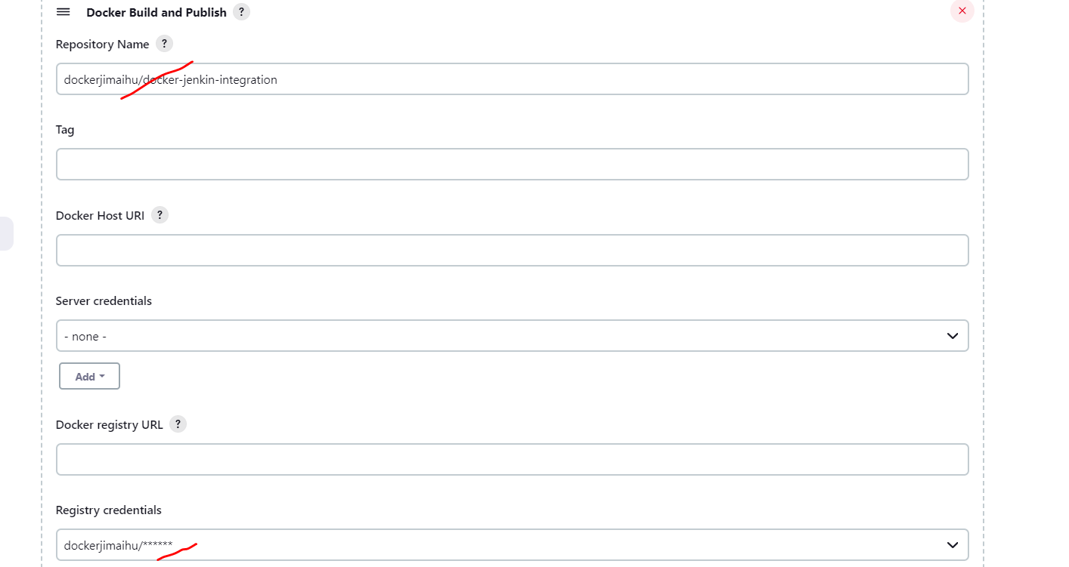

Credential – dockerjimaihu/KrTum5h87@7

Now start the build so it will create a docker image and push that image to docker hub.

* **Deploy Spring Boot and MongoDB as Containers Using Docker Command & Docker-Compose**

Basically, we will run two docker container, in docker container 1 we will run our spring boot application and then in docker container 2 we will run our mongodb image. Then we will understand how they will communicate with each other. Basically, there is a two way with which docker container can talk to each other. First they can go with the command prompt, it means we need to link these two docker container using command prompt, you can directly use docker link. Otherwise, there is an alternative way which you can use called docker compose. Basically, docker compose is a tool for defining and running multi container docker application, we just need to define the configuration file, then rest everything will be taken care by docker itself. So, if you are using docker compose, then we can deal with n number of docker container. So, we will demonstrate both the approach with one simple example.

let's quickly create a spring boot project. But note here, we are not going to use our local MongoDB. We are going to pull the MongoDB image from Docker, and we are going to that MongoDB container. so, what I can do first, let me get the latest image of MongoDB from Docker.

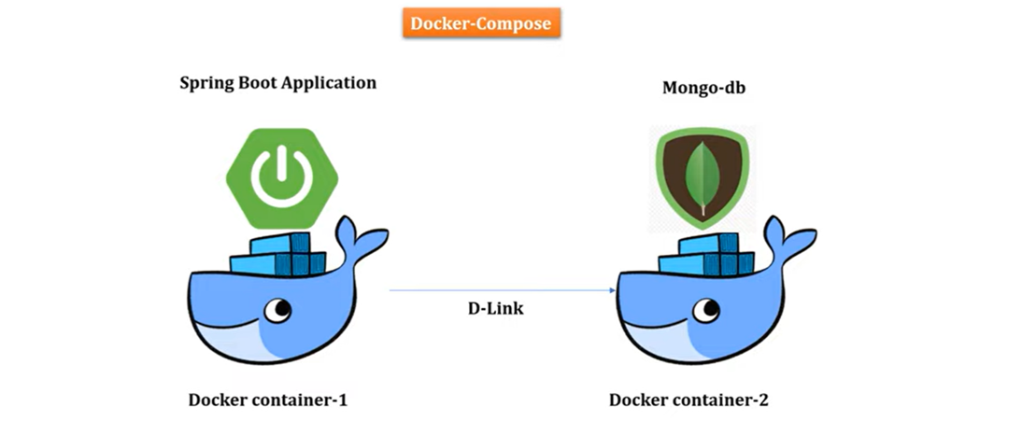

**Application -** [**springboot-mongo-docker**](https://github.com/Java-Techie-jt/springboot-mongo-docker)

Dependencies - Web, Lombok. MongoDB

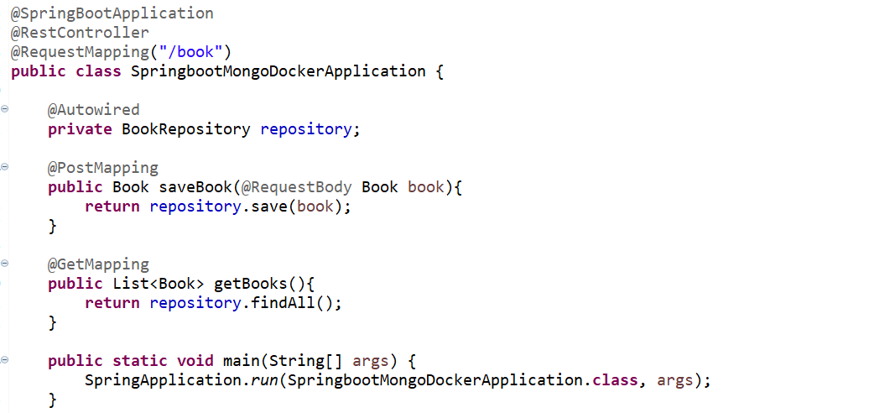

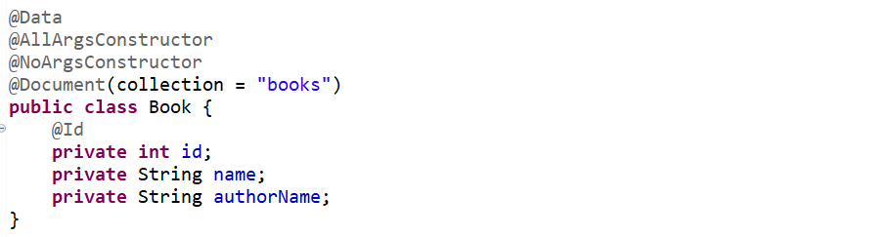



++ first, let me get the latest image of MongoDB from Docker.

**++ docker pull mongo:latest**

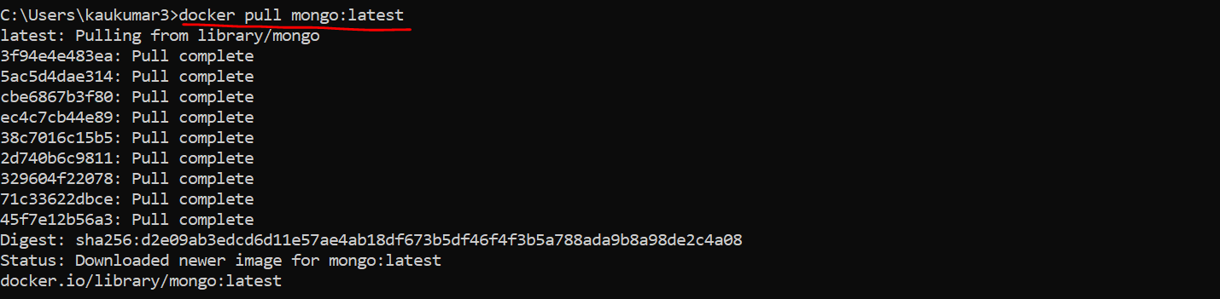



Now, I can run this image, which will be of my MongoDB in container itself. So, to run that I can directly use command

**++ docker run -d -p 27017:27017 --name selfdevelopedmongodb mongo:latest**

**++ docker ps**



So, host and container port, I'm giving the same 27017. Then I can give the name of my container which is selfdevelopedmongodb, then just give the image name, which is mongo:latest.

you can find one container name selfdevelopedmongodb, wherever MongoDB image is running.

* Now we're not going to use our local MongoDB instance, we'll use this container image of Mongo.
* Then we just need to provide the data source properties of MongoDB, which is running in our Docker container to my application. Right. So how I can give that? Let's go to the resource. Then I will create a file called application.yaml. I just need to provide what is my database name so I can give book. similarly, I just need to provide the host. So, host I can give selfdevelopedmongodb. If you observe in the command, this is what the container we run. Port will be default. So we configured everything. Now only we just need to dockerize this application.

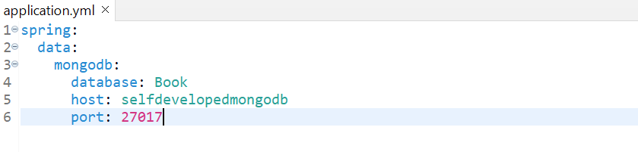

Now I just need to dockerize this application

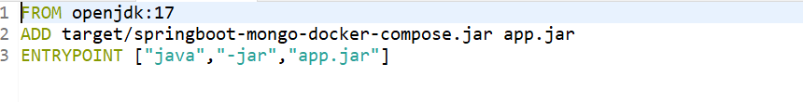



Run AS-> Maven Install

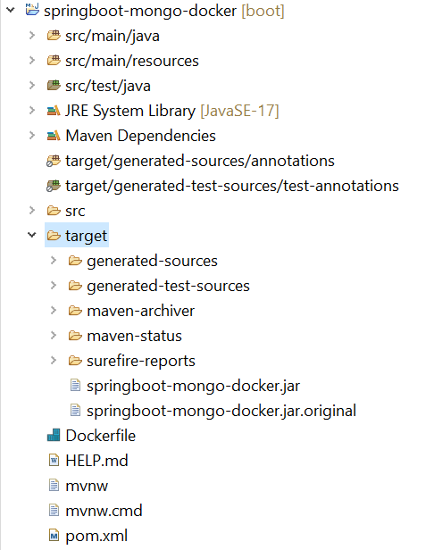

Go to project directory and create a docker image using docker file…

**++ docker build -t springboot-mongo-docker-compose:1.0 .**



So, we have the spring boot image. We have the MongoDB image. So, let's link these two images and let's run our spring boot MongoDB container. So, what I can do I'll just need to link that to my spring boot application. So, there is a command called link.

**++ docker run -p 8080:8080 --name springboot-mongo-docker-compose --link selfdevelopedmongodb:mongo -d springboot-mongo-docker-compose:1.0**



To see the running container

what we can do let's verify it docker ps. You should see two containers. So, one container for MongoDB and second container our spring boot application.

**++ docker ps -a**



Now let me verify the log of our spring boot application whether it is able to connect to the remote or container MongoDB or not.

So, to see the logs what I can do docker logs container name.

**++ docker logs 26beea75ada4**

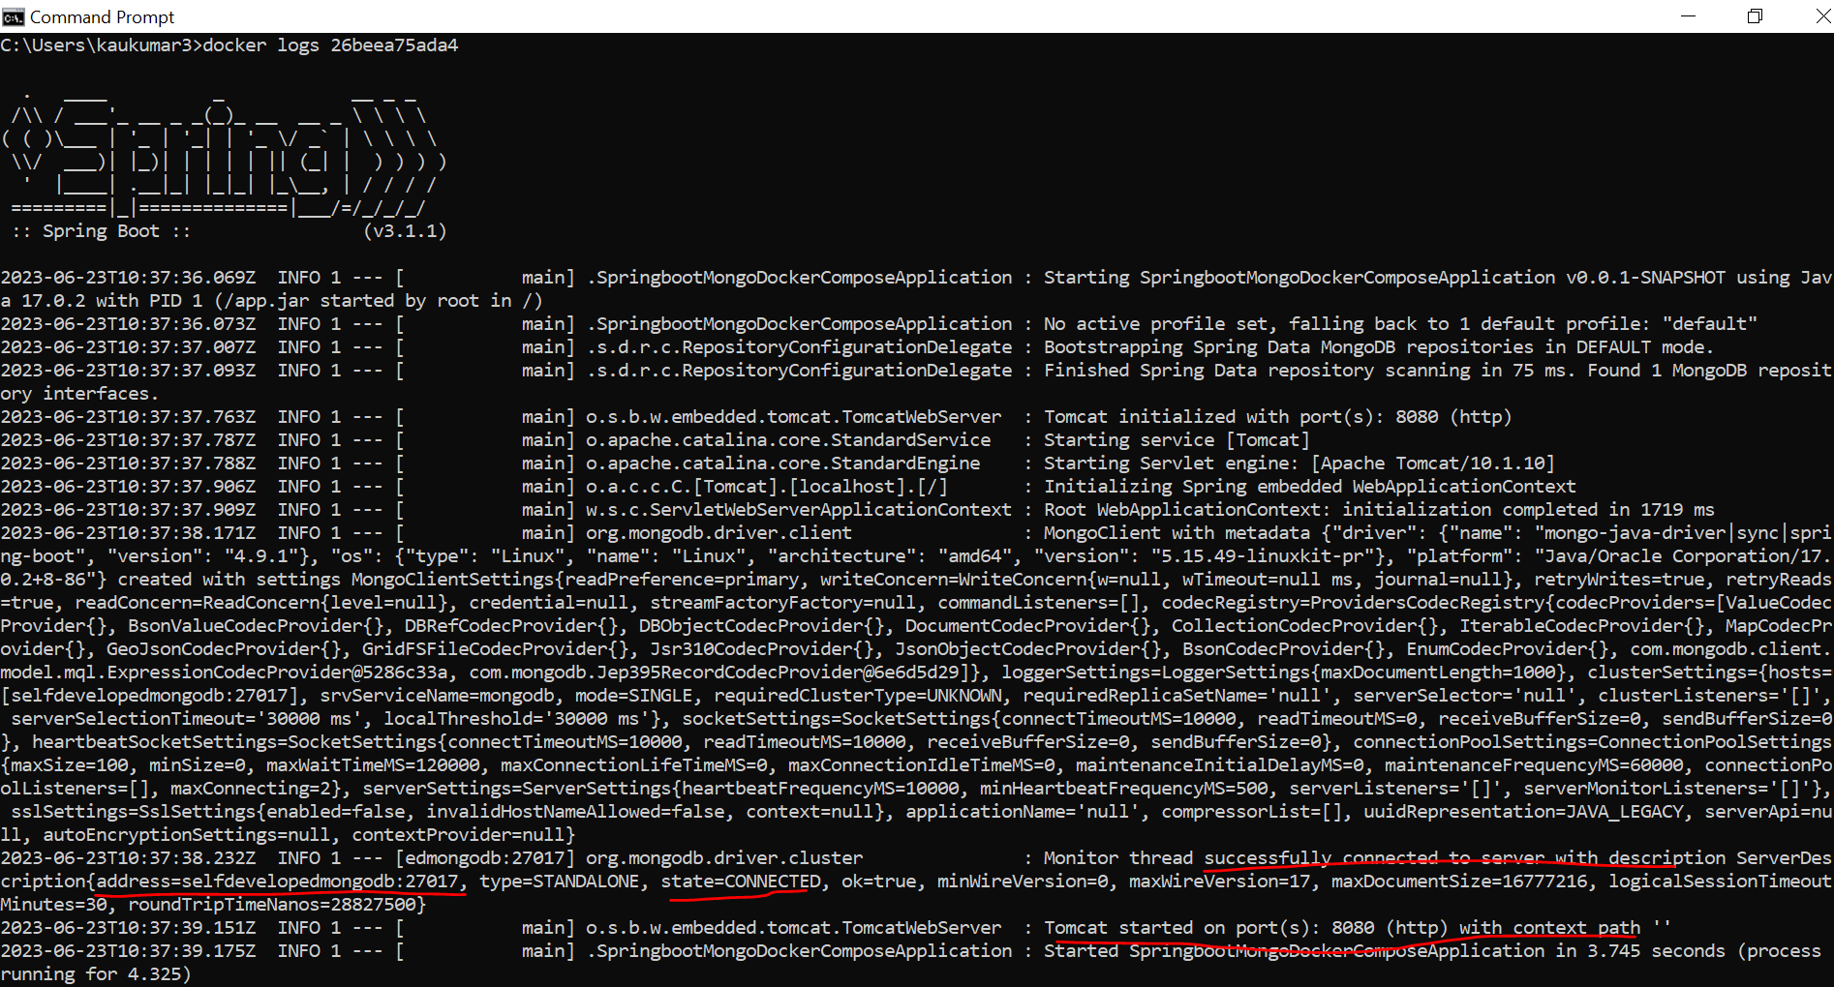

it's also able to connect to the host selfdevelopedmongodb which is the container mongodb right now to verify that let's go to our postman then just hit the endpoint.

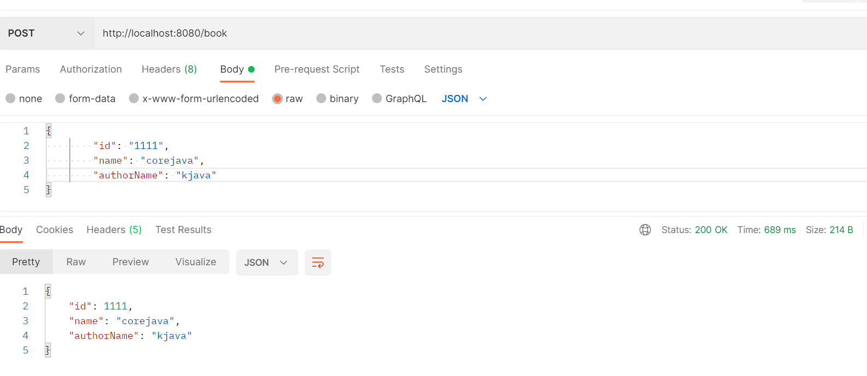

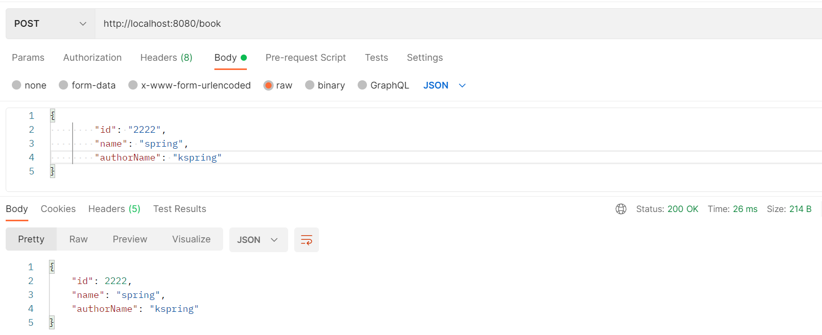

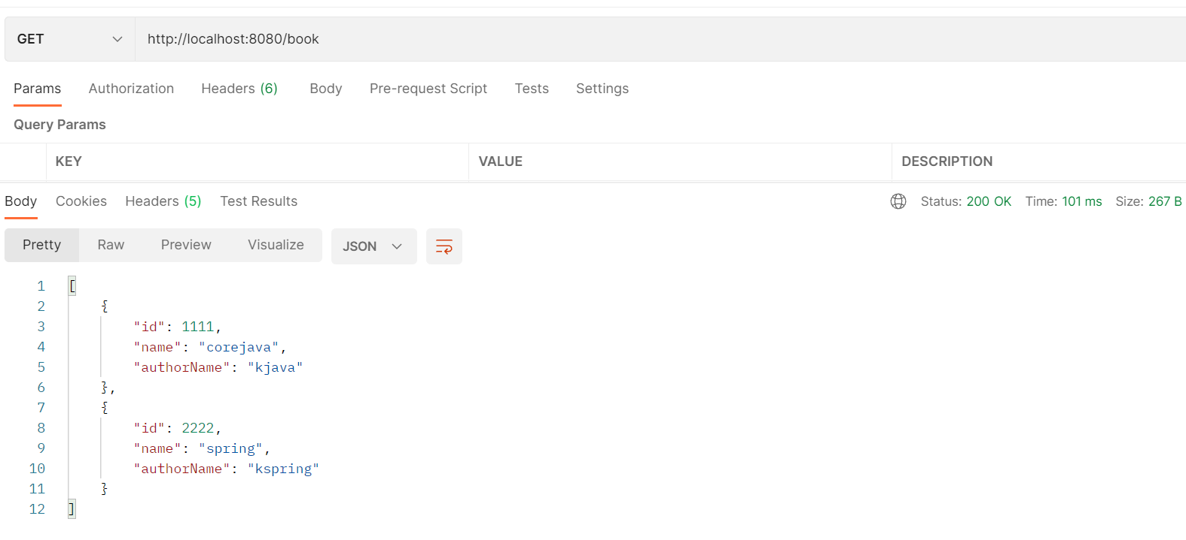

Let me try through command prompt database verify-

**++ docker exec -it selfdevelopedmongodb /bin/bash**

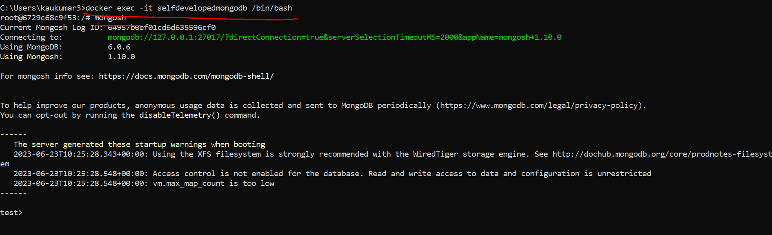

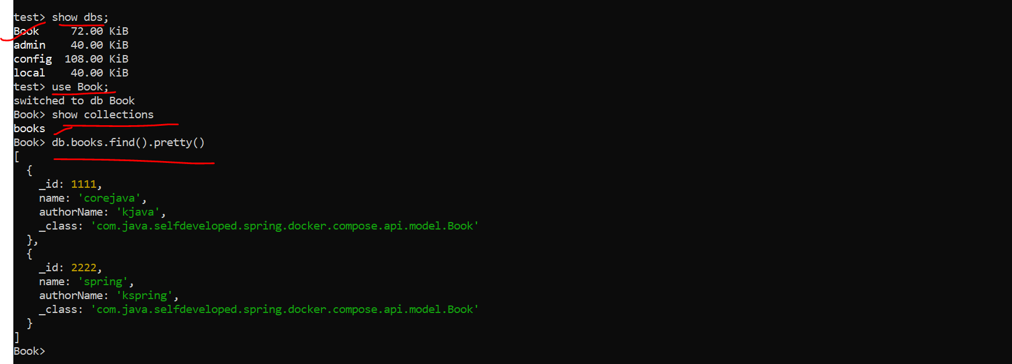

**----------****************Now let’s use docker compose*******************------**

Earlier we created 2 docker image one for mongodb and another for spring boot application. Both are running on 2 different containers. So, to so communication using docker compose let’s first delete these 2 running container and we will use **docker-compose.yml** file**,** to start running 2 different containers. So, let’s first stop container…

How we can find running container(running instance of docker image)

**++ docker ps -a**

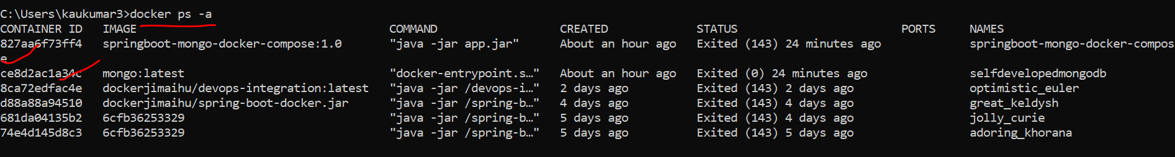

**How to delete these running container**

**++ docker rm -f 827aa6f73ff4**

**To delete image-> docker rmi <image_name>**

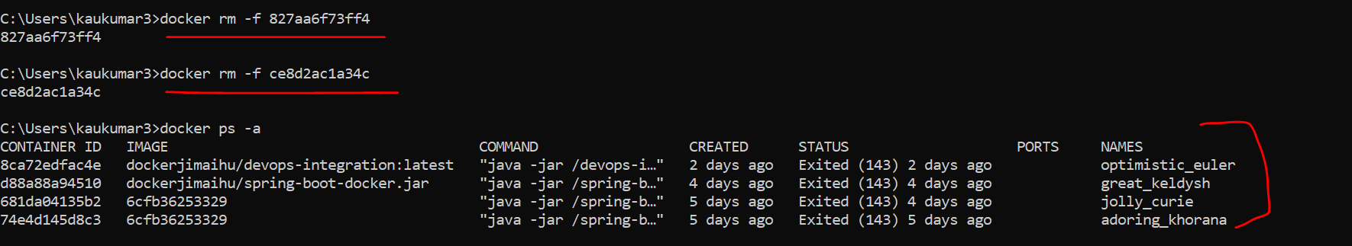

**Let’s use Docker Compose**

So, our **docker** **file** is

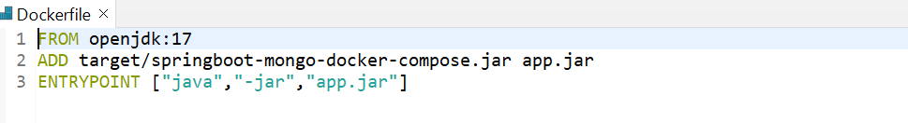

**Let’s create a docker image**

**++ docker build -t springboot-mongo-docker-compose:1.0 .**

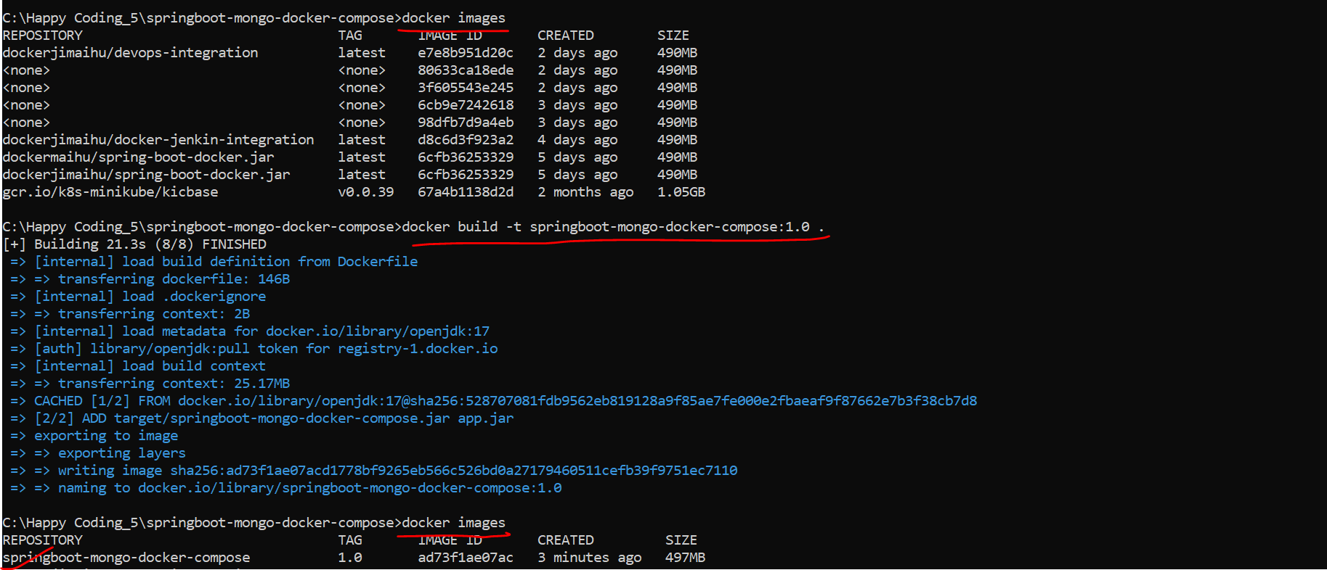

I was getting exception like Docker - Name is already in use by container

To see the complete details abt containers use command

**++ docker ps -a**

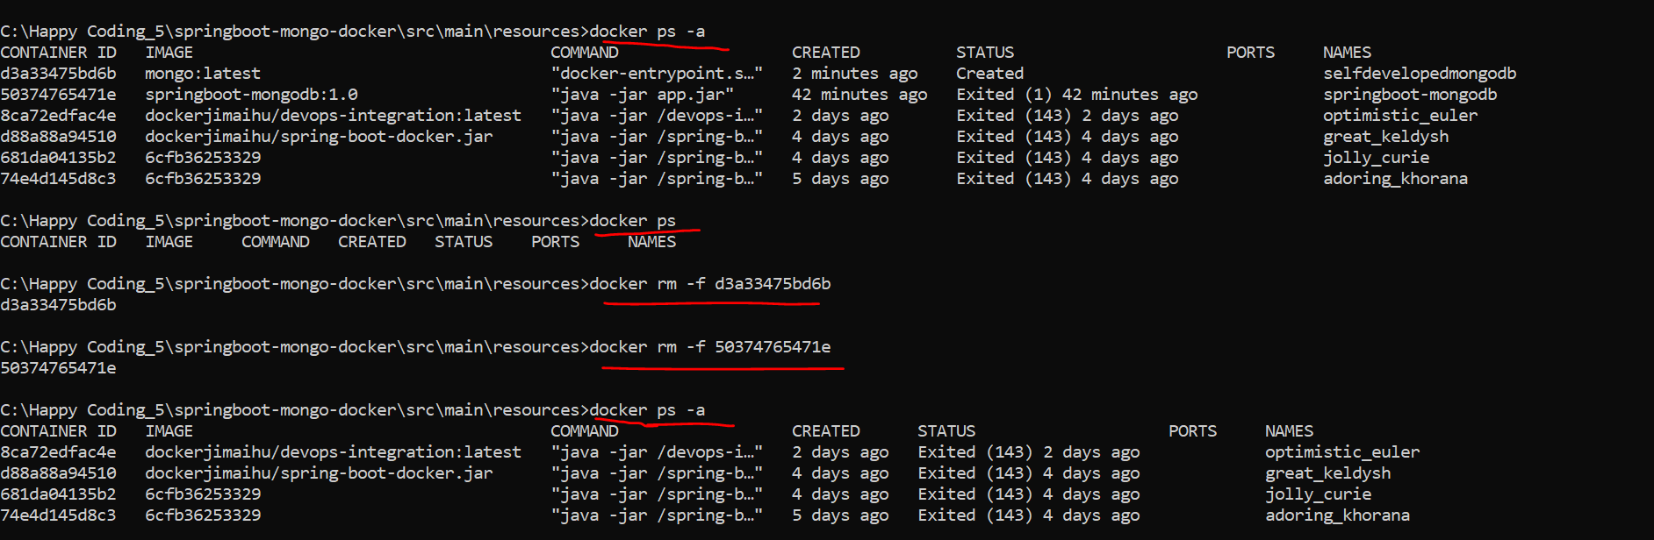

**++ docker rm -f 1797aa434257**

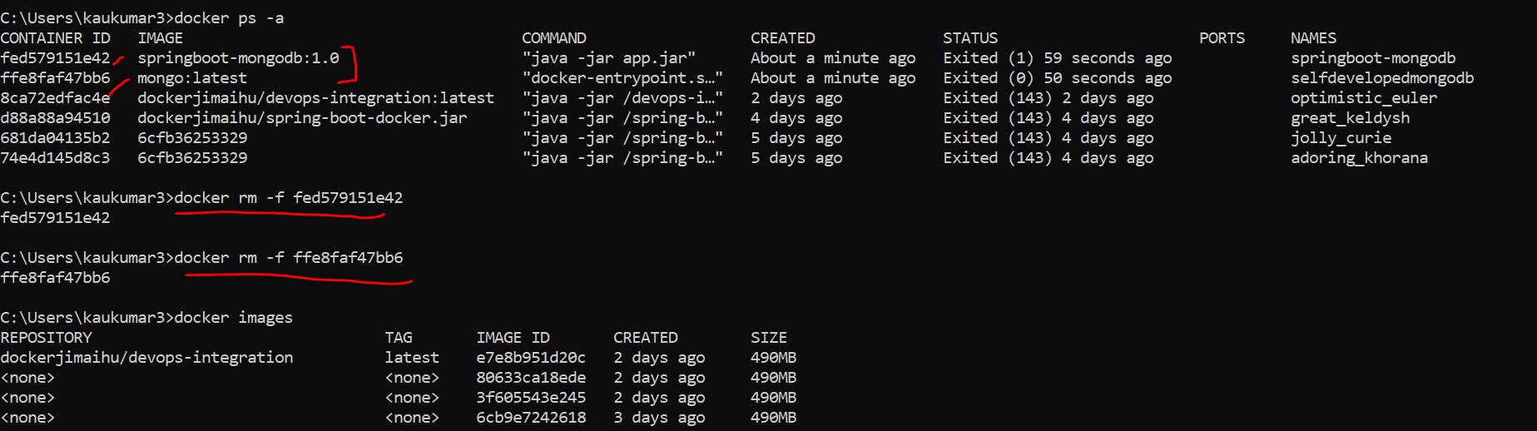

Now we want to run these 2 containers through docker compose.

Now we just want to run these two container through Docker compose. So, to do that, what we can do, let's go to our java editor, then we just need to create a file called **docker-compose.yml**. Now let me go inside the resource folder and I can just create a file called **docker-compose.yml**.

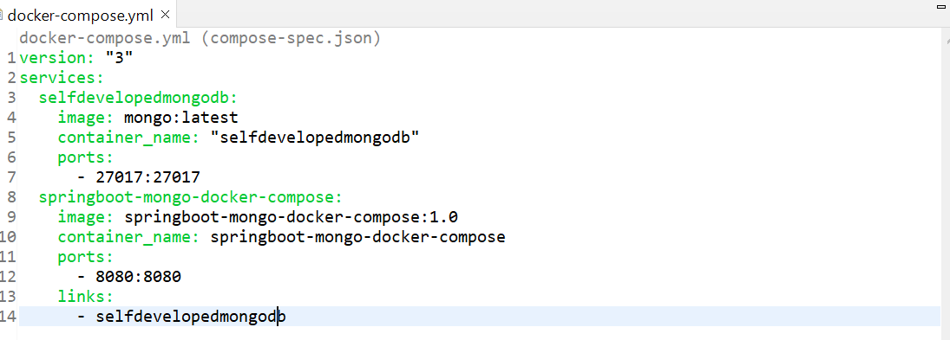

* So, the first configuration about my Mongo image, which is selfdevelopedmongodb and the image name of actual Docker image is mongo with the latest version and container name I'm giving selfdevelopedmongodb. That's what we fire from our command prompt. If you observe here this is what our selfdevelopedmongodb and the same command, I just configured in our docker-compose.yml file. Now similarly, I specify the port for that. So, this part covered about the Mongo configuration.
* This second part covered about our Spring Boot Docker configuration. Image container name and this is what the port and link the Spring Boot application. I just want to link with the MongoDB. That is what my container names, which I configured here. So, the same thing which we did in our command prompt, that's what we configured in our docker-compose.yml. In future, if you want to add five more container, you can add as a different service in this docker-compose.yml and you can link whenever you want. Now what we can do, we just need to simply execute this docker-compose.yml.

**Now let’s try to run docker compose up. So first go inside resource folder where docker-compose file is there and run**

**++ docker-compose up**

**C:\Happy Coding_5\springboot-mongo-docker-compose\src\main\resources>docker-compose up**

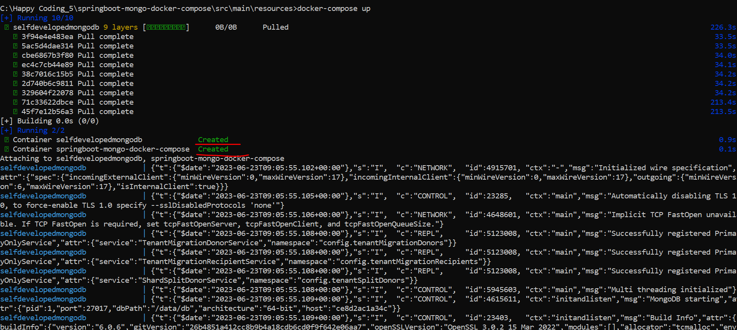

Now we got there are 2 containers its running

So, to verify that I will open another command prompt.

I'll simply fire Docker ps. Okay. It should show us two container. One container for MongoDB. This is this one for MongoDB. And this is for our spring boot application. Now as we restarted this container, it will bring up a fresh Mongo instance.

**++ docker ps -a**



So, to verify that, what I'll do, I'll just go to the postman and simply I'll fire a few requests. So let me change it to four. We'll try the new test one. Let's say rock one, something like that. Click on send. Yeah, we got the response.

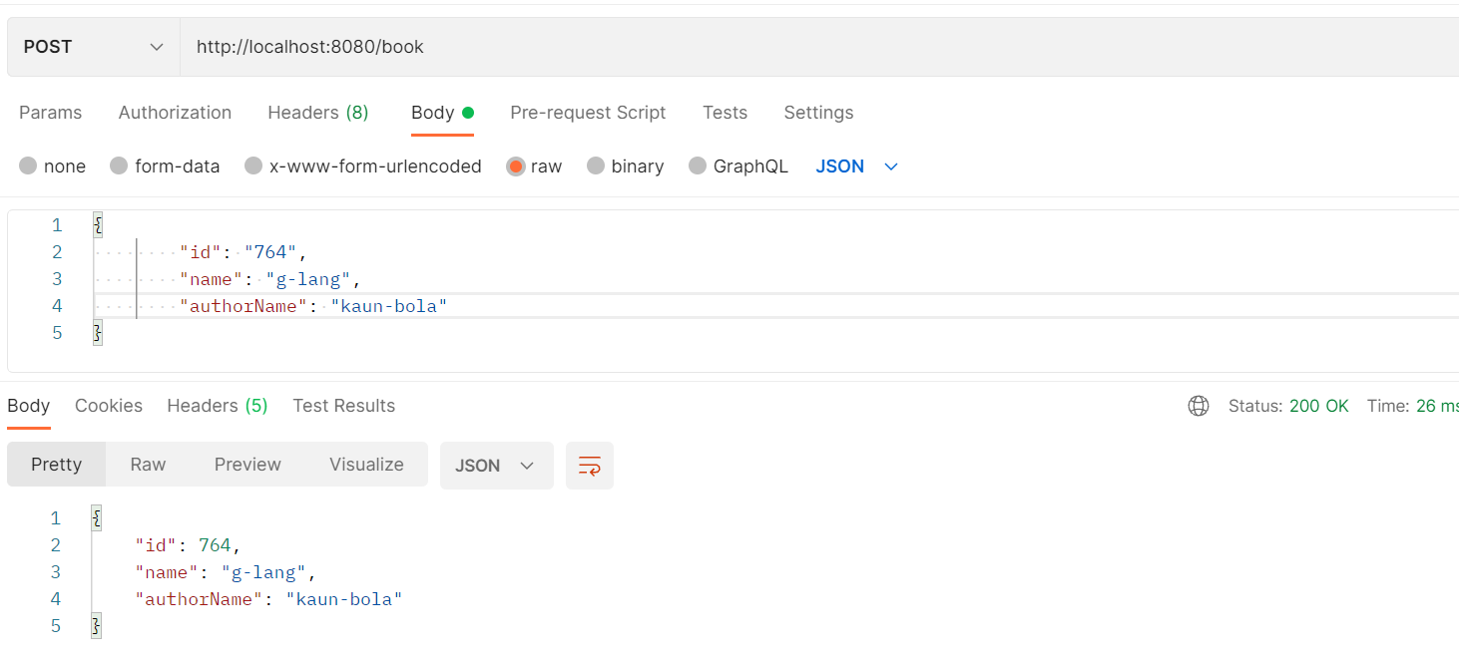

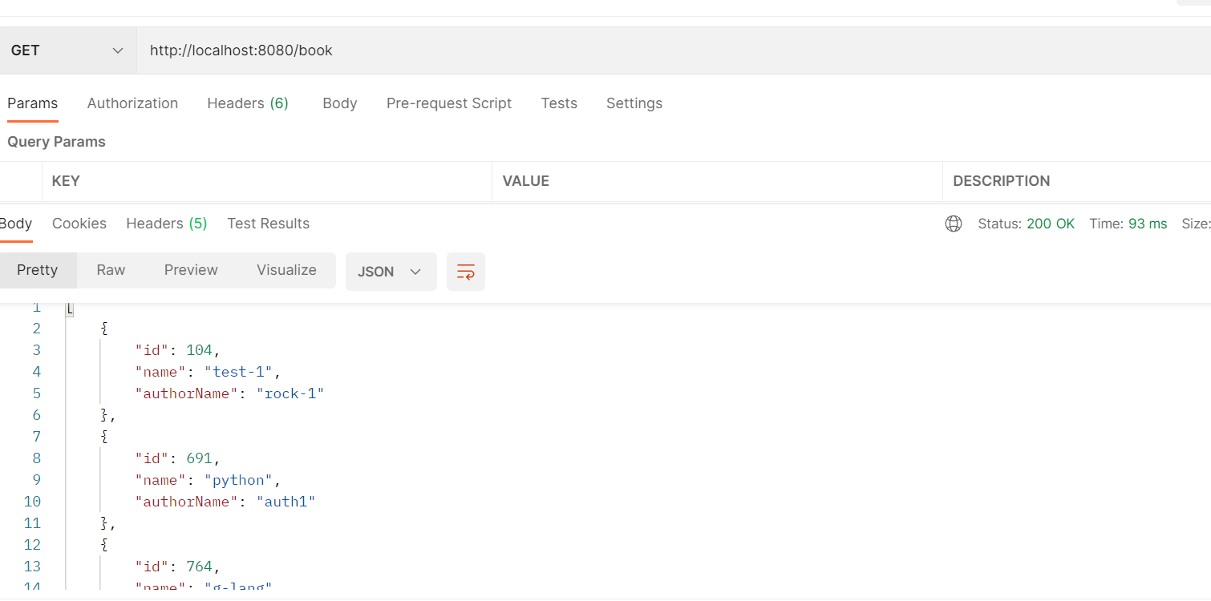

Now to verify that, let's go to the terminal where we just execute our integrated terminal to see the Mongo record.

**++ docker exec -it selfdevelopedmongodb /bin/bash**

Enter mongosh

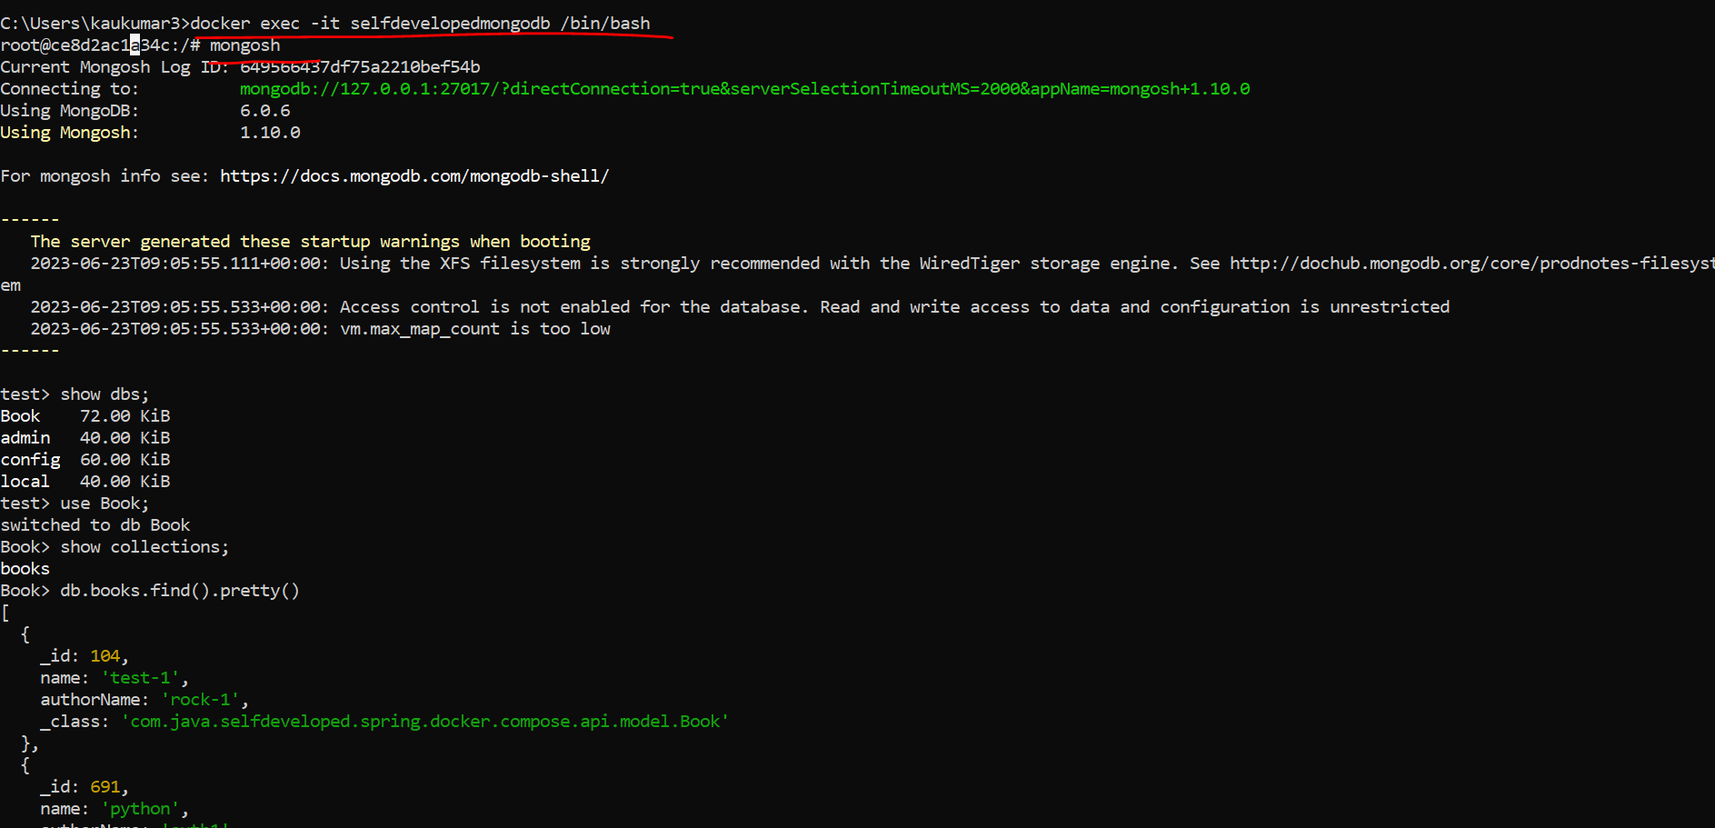

I believe we tested in both the way command prompt and docker compose. We communicate to containers. Right. So, I'll use the same example in my upcoming Kubernetes tutorial.

* **Build & Push Docker Image using Jenkins Pipeline | Devops Integration Live Example Step By Step**

Here we will learn how to build and push docker image to docker hub using **Jenkins Pipeline**.

**Integration workflow-**

As a developer we commit the code to the github which act as a version control tool. Now we need to perform **continuous integration and continuous deployment** so, for that we need to integrate github with our jenkins. When I say continuous integration and continuous deployment it means with my committed code, I want to build my project then I want to create docker image of my application then I want to push my docker image to my docker hub.

Now the question is how will jenkins know what steps you want to perform. Whether first you want to build your project then you want to create a docker image then you want to push docker image to docker hub how jenkins will know these steps as part of continuous integration and continuous deployment. So, that’s why the **Jenkins Declarative Pipeline** concept came into picture. Where you need to define all the steps what you want to perform in a file called jenkins file.

So now when going forward when you commit your code to github jenkins will read this **jenkins file** from your project and he will perform the request steps you mentioned.

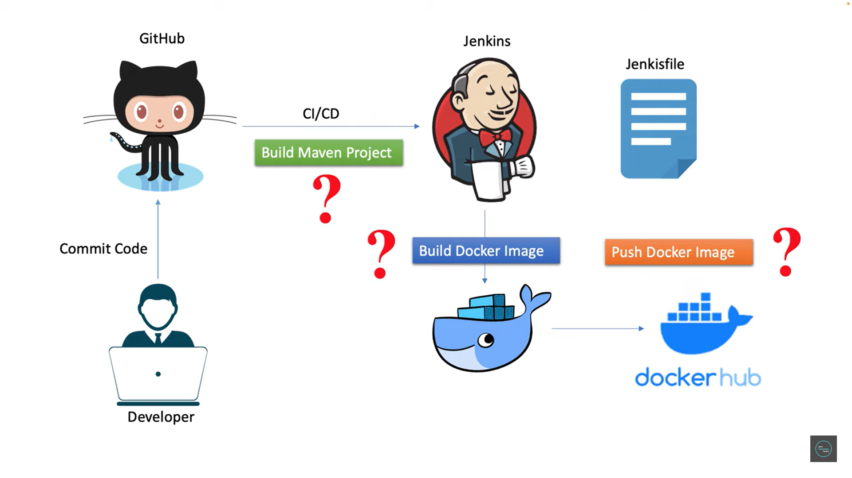

**Application**- **devops-integration**

**Git repo**- <https://github.com/kaushal8707/devops-automation>

Now we have committed our code to github, so my machine code is **sync up** with the github.

Now I need to integrate the jenkins with github so that I can perform CICD steps.

Let’s create a pipeline or a new job.

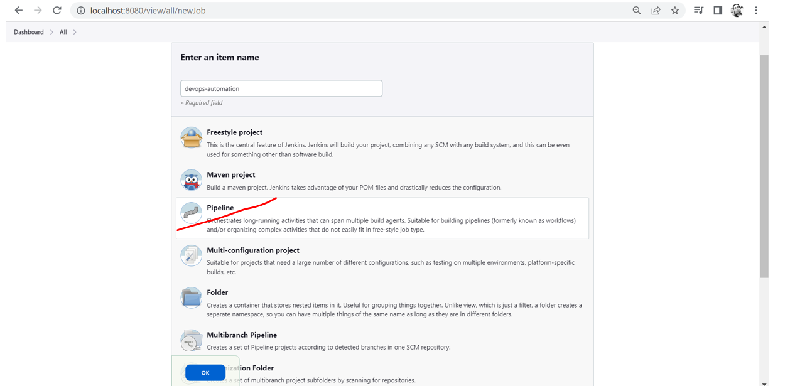

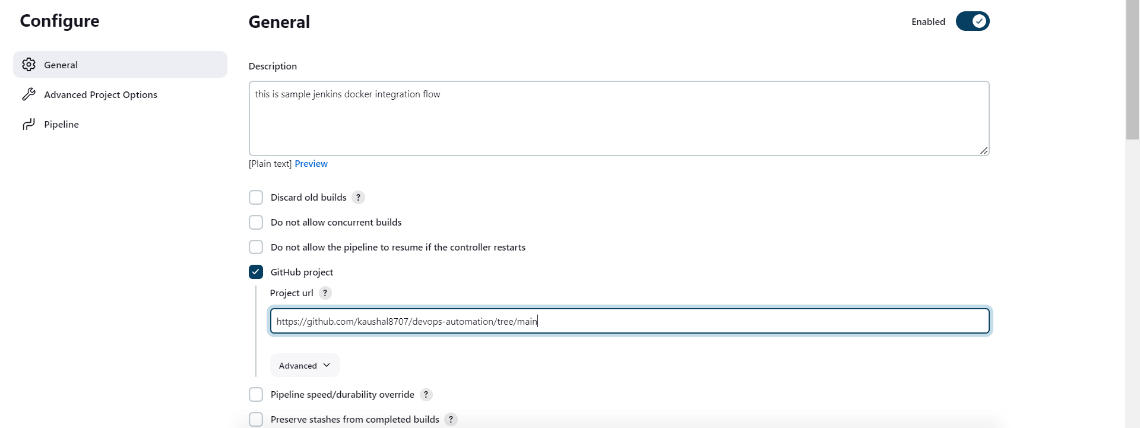

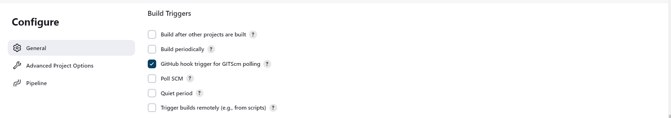

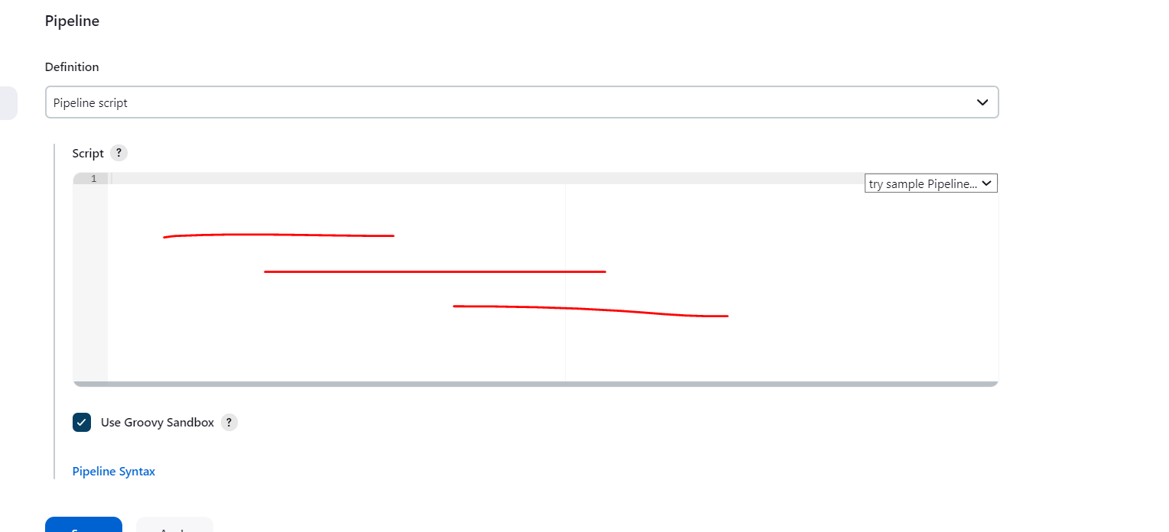

Here u need to tell to jenkins what steps u need to perform. 1. u need to define build maven project. 2. Build docker image and 3. then push docker image to docker hub.

These 3 steps we need to define in the jenkins file.

So, there is 2 options either u can directly write jenkins file here if not if u have jenkins file in ur github project then directly u can import it from there, let’s see both.

As per CICD I need to tell to jenkins first build my project, check out my code from github then build my project. That’s what I need to define in jenkins file.

To add or show whare need to add maven path or version go Manage jenkin->tool->maven(optional)

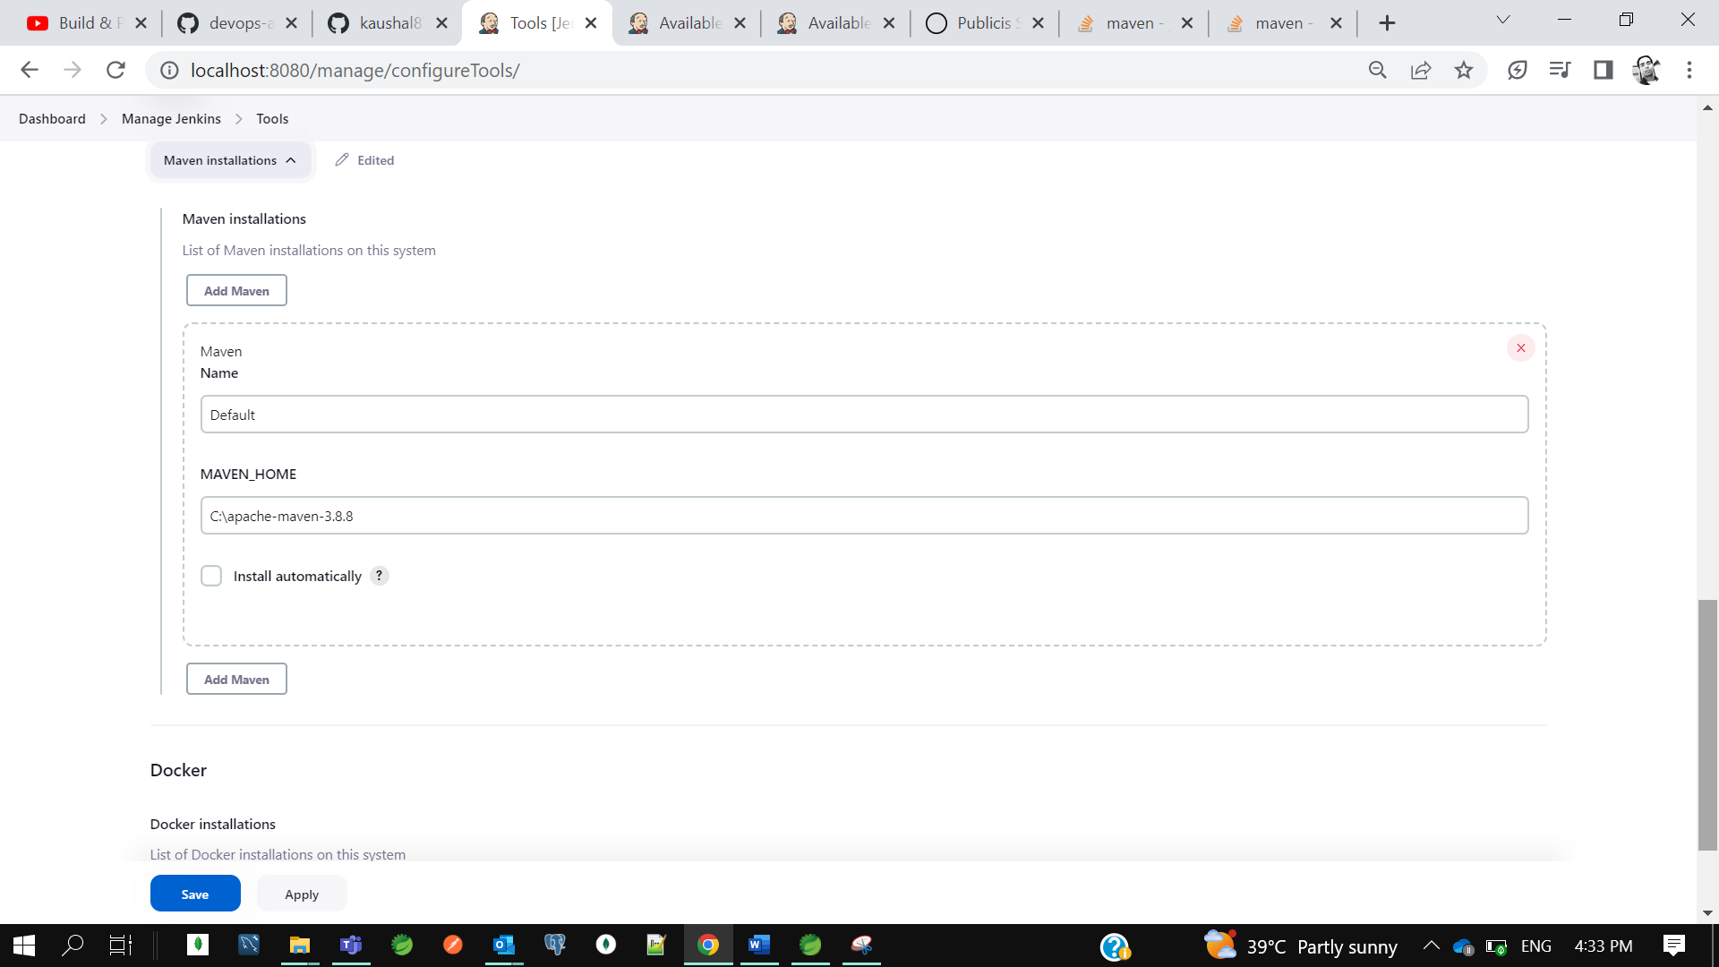

First, I will tell to my jenkins this is my pipeline. Then as part of my pipeline use agent as any then I will specify the tool which I use to build my project which is nothing maven. you can define the maven which you have in your jenkins. So, I am telling jenkin pipeline please use the maven tool to perform build operation.

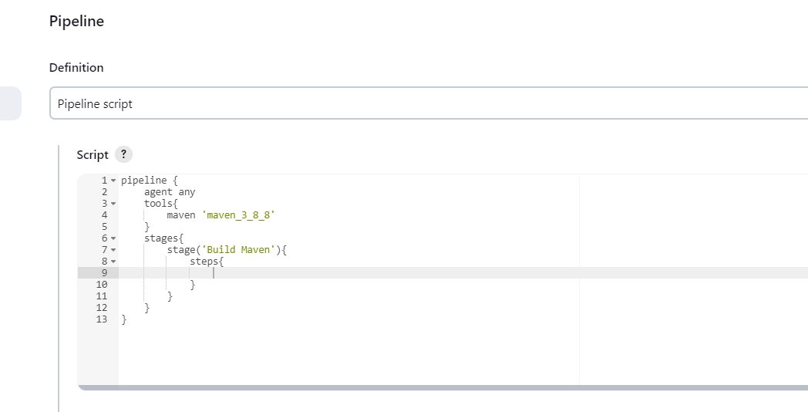

Now next I need to define the stages. Stages is nothing the steps u want to perform. Build maven project is one stage build docker image is another stage then push it to docker hub is another stage. This is how we can define multiple stages.in this stage I just want to define the steps. I just want to tell to the jenkins as part of this pipelines I want to perform multiple stages or stage inside that I want to perform multiple steps. So, I want to tell to jenkin that I want to perform one stage Build Maven and inside that stage I want to perform is I want to checkout code from github and then we need to perform maven clean install.

So, to get the syntax to checkout code from github. You can directly use the pipeline syntax. Since it this is public no need to give credentials.

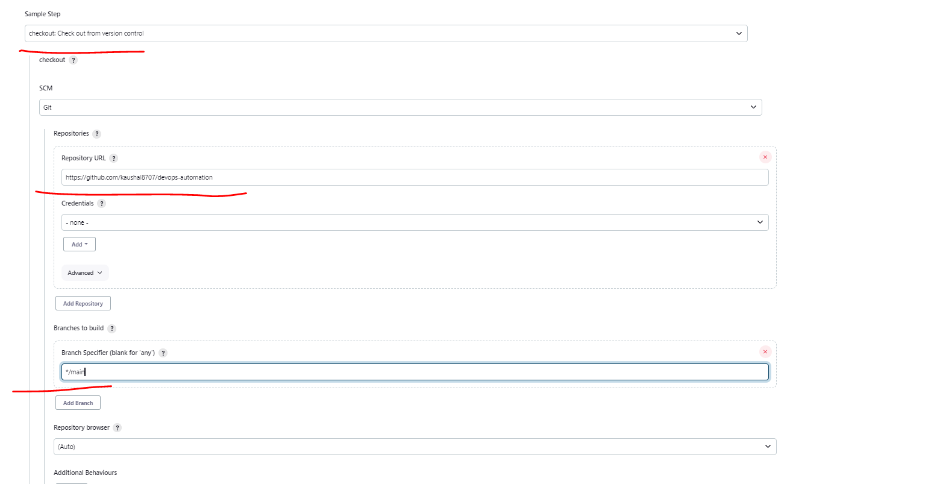

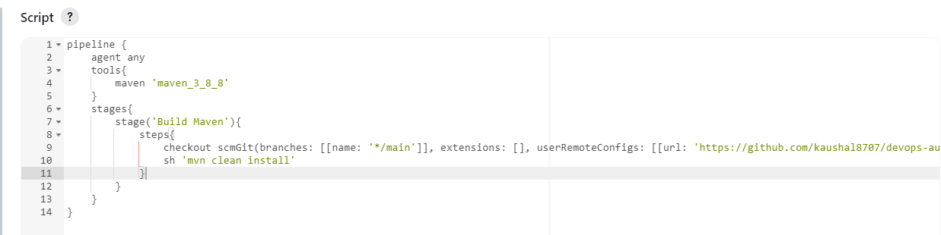

So, as per the steps I am telling this do the checkout and just execute mvn clean install its nothing the packing.

Let’s save it and build now.

Earlier we were getting exception 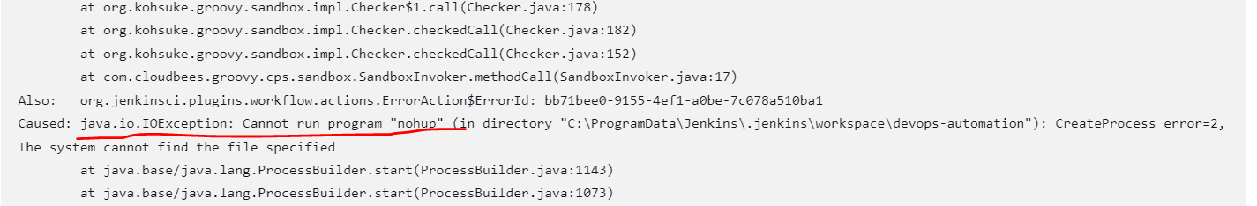

The error is like c

[Jenkins pipeline sh fail with "cannot run program nohup" on windows](https://stackoverflow.com/questions/45140614/jenkins-pipeline-sh-fail-with-cannot-run-program-nohup-on-windows)

We have fixed this issue after setting get path in env var.

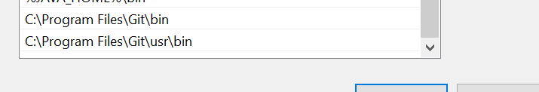

Bcz we are running cmd **sh ’mvn clean build’** and this is a linux cmd

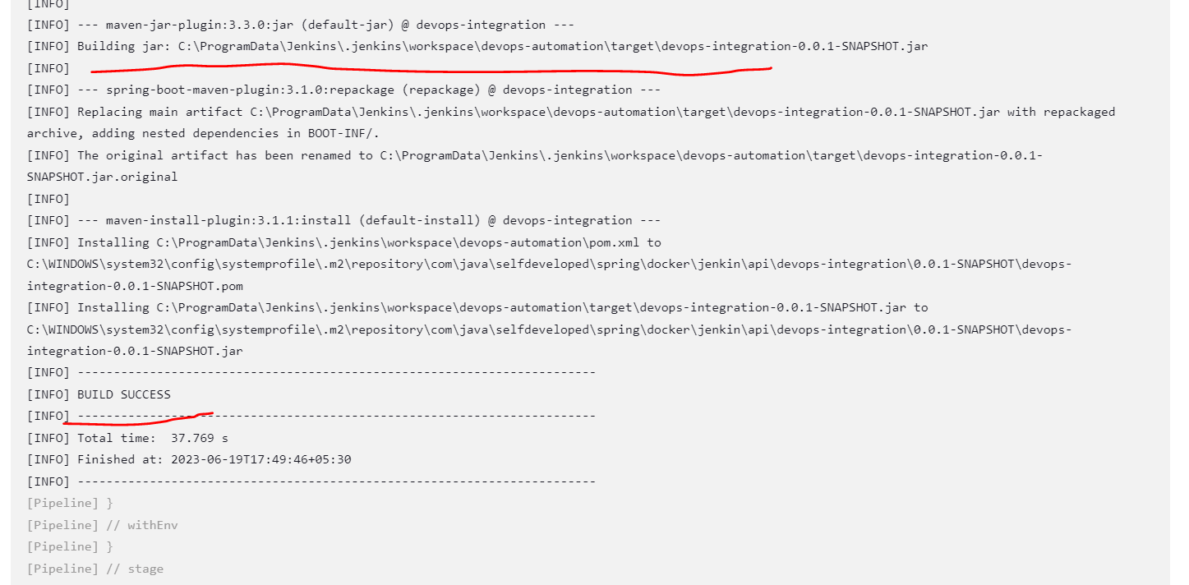

Now our build got success…

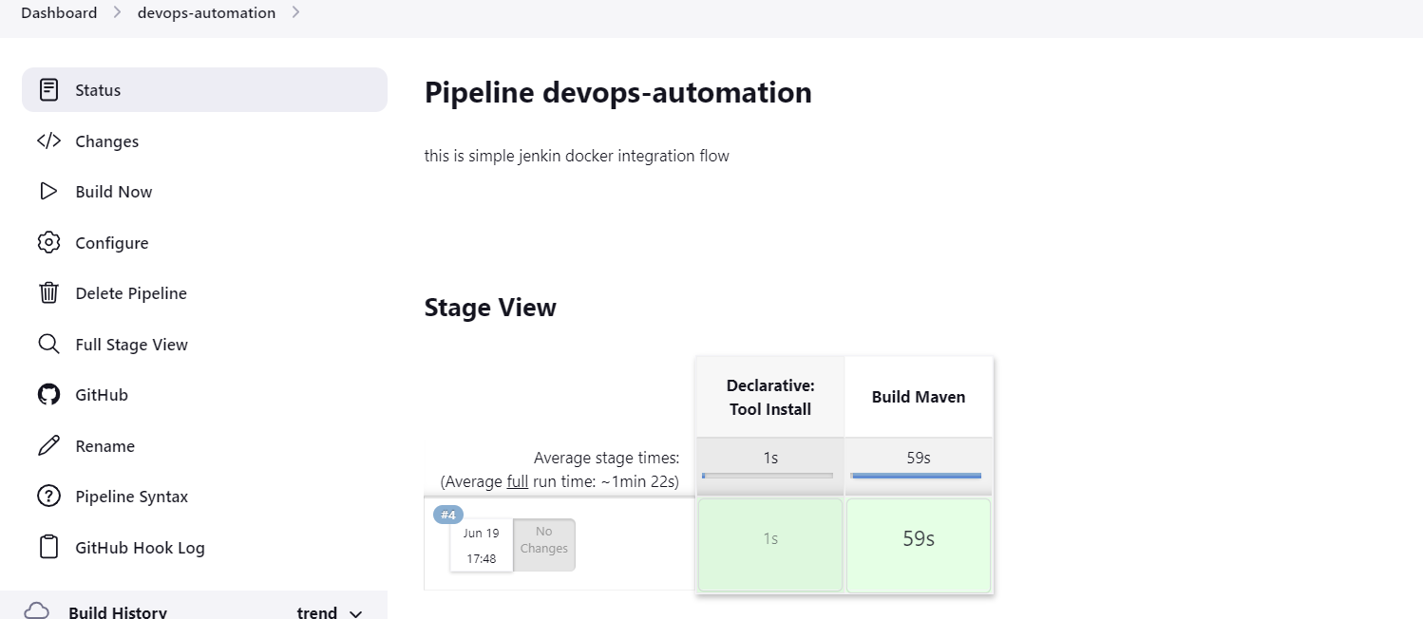

*** So we had performed the first step that we just tell to the jenkins using jenkins file build my maven project. Now next we need to tell to the jenkins that build docker image.

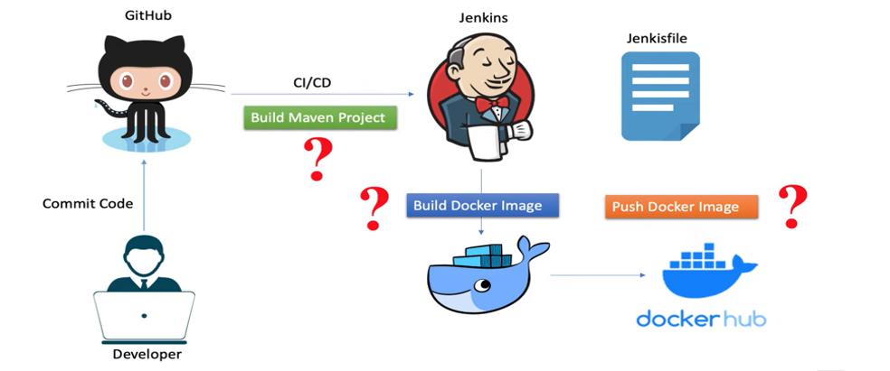

So, first step we have done now we will go with the second step to build the docker image your application should have the docker image. So first let’s do that then we perform the build docker image. Let’s create the docker file and build the jar.

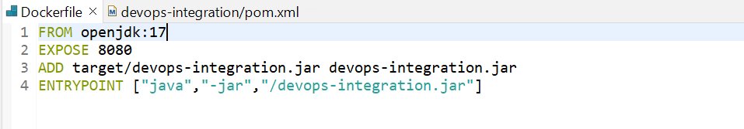

------------------------------------------------------------------------------------------------------------------------------------

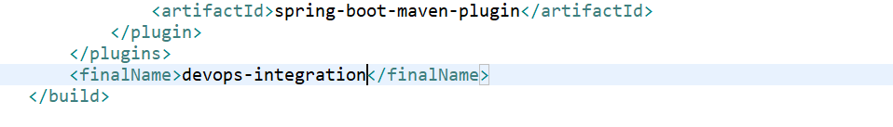

Execute cmd mvn install to build jar in target folder.

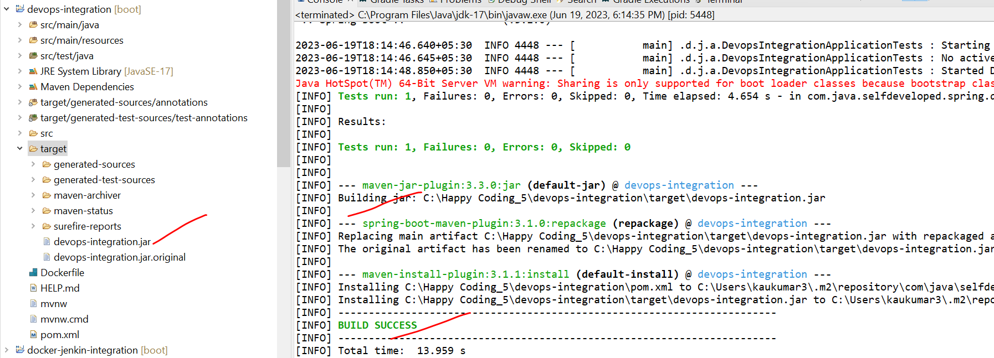

We created the docker file now we need to build the docker image

So, let’s commit these changes to git

So now in our jenkins pipeline file we need to define read my Dockerfile and create a docker image.

Before adding make sure docker desktop is up and running in your machine.

Let me add another stage to create and build the docker image. Withing stage I need to add what steps I need to perform to build docker image.so again in this step we will write and execute a script who will run and create a docker image.

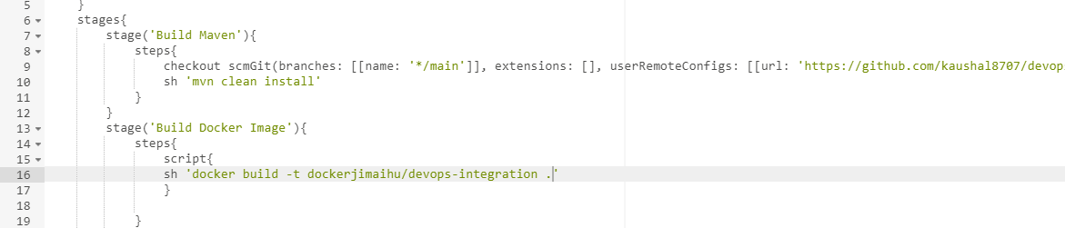

Make sure our docker desktop is running. Now save and start build.

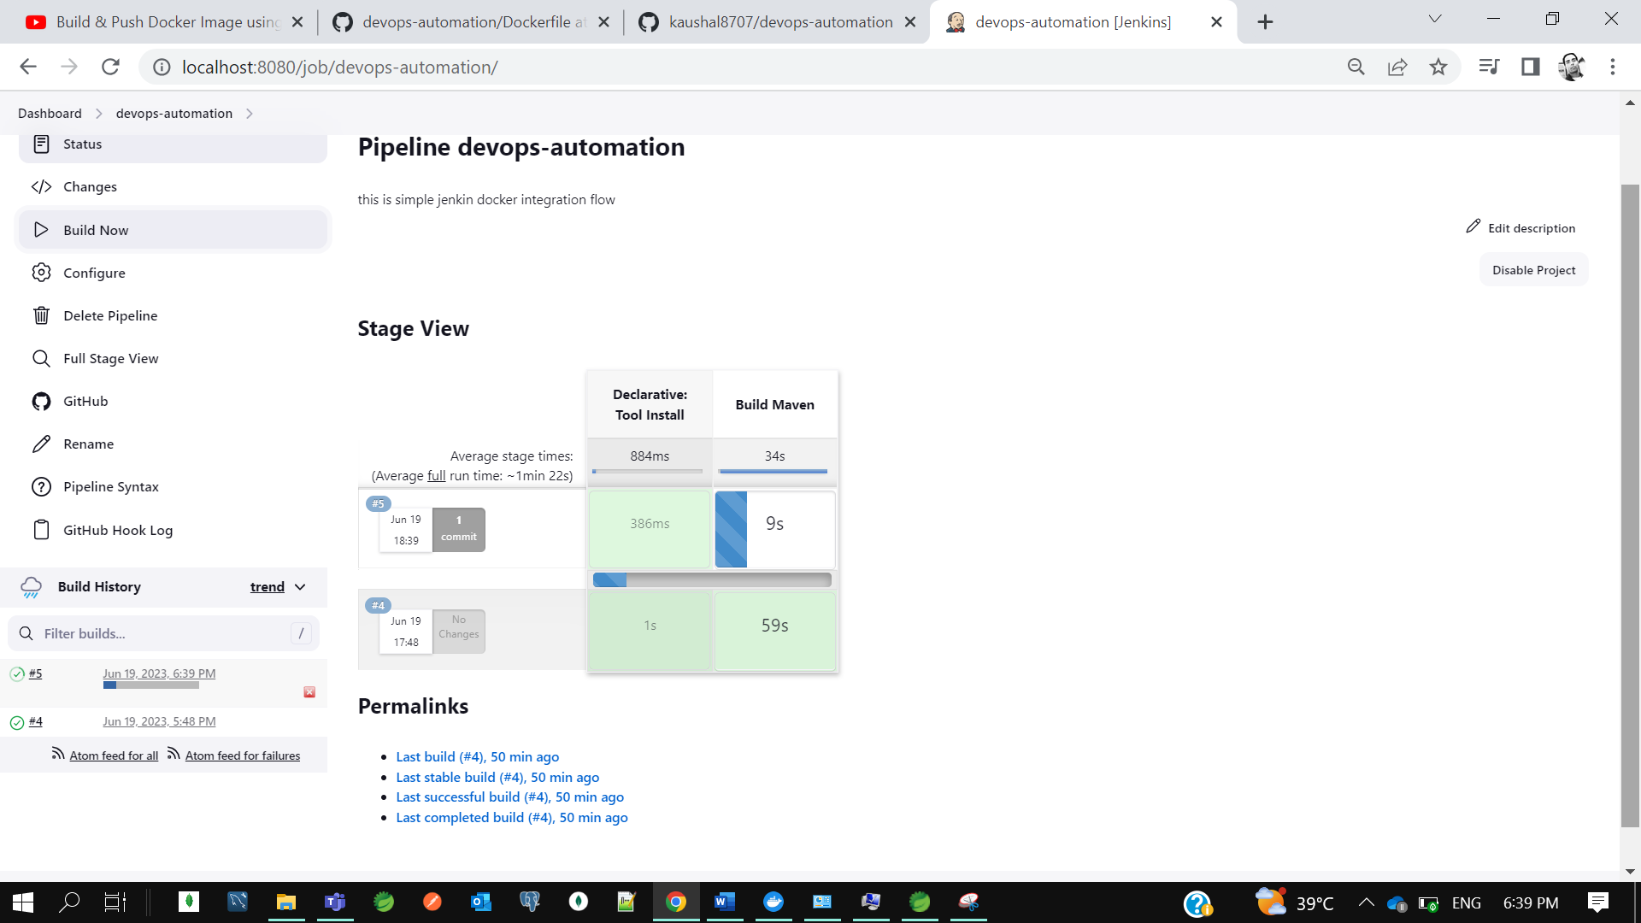

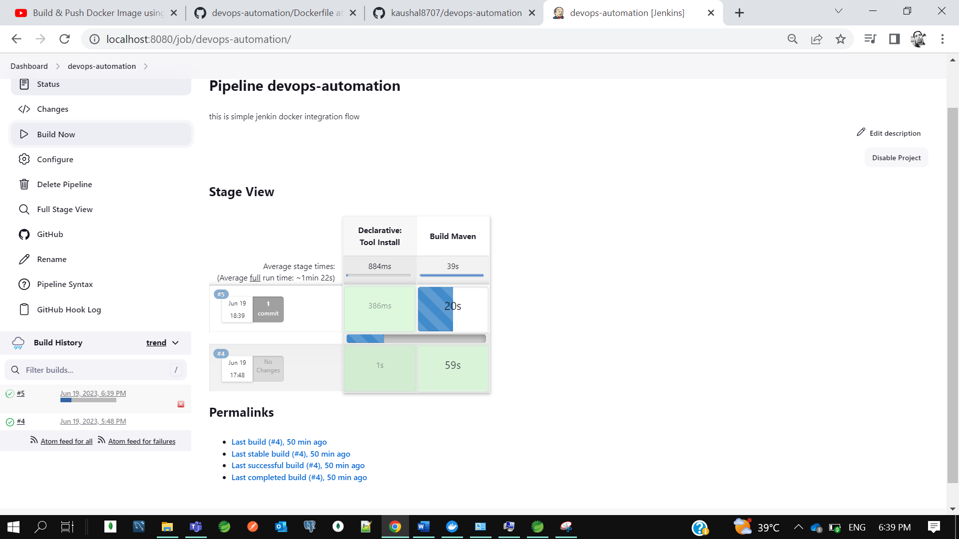

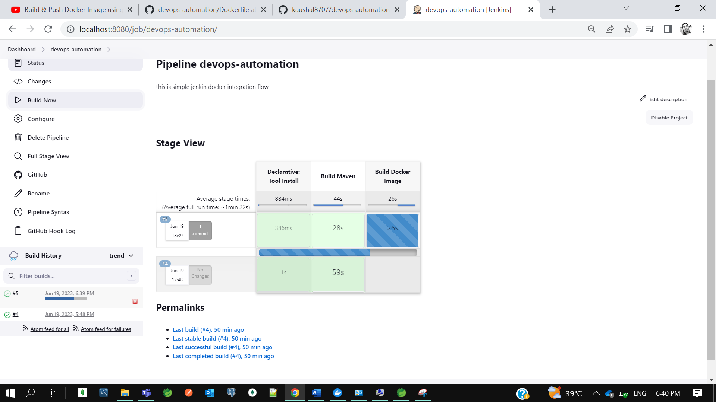

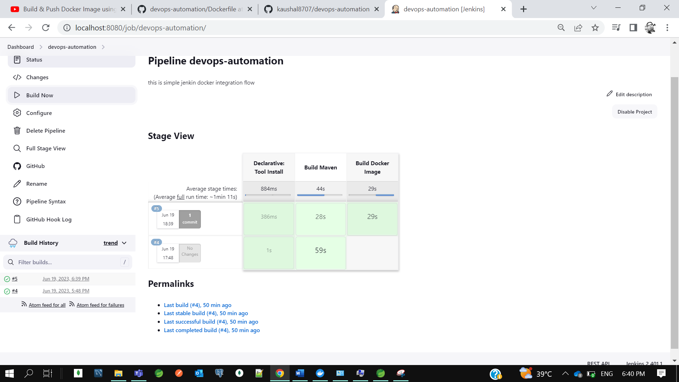

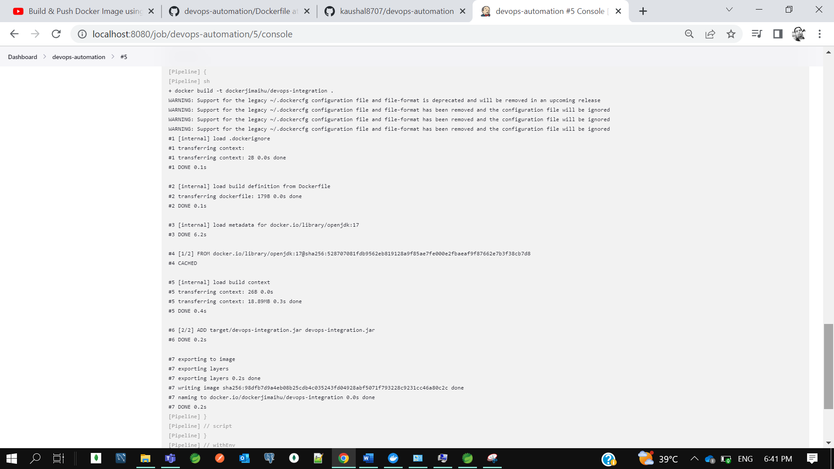

So, our build got success and image got created.

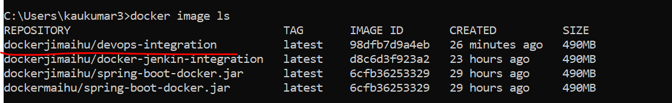

Now next step is like I need to mention in jenkins file I want to push docker image to docker hub. So again, I need to define a stage. For each step or requirement, I need to define separate stage. Now I want to push docker image to docker hub.

Now to push any image to docker hub I need to login first on docker hub.

So now click on pipeline syntax and let’s see.

Select : **withcredential**- Bind credential to variable

Now select secret text for binding.

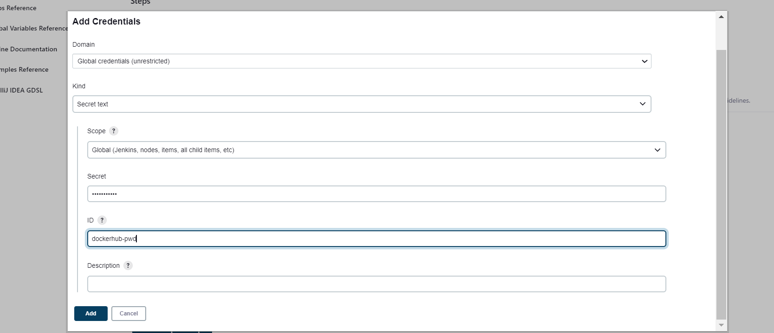

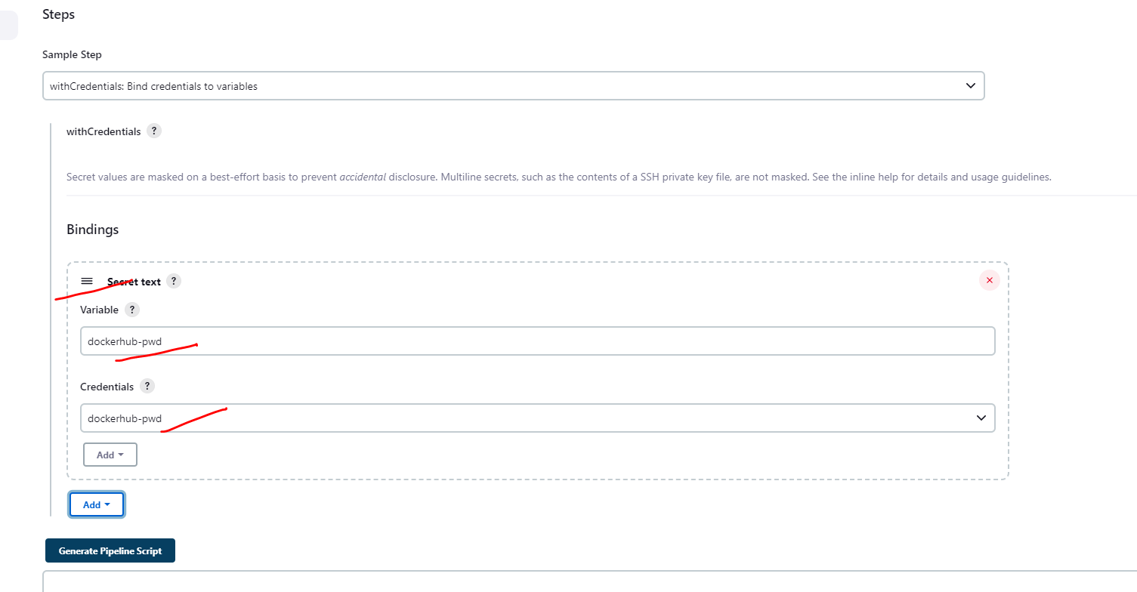

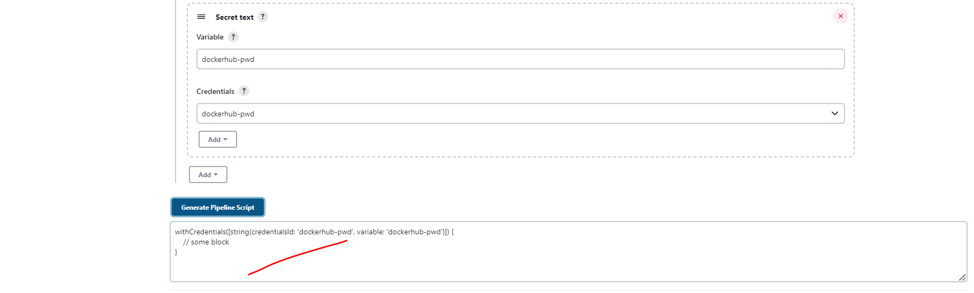

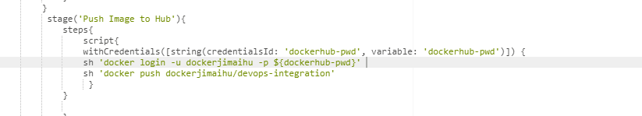

Let’s first open our docker hub.

Let’s save and start build now.

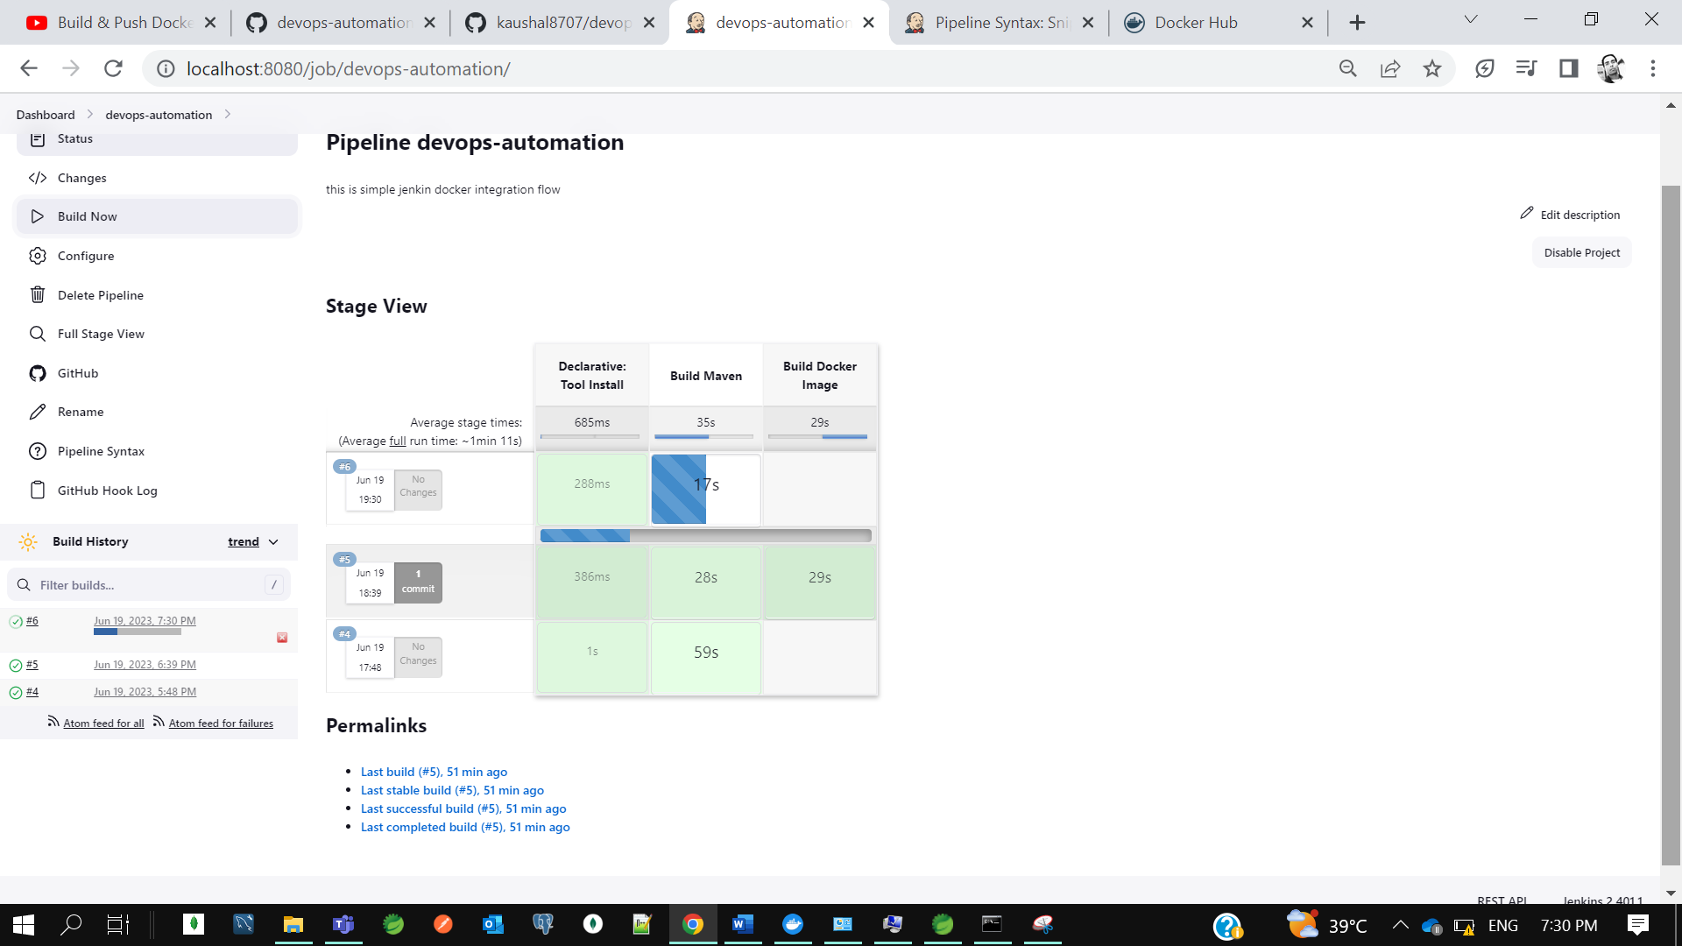

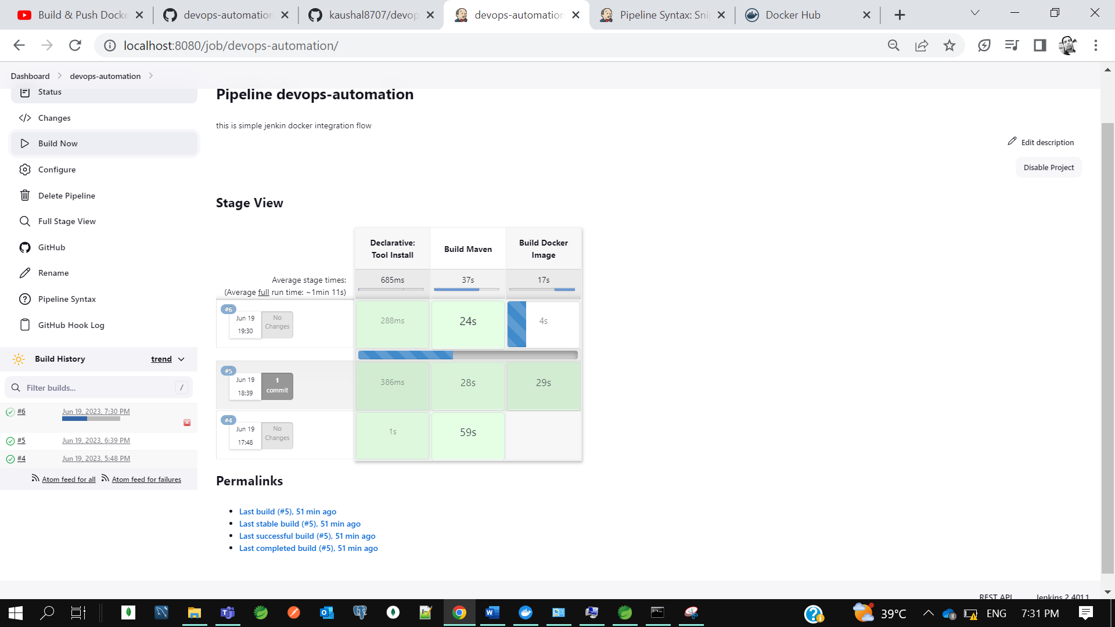

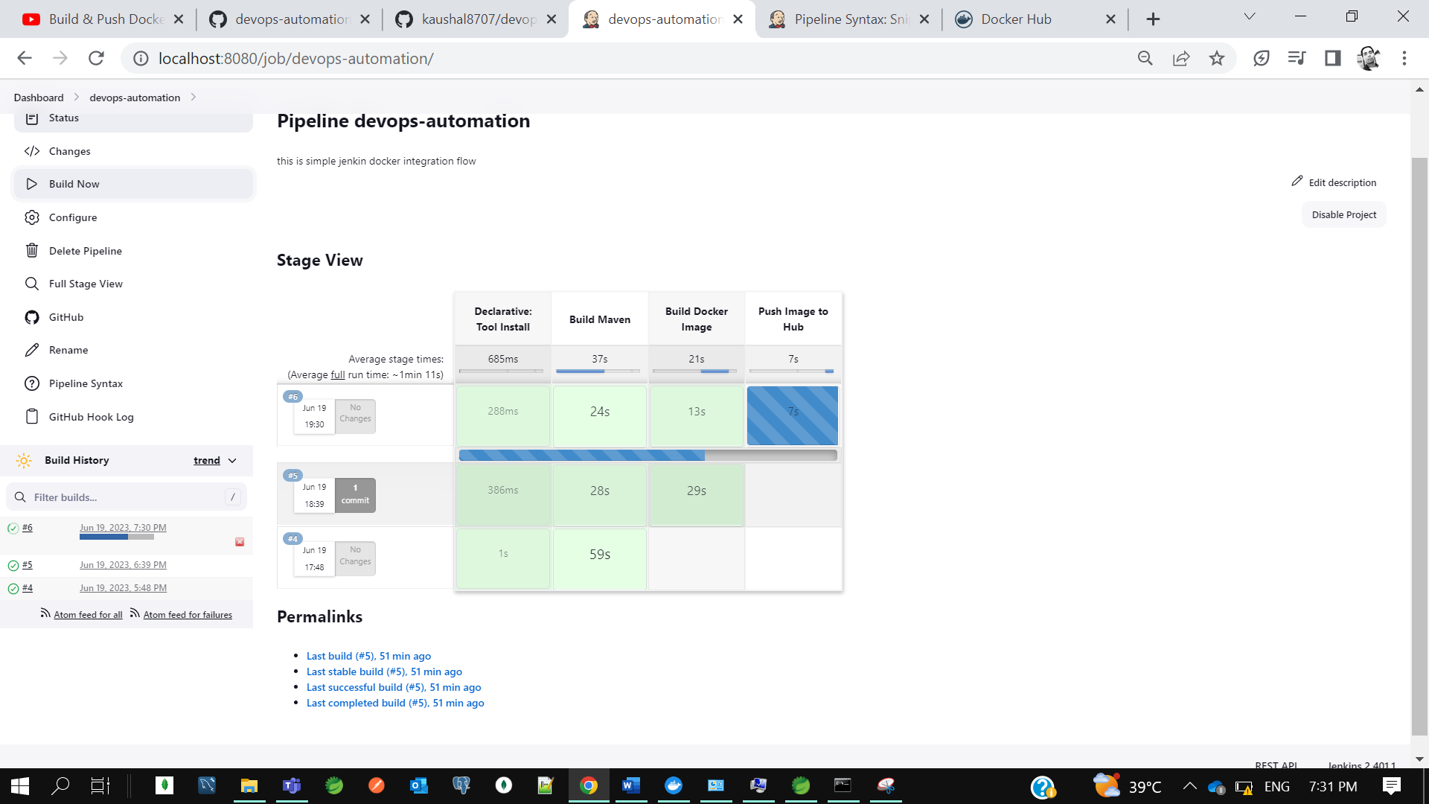

Now using the jenkins file we are able to build create image and push the image to hub. This is actually manually we created in jenkins portal itself. If I don’t want to keep global, I want to keep jenkins file in my code itself, we can do it. Let’s create in our project one file called **Jenkinsfile.**

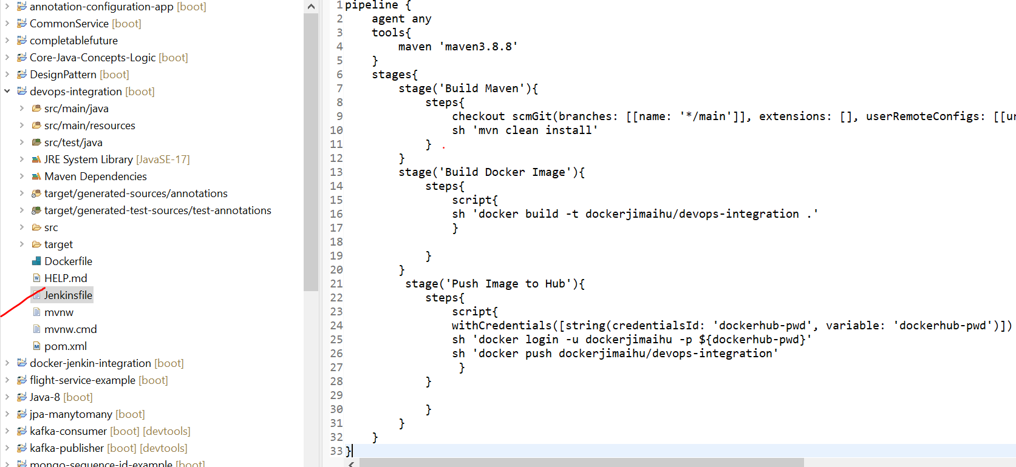

So rather than keeping in jenkins portal we can keep jenkin file in our code base itself so we can customize as per requirements.

Let’s commit our code to git.

Now let’s create another pipeline instead of changing the existing one

Now for pipeline I will load the jenkins file from application rather than writing jenkins pipeline script on jenkins.

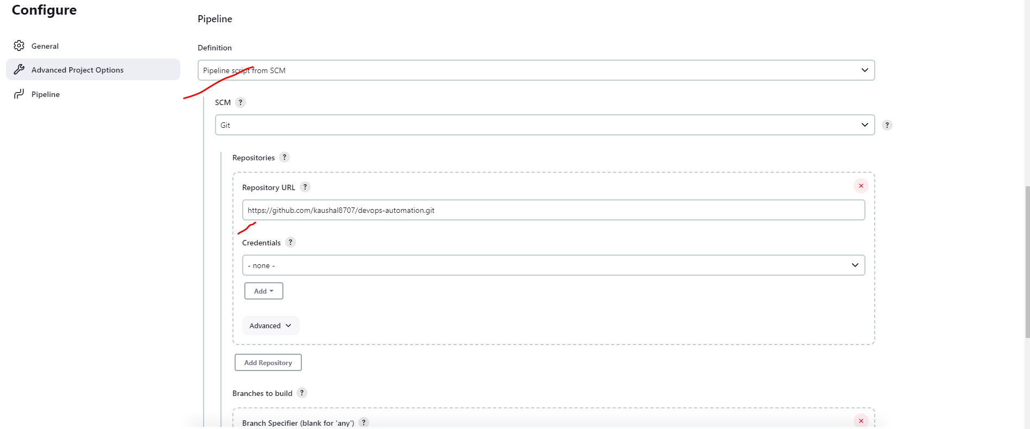

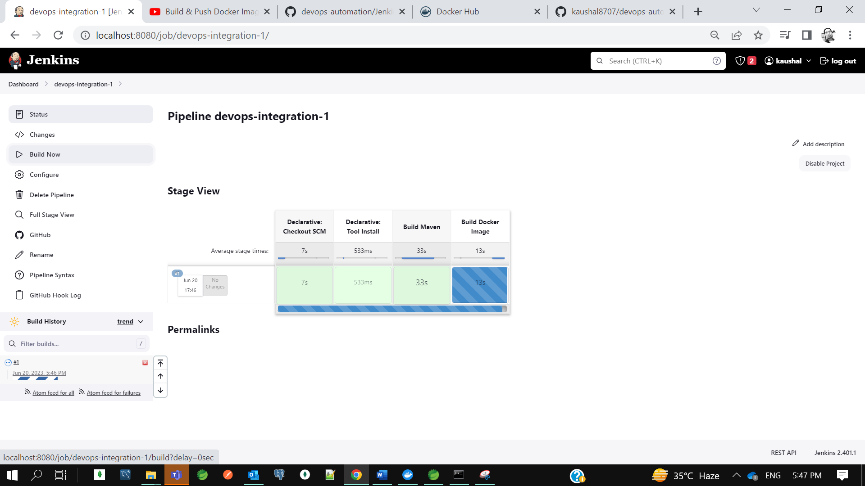

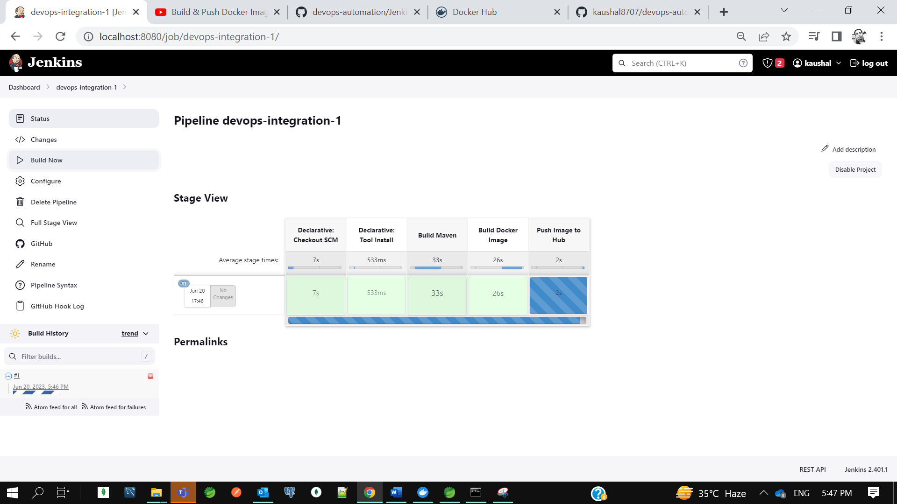

U can see on docker hub. So, this is what all about Declarative Jenkins pipeline approach. That is what the industries follows guys. No one is using the plugin and all. They usually write the jenkins file in their application and they just define stages to perform.

* **CI CD Pipeline Using Jenkins | Deploy Docker Image to Kubernetes using Jenkins**

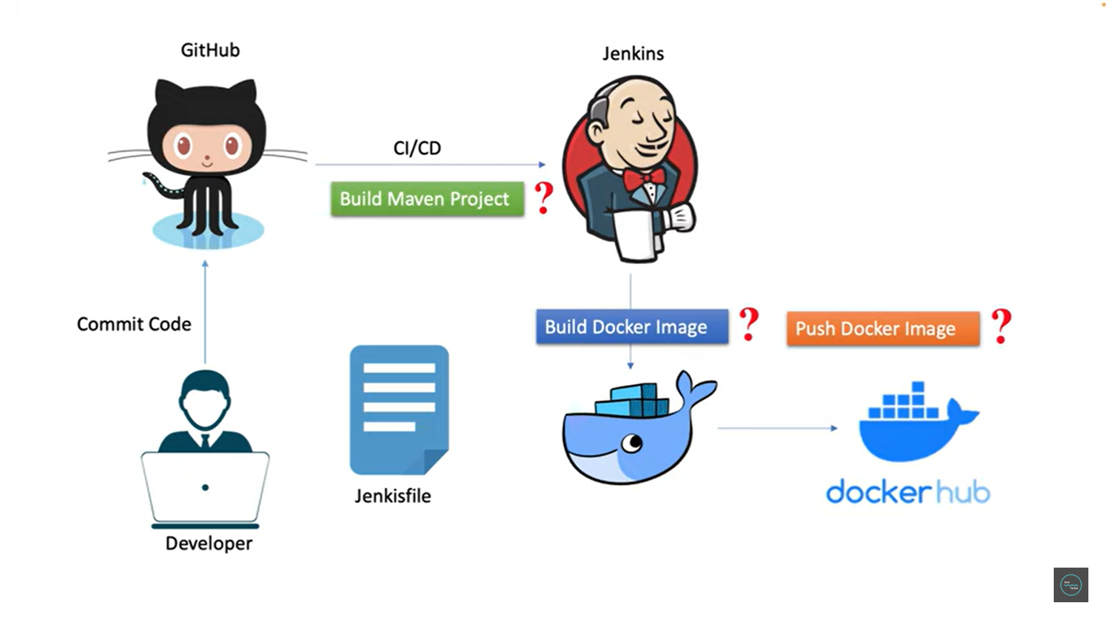

In our last tutorial, we discussed about how to build and push docker image using Jenkins pipeline. Now let's move one step ahead and try to understand how to deploy docker image to Kubernetes cluster using Jenkins pipeline. We'll follow the same declarative pipeline syntax approach.

So, to perform this end-to-end DevOps integration, we need to up all the components. I need to start the docker, then I need to start the Jenkins. So first let me start the docker desktop. Okay, you can see here and then next I need to start my Jenkins. i need to run war file using java -jar jenkins.war. You can start the Jenkins server. Now I need to go to the browser, and I need to hit localhost **8080**, which is the default port of the Jenkins.

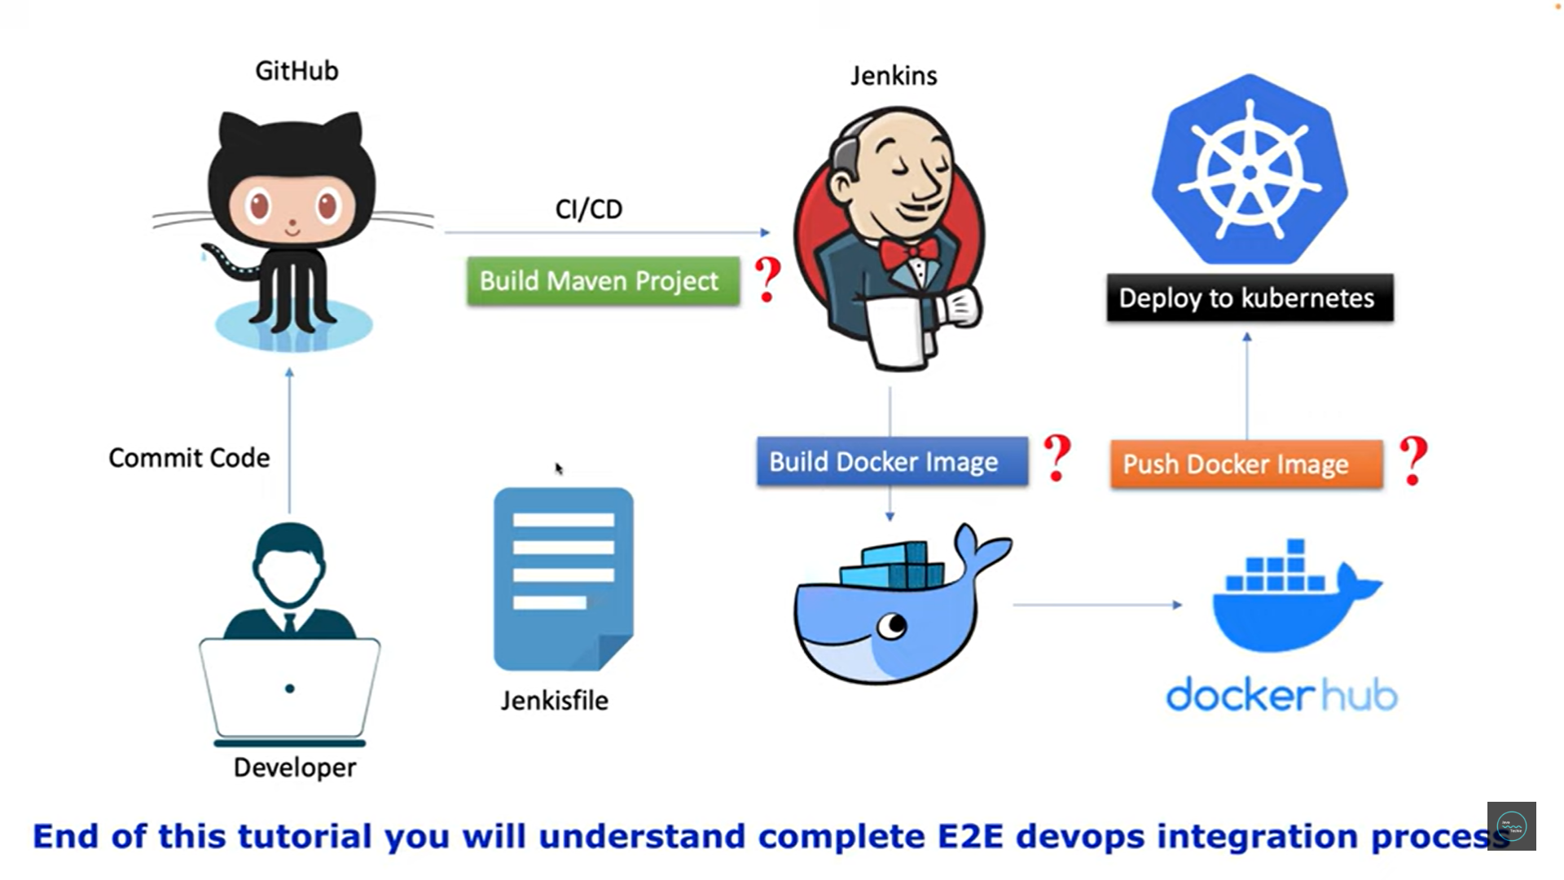

**Application name- devops automation/devops integration**

Now if you can remember, this is what the last project we created. If you'll open this DevOps automation and if you'll check the configure, you can see the pipeline which we created. You can see here we build Maven project, then we create a Docker image. Then we push that image to the Docker hub and the next step, we are going to add a new stage to push that Docker image to the Kubernetes cluster. Since we want to play with Kubernetes, so first we need to start our minikube server.so that we can bootstrap the local Kubernetes cluster. So, what I'll do, I'll go to the terminal and simply I'll type minikube start. Okay. It will take a few seconds to start the minikube. Meanwhile, I'll just add a plugin in the Jenkins so that we can perform this Kubernetes deployment.

**++ minikube start**

**++ minikube status**

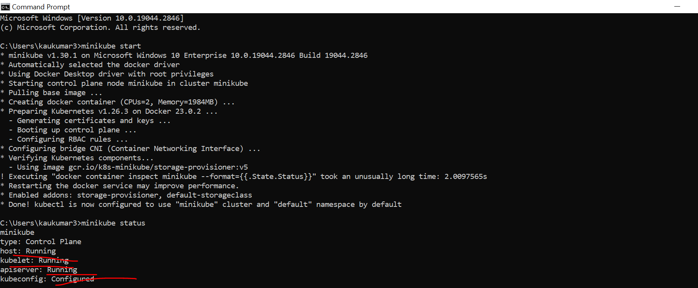.

Now we are going to continue with pipeline **devops-automation.**

* Now go to the configure section here. We just want to add a new stage.
* Now I need to sync my Docker with Kubernetes.
* Now if I type Docker images, I can see all the images from the Kubernetes component.

**++ minikube docker-env**

**++docker images**

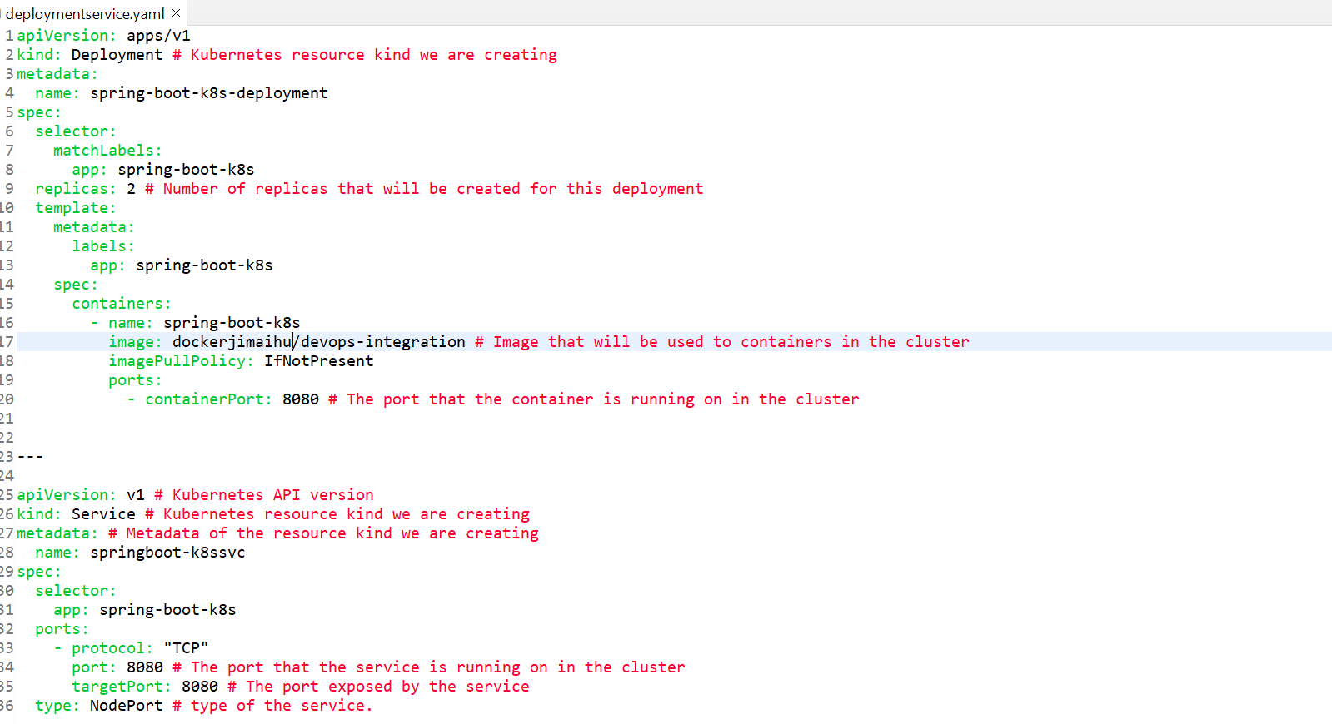

* since I want to deploy my application to the Kubernetes cluster, I need to create service and deployment object. Now first I need to create the **deployment** and **service** **object**. So how we can do that simply in our same application, we'll create a new file, and we'll name that file something like **deployment**. okay, there you need to define the **deployment** and **service** **object**. So just add it.

if you can observe this is what my deployment object and the name of my deployment and then the replica number of parts I want to up for this particular deployment and the level you need to specify, then you need to specify the containers information. This is the important things you need to remember. You need to give the image name which you are creating from the Jenkins file. So, if you'll go and check in our configure section.

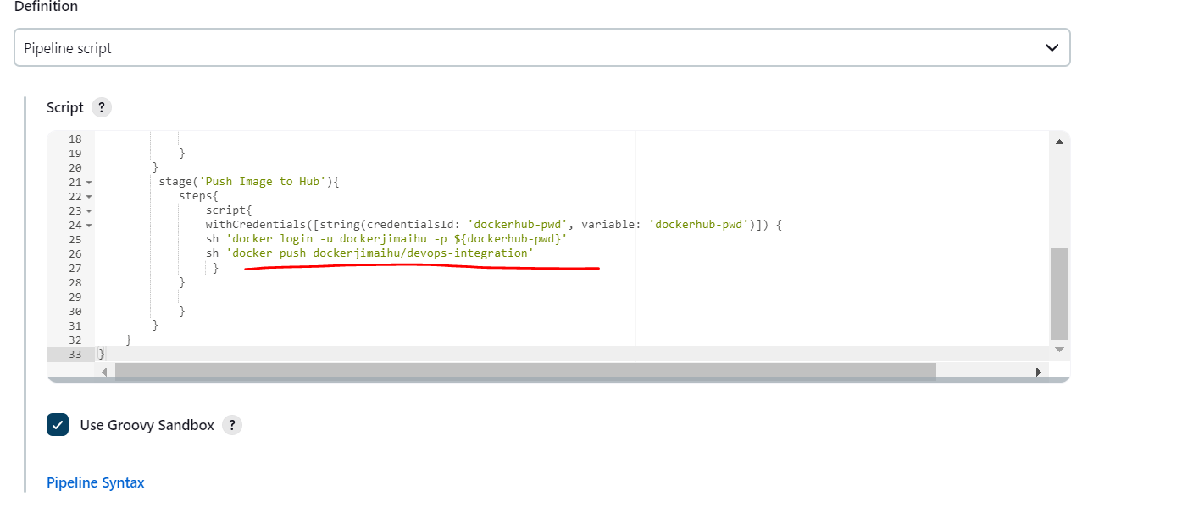

the image name we are giving devops-integration. Then go back to your code in the deployment and service. Just replace the image name. Because this is what the image Kubernetes will pull from your Docker Hub so that both will be on sync and make sure we have the same image name in our Docker file. Now if you observe the second object is service, there we are just specifying the service type which is node port. But to deploy any application to the Kubernetes cluster, we need two objects. One is the deployment another is the service object and that is what we configured through the YML file. Now let me commit these changes. Okay. I'll just add deployment file. commit and push.

So, this is what we added, and we changed the image name which we are pushing to the Docker Hub so that Kubernetes will pull the same image from the Docker Hub, and it will continue to deploy it to Kubernetes cluster. Fine. Now let's go to the Jenkins and configure a new stage for Kubernetes deployment.

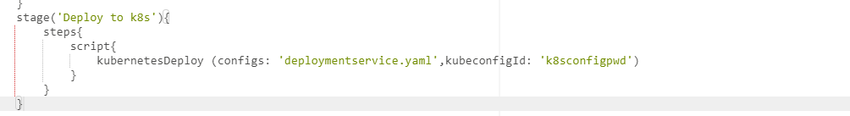

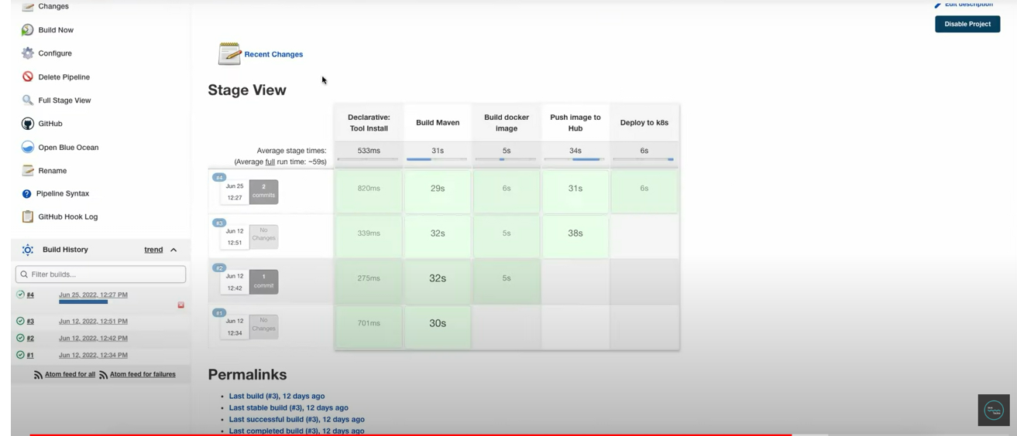

Let’s add the jenkins file in our project file.

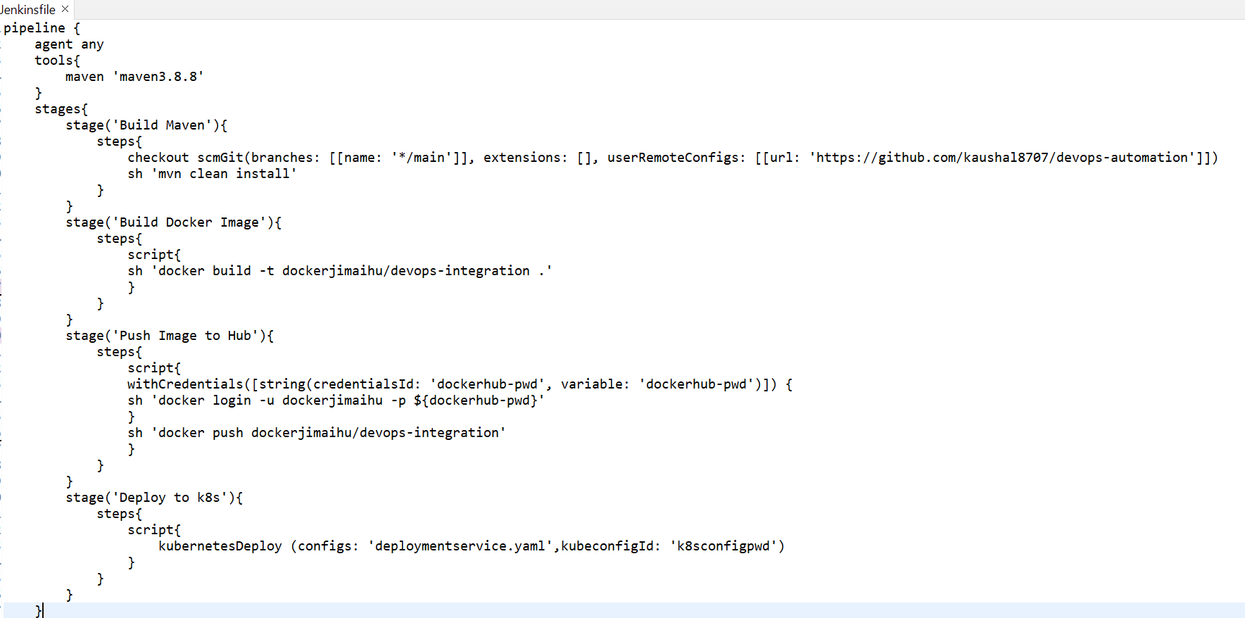

How to verify either our application is successfully deployed to Kubernates cluster or not. Go to terminal and type kubectl get deployments.

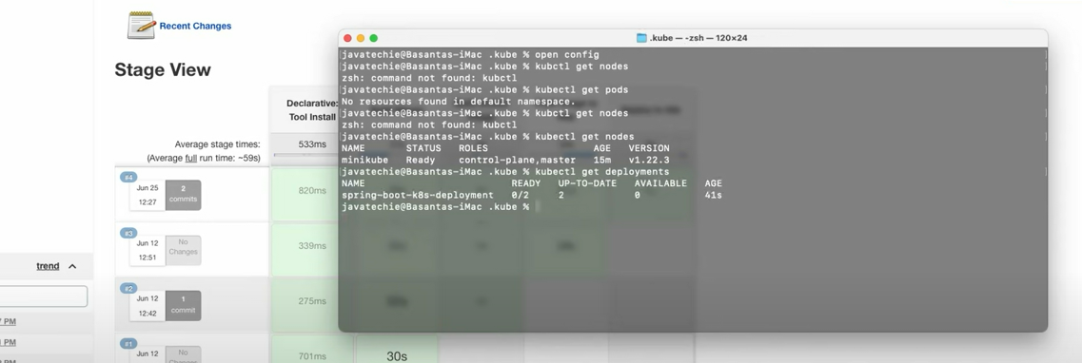

Now let’s check the pods either container is started running or not.

**++ kubectl get pods**

**++ kubectl logs <pods name>**

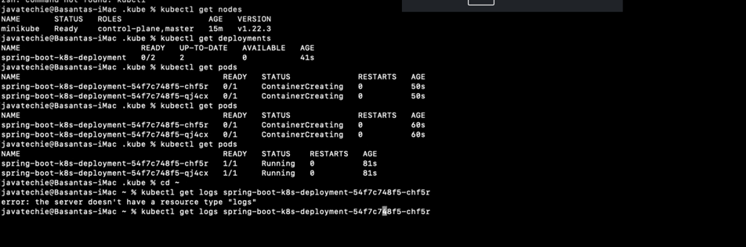

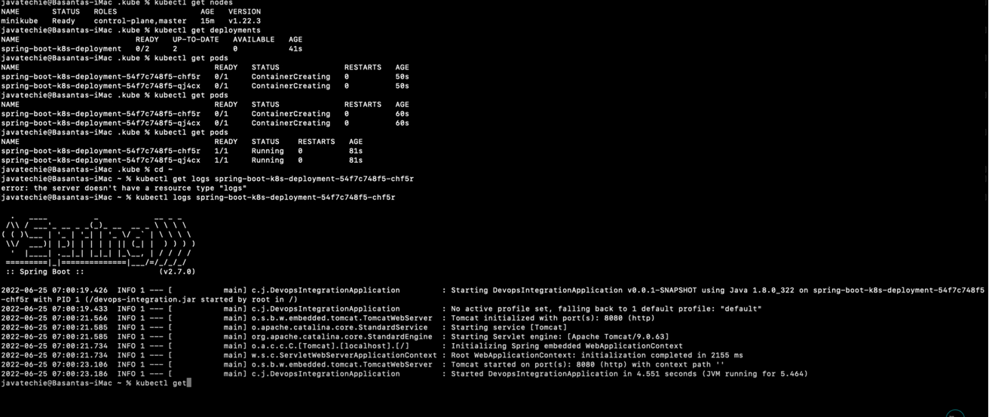

Now check to expose our app outside container so check service to get ip address and port

**++ kubectl get svc**

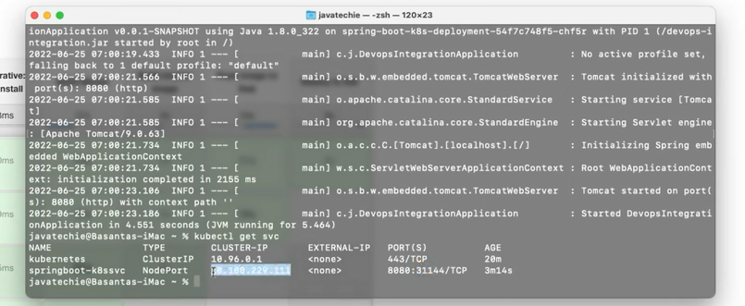

So, this is what the cluster ip and 31144 is port specified.

So, there is a command to get the service url from minikube itself to access your endpoint.

**++ minikube service springboot-k8ssvc –url**

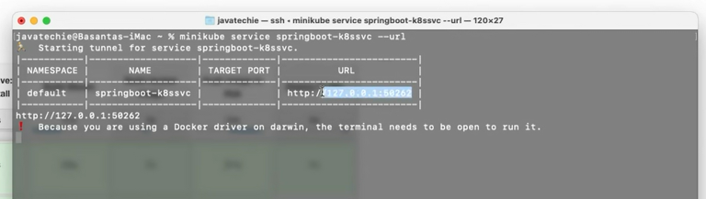

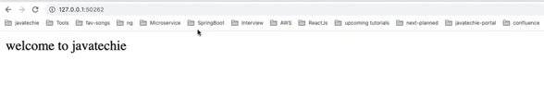

Fine so we are able to access it.

* **Build CI/CD Pipeline Using GitHub Actions | Build & Push Docker Image**

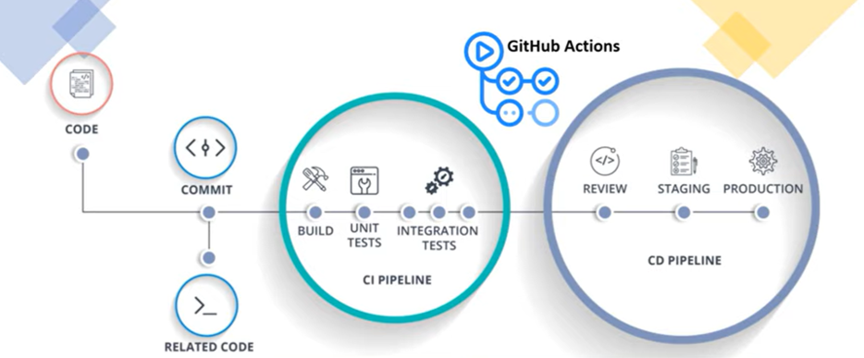

* In this tutorial we will demonstrate how to build a cicd pipeline workflow using git hub action. So, you might have a question, why git hub action when we have a lot of cicd tools like circleci, bambo, jenkins, gitlab, timecity and travescii. If we have already those many cicd tools then what is the need of git hub action. In order to understand this, let's start with what a very simple flow of any particular cicd system. So, let's consider jenkin as a cicd tool. So, let's assume I am a developer, so I write my code, then I need to commit that code to my git hub repo which is nothing but the source code repository. Then from my git hub repo, I need to integrate to the jenkins through webhook to perform continuous integration and continuous deployment. As part of continuous integration, jenkin will build my code, it will test my code, if there is any code coverage configured, it will just find out the coverage of my application, then it will create the docker image. Then as part of continuous deployment, jenkin will just deploy my code and the created docker image, it will push to the corresponding docker hub which is configured in your pipeline. So, if you observe, the entire cicd flow will be taken care by jenkins which is a third-party tool and in real time, this required an additional resource, let's say at least a vm with some memory to install it in hosted server. Basically, in short, you need a separate infrastructure for this which is completely an extra burden for a developer. So why can't we use git hub actions where your source code repo which is git hub and cicd pipeline will run on the same platform. So, if you are using git hub actions, then you don't need any dedicated infrastructure to configure this git hub actions or to perform the cicd workflow. Github actions helps us to automate our software development workflow in the same place where we stored our code. Also, with github actions, we can build end to end continuous integration and continuous deployment pipeline directly in our repository itself.

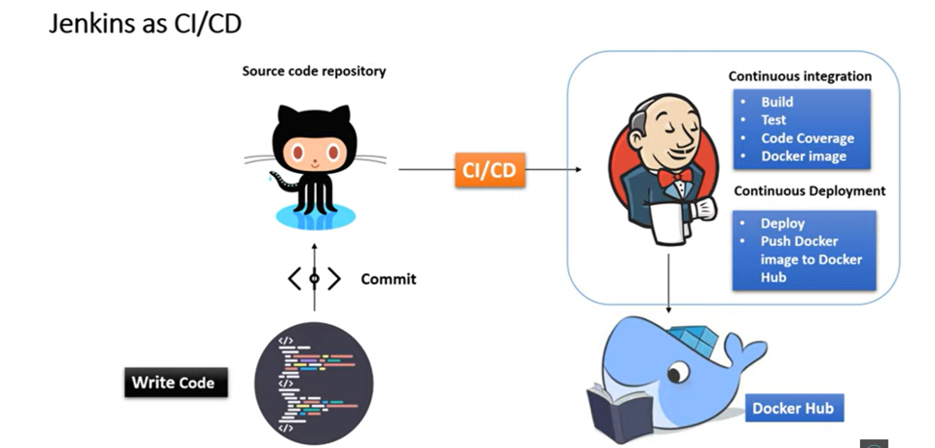

* The major advantages that workflow can be run in Linux, MacOS, Windows and containers any kind of operating system on git hub hosted machines. In the case of private repository, let's say you have some private repo, then we have the flexibility of configuring our own machine with the choice of our environment. So, I believe this is really awesome platform for developers where they can directly automate their workflow from dev to prod. So now let's understand how we can use git hub actions to build a cicd pipeline and what all steps we will execute in our example. Basically, we are going to create a spring boot project.

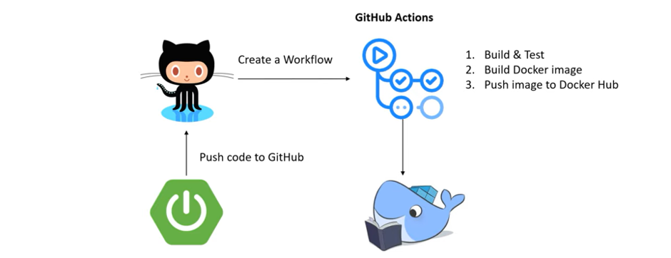

* Then next we need to push that code to the github. Then from github action tab, we need to create a workflow to perform continuous integration and continuous deployment. So as part of continuous integration and continuous deployment actions, we can tell to the github action to perform build and test my code, then create Docker image of my application, then push that Docker image to Docker Hub. So, these are the steps we need to mention as part of the workflow. Then git hub action will execute these steps. then finally it will create a Docker image and it will push to the Docker Hub. So, the entire flow we are going to automate using github cicd action..

Let’s create a public git repo and commit our code-

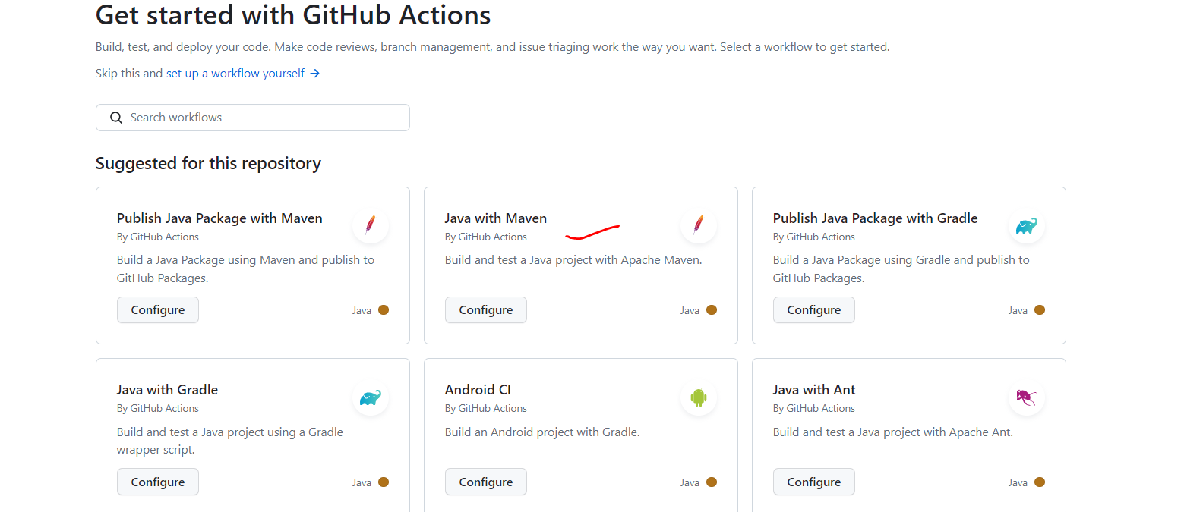

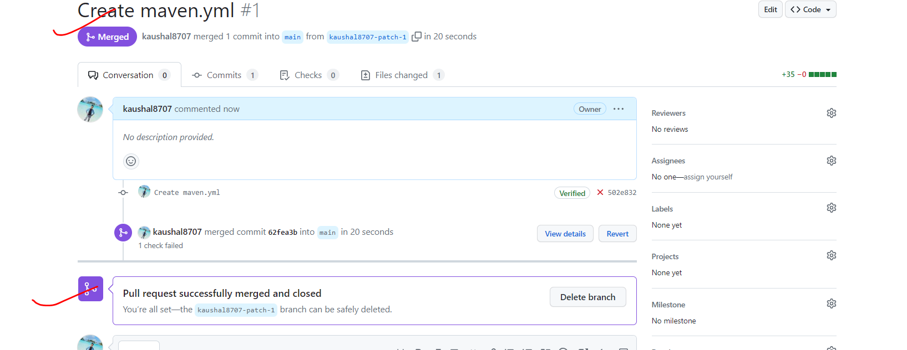

So, you can see in our github project **.github/workflows** folder got created.

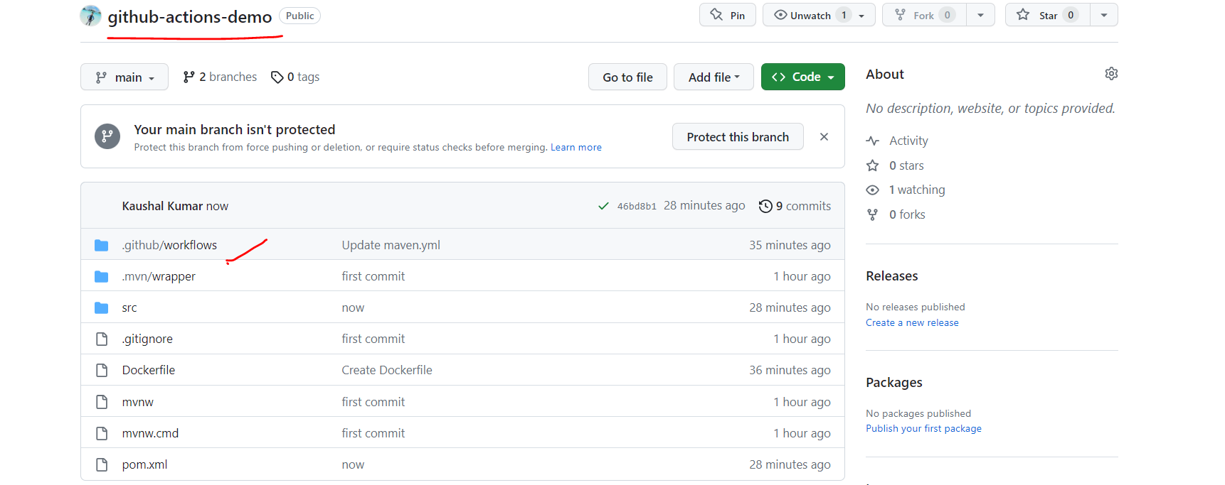

Inside that we have a **maven.yml** file for cicd **pipeline** scripts.

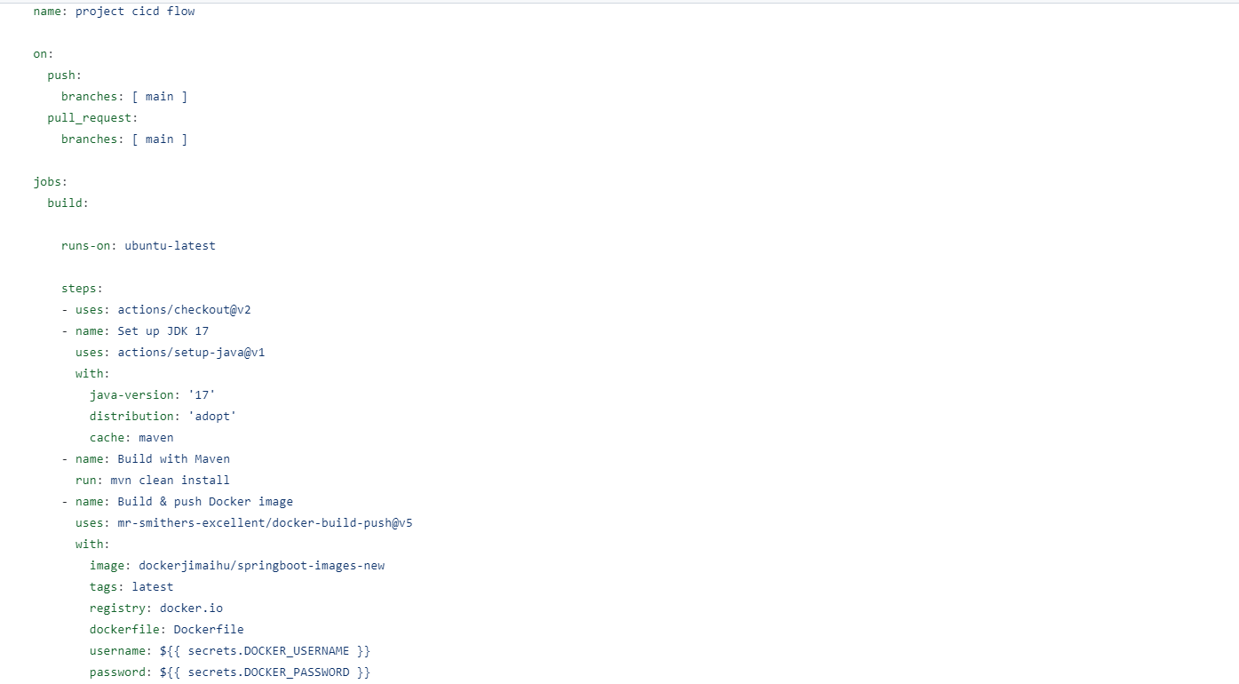

So, in this workflow, we just mention our or we just need to mention our actions. What actions we need to perform to complete this CI-CD pipeline. So just go into this Maven.yml file. So, if you observe this Maven.yml file, you're just giving the name of our CI-CD, which is nothing. We just added project CI-CD flow. So, as I already mentioned, you can execute your workflow in any operating system. It can be Ubuntu it can be Mac OS or it can be Windows. So, this is the Ubuntu latest because all the Docker and predefined tools already installed in this Ubuntu latest. That's the reason this is what the default template.

Then as part of the steps, we are just specifying use actions checkout. Now if you go to the GitHub, I'll show you what is the checkout. Let me go to the Maven.yml. Let me go to the browser right away.

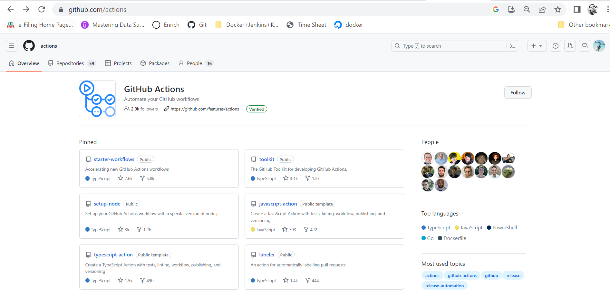

So, you can type GitHub slash actions. These are all the readymade actions you can find here. Let me show something called checkout. It will just check out your code. Now this is what the checkout action. If you go inside this checkout. There is some again .github workflow. These are the checkout actions. OK. That's what we are just directly configuring in our code. So, it will just go to that particular repo slash actions, GitHub slash actions and it will check out this V2 version and set up JDK. We are just using 17. Then cache is maven and then name of your build which is nothing build with maven and the goal or the run command which we provided maven clean install. So based on this condition, it will just execute the job. What do you mention here? OK. Now, since we already added one commit, if you go to the repo and if you go inside actions, it already started one. OK. So not not here. Let's go to the repo. Go to the action. See this. It already added create maven.yml. If you go inside that, it just executes and it took 36 seconds. Now if you click on build, it just executes all the steps which we mentioned in our maven.yml file. Now I can show you the maven.yml file. We can compare both. OK. Go to the IntelliJ IDEA. Let me minimize this. So, if you observe the first step set of jobs, then run actions, check out v2. This is what we specify here. And then we later reconfigured it to the v1. Build with maven. So as part of maven, it executes the clean and install goal. I can show you the entire full log. Let me scroll down. I can show you the build succeed status with the spring boot. Let me scroll down. There is so many things executed. See here you can see build succeed. Right. This is what our spring boot code. So you can see here finally it execute all the steps which we mentioned in our maven.yml file. Now if you go to the flow diagram as per the diagram, we created our Spring Boot project. Then we push that to the GitHub. Then we created workflow to perform build and test our code. That's the reason we added maven clean and install. Right.

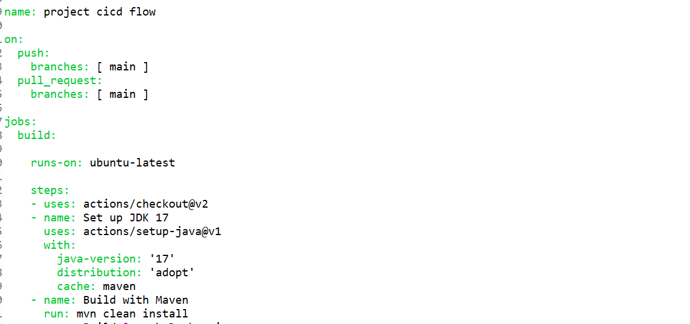

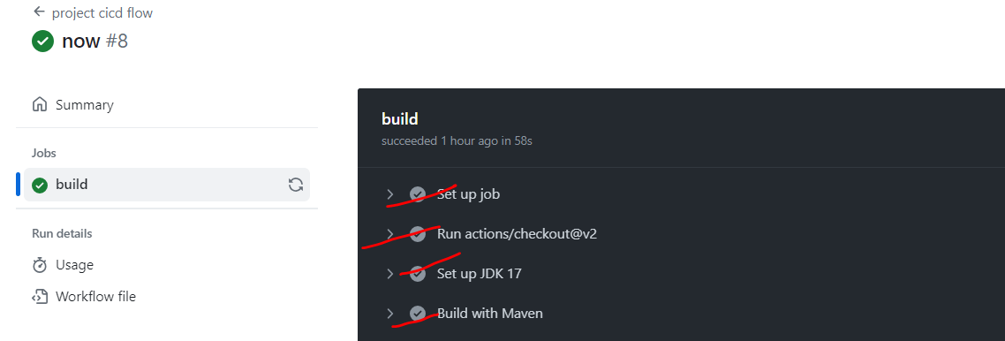

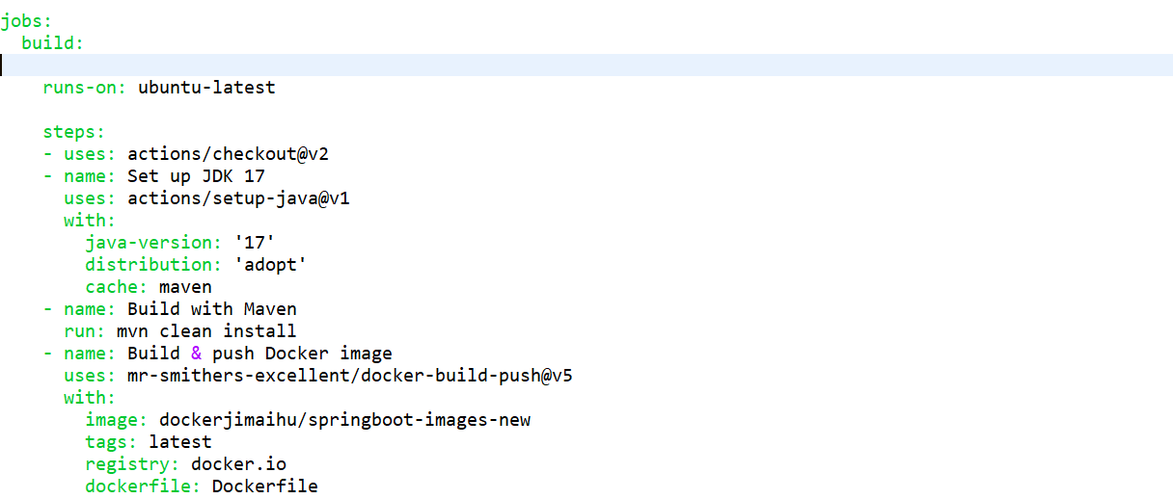

Now the next step we need to tell the GitHub action to create a Docker image and push that image to Docker Hub. Now we need to specify a few actions in the existing workflow to create the Docker image and push that image to Docker Hub. Now if you go to the maven.yml file, so here you can specify first you need to tell to the GitHub action to login to your Docker. Then you need to tell him that create or build a Docker image. Then you can add a command to push that image to Docker Hub. So, we can configure these many steps in this maven.yml file to inform to the GitHub action to create a Docker image and push that image to Docker Hub. Similarly, you can add each goal or each step, whatever you understand. So here you can provide the name login to Docker Hub. Then you can add a command to log into your Docker Hub. You can provide the command the way you set your goal here maven clean install. Similar way you just need to provide a command Docker login and then you just need to add another name or another steps which is build Docker image. And again, you need to provide the command to create a Docker image. Similar way you can configure push that image to Docker Hub. You just need to provide the name of your action. Then corresponding command to execute that action. Rather than we do it, the GitHub provided readymade actions which you can directly use to create a Docker image and push that image to the Docker Hub. So, I don't need to configure these many steps here. So, the name build and push Docker image and this is what the action. We can directly get it from the GitHub actions section. And then you need to provide your repo and then name of your image. Then you can provide the tag of your image. Any name you can provide. Then register name. you just need to add the Docker file. And you need to provide the username and password of your Docker Hub. So this is YML file. It needs to be in proper hierarchy. Otherwise, you'll get the compilation error. OK. So I'll just add this. Usage. Then with. Fine. So, name of my action is build and push Docker image.

Login to Docker Hub. Then I just need to provide the Docker ID, which is dockerjimaihu. Then I just need to provide my password. Just log in. So, I just need to create a repo here. So click on create repo. I'll just give a name something called SpringBoot-image-new or something like that. OK. this is my repository name. This is what my Docker ID. OK, now click on create. Now go to your IntelliJ ID. So the image name, the repo name, you can provide your Spring Boot images new and And the registry is Docker.io. Just change it to Docker.io then you just need to provide a Docker file in your application. Let me create a new file. Docker file.

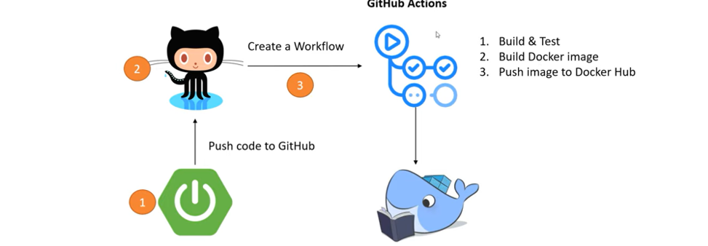

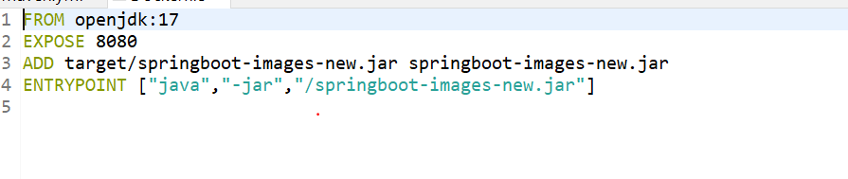

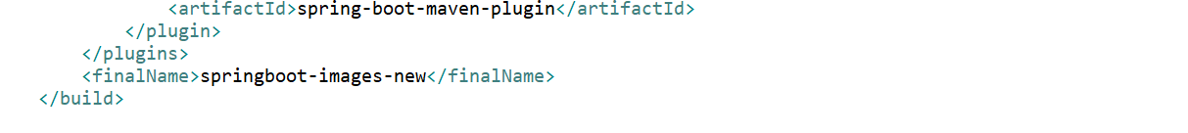

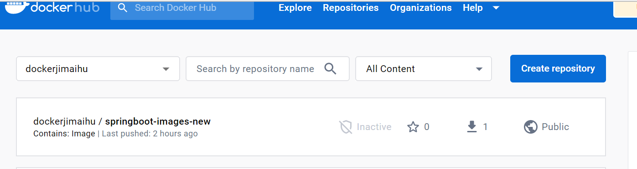

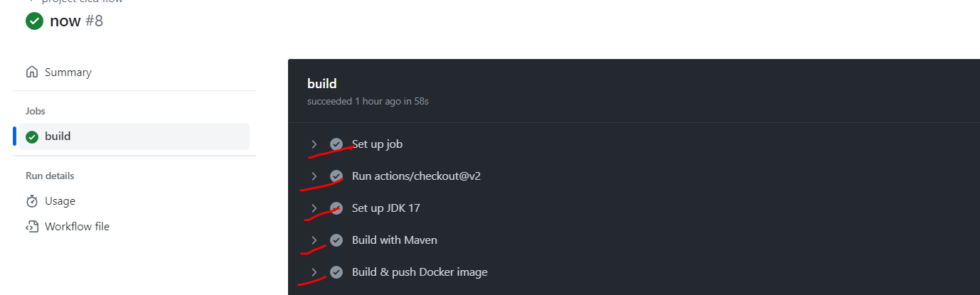

To create the secrets of docker username and password

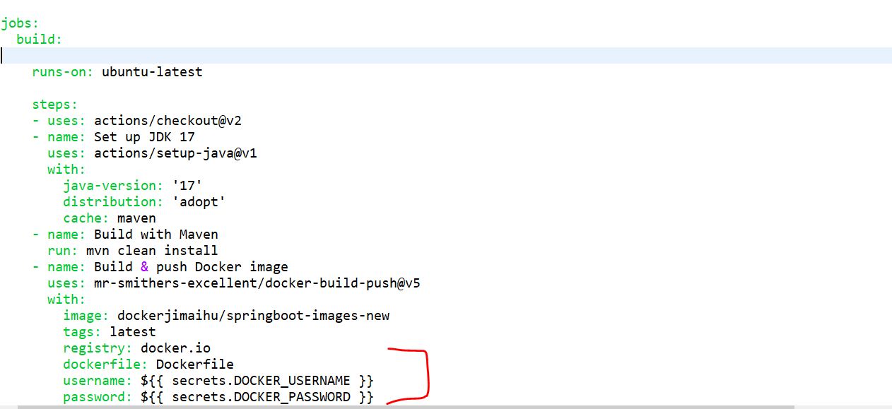

Github project/Settings/secrets/Actions

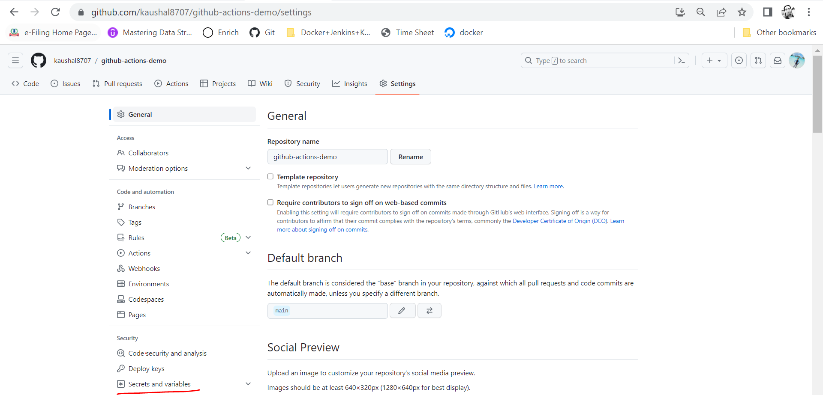

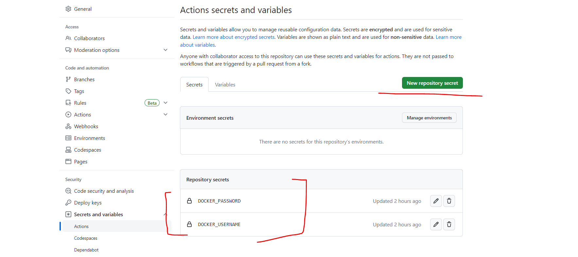

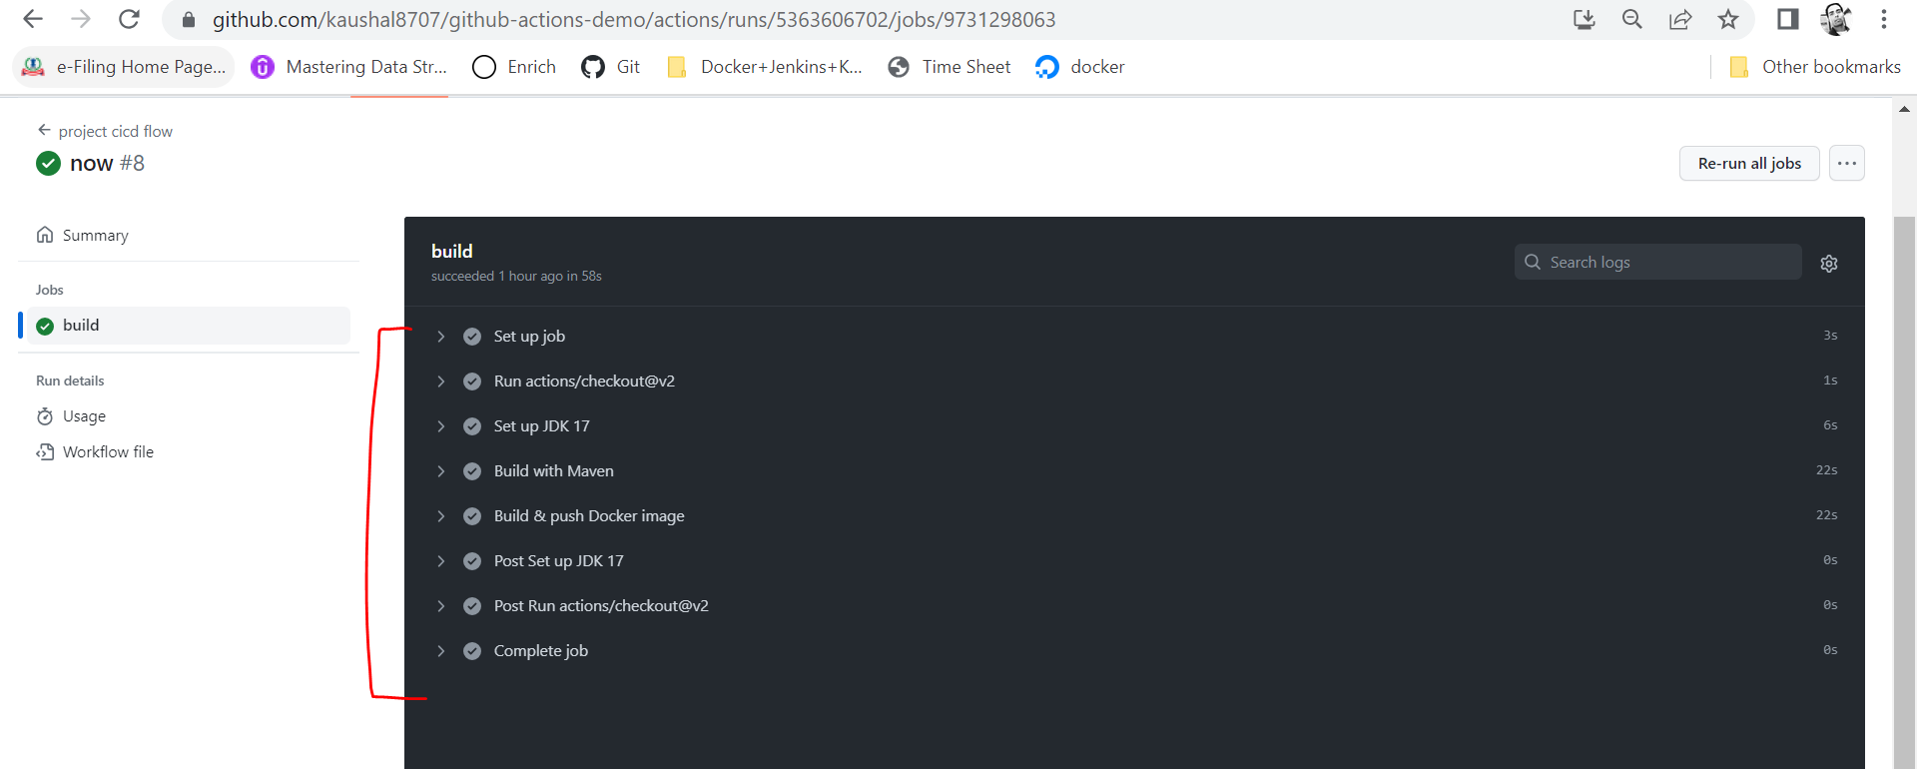

Docker image got created and pushed to docker hub

Go cmd->

**++ docker images**

**++ docker pull dockerjimaihu/springboot-images-new**

**++ docker images**

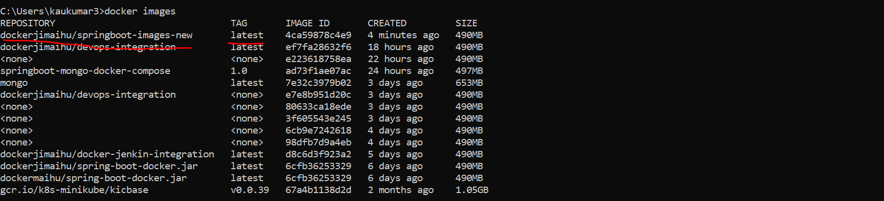

Run our docker image to our docker container

**++ docker run -p 9090:8080 dockerjimaihu/springboot-images-new:latest**

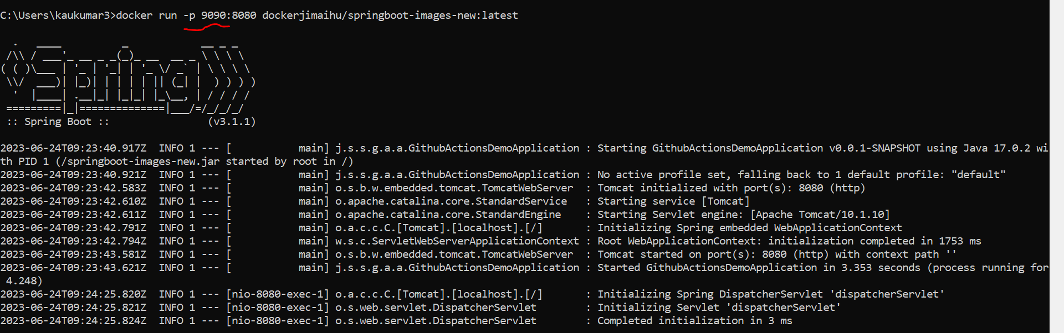

Let’s verify with endpoint

